

Sri Lanka Institute of Information Technology

**Collaborative** **Shopping Platform Using Restful Services**

**And**

**WSO2 Enterprise Integrator**

**Project Report**

Distributed System Assignment 02

Submitted by:

IT19133850 – (Yasas R.M)

Submitted to:

………………………………

Dr. Dharshana Kasthurirathna

**Group members**

|  |  |
| --- | --- |
| Student ID | Name |
| IT19133850 | Yasas R.M. |
| IT19152288 | Bandara M.H.M.N.D.T. |
| IT19215884 | Gunawardana K.H.R |

**Group Contribution**

|  |  |
| --- | --- |
| Student ID | Implementations |
| IT19133850 | 1. Product service to search (Full text), filter and perform all crud operations. 2. Shopping cart management. 3. Dummy credit card payment gateway service. 4. Dummy mobile payment gateway service using Twilio. 5. Place orders with multiple products. 6. Track orders. 7. Using WSO2 EI (Enterprise Integration – ESB) to integrate services at the backend and expose a common web API. 8. Route the payment to either the banking payment gateway or the mobile operator, based on some parameter of the payment request message. 9. Frontend of Delivery service. |
| IT19152288 | 1. Seller service where sellers can add/update/delete items. |
| IT19215884 | 1. JWT authentication service to perform role based authentication. 2. Delivery service to deliver orders. |

Contents

1. High Level Architectural Diagram of the System 5

2. Service Interfaces exposed by each service 6

2.1. Authentication service (IT19215884) 6

2.2. Seller service (IT19152288) 7

2.3. Buyer service (IT19133850) 8

2.4. Credit card payment gateway service (IT19133850) 10

2.5. Mobile payment gateway service (IT19133850) 10

2.6. Delivery service 11

3. Workflows explained with code Snippets 12

3.1. Process of registering a new user 12

3.2. Process of login 14

3.3. Process of forgot password 16

3.4. Process of resetting user password 19

3.5. Process of validating the token 20

3.6. Process of creating a new product 22

3.7. Process of updating a product 25

3.8. Process of retrieving all products 26

3.9. Process of retrieving a product 27

3.10. Process of deleting a product 28

3.11. Process of searching the products 29

3.12. Shopping cart management 30

3.12.1. Add a product to shopping cart 31

3.12.2. Update products quantity in shopping cart 35

3.12.3. Retrieve user’s shopping cart 37

3.13. Order management 39

3.13.1. Process of creating a new order 40

3.13.2. Process of Saving / Updating buyer details and delivery in order 44

3.13.3. Process of retrieving order details 48

3.14. Processing payments 50

3.14.1. Process of payment through credit card 52

3.14.2. Process of payment through mobile payment gateway 56

3.14.3. Process of requesting mobile pin number 60

3.14.4. Process of listening to payment notifications 64

3.14.5. Process of placing cash on delivery order. 72

3.15. Delivery service 75

3.15.1. Process of creating a new delivery 76

3.15.2. Process of updating a delivery 77

3.15.3. Process of deleting a delivery 78

3.15.4. Process of finding a delivery 79

3.15.5. Process of listing all deliveries 80

4. Authentication and Security Mechanism adopted with system 81

4.1. User Authentication 81

4.2. Service Authentication 81

4.3. Payment Security 84

5. Screenshots of the User Interfaces 85

6. Appendix 109

6.1. Rest Services 109

6.1.1. Authentication service 109

6.1.2. Seller service 122

6.1.3. Buyer service 130

6.1.4. Credit card payment gateway service 153

6.1.5. Mobile payment gateway service 159

6.1.6. Delivery service 167

# High Level Architectural Diagram of the System

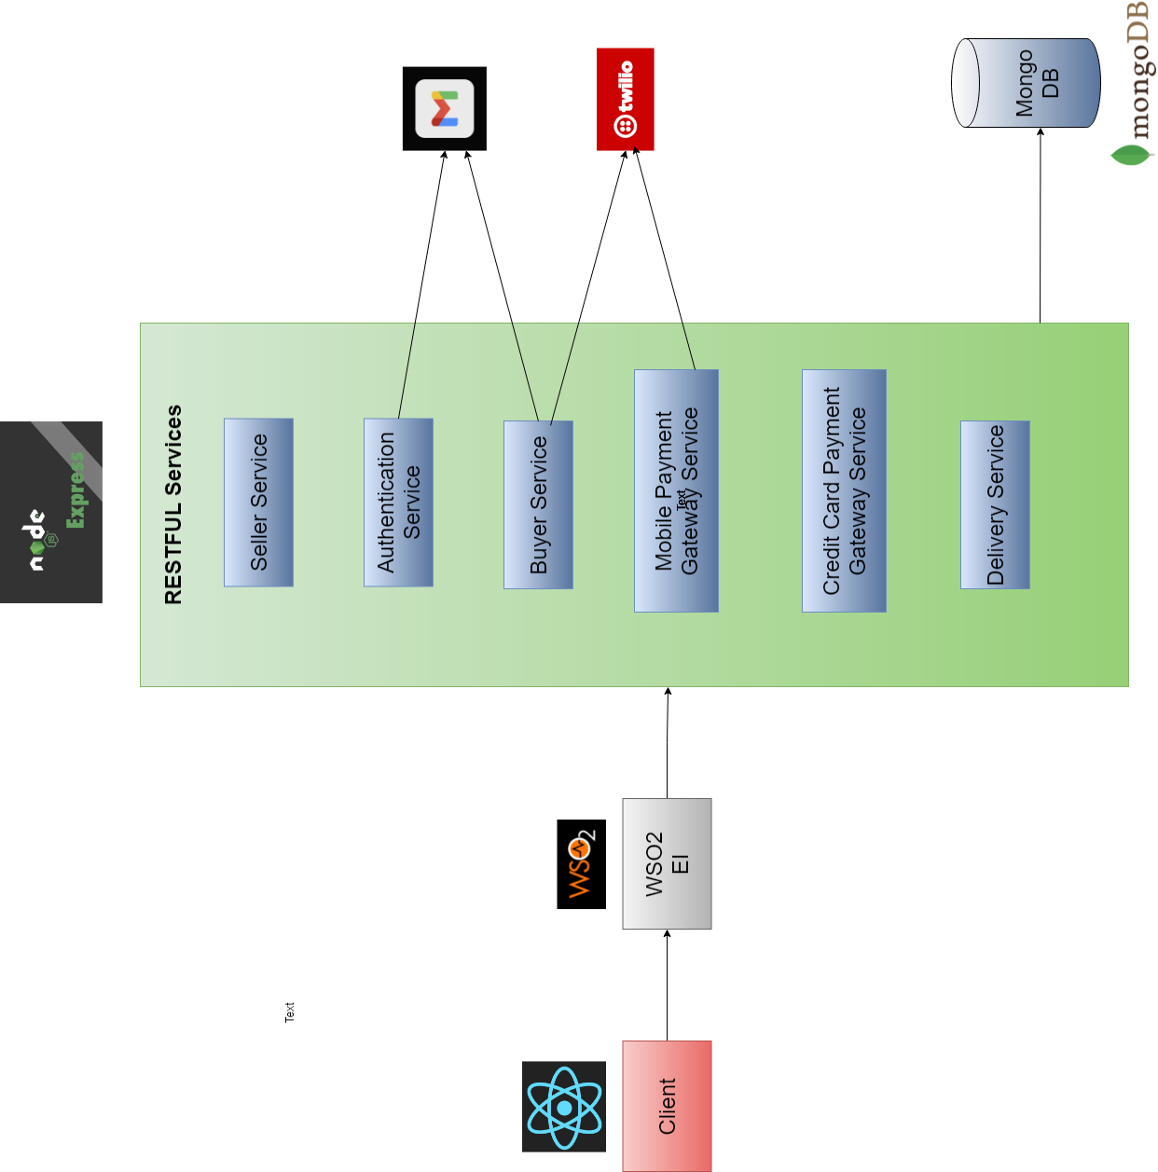

# Service Interfaces exposed by each service

## Authentication service (IT19215884)

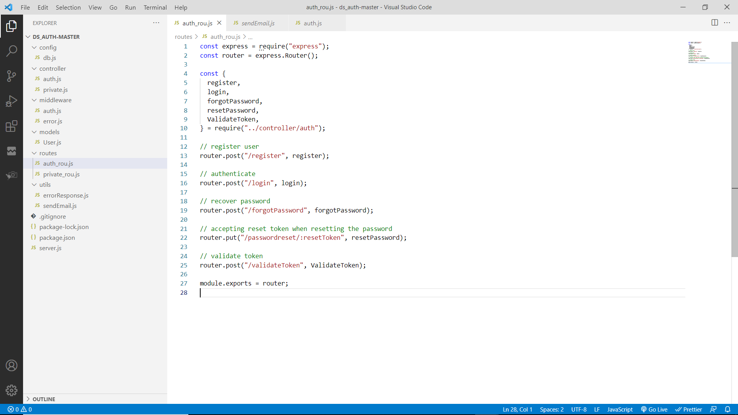

## Seller service (IT19152288)

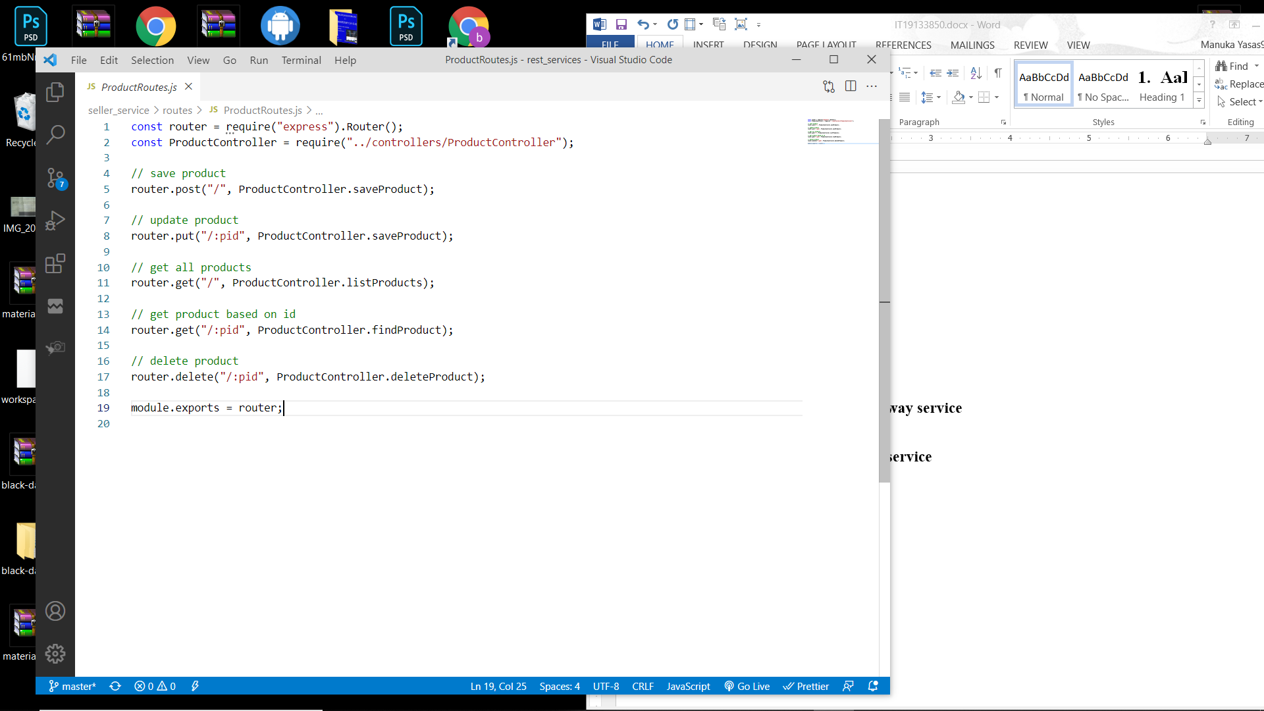

## Buyer service (IT19133850)

**Cart interface (IT19133850)**

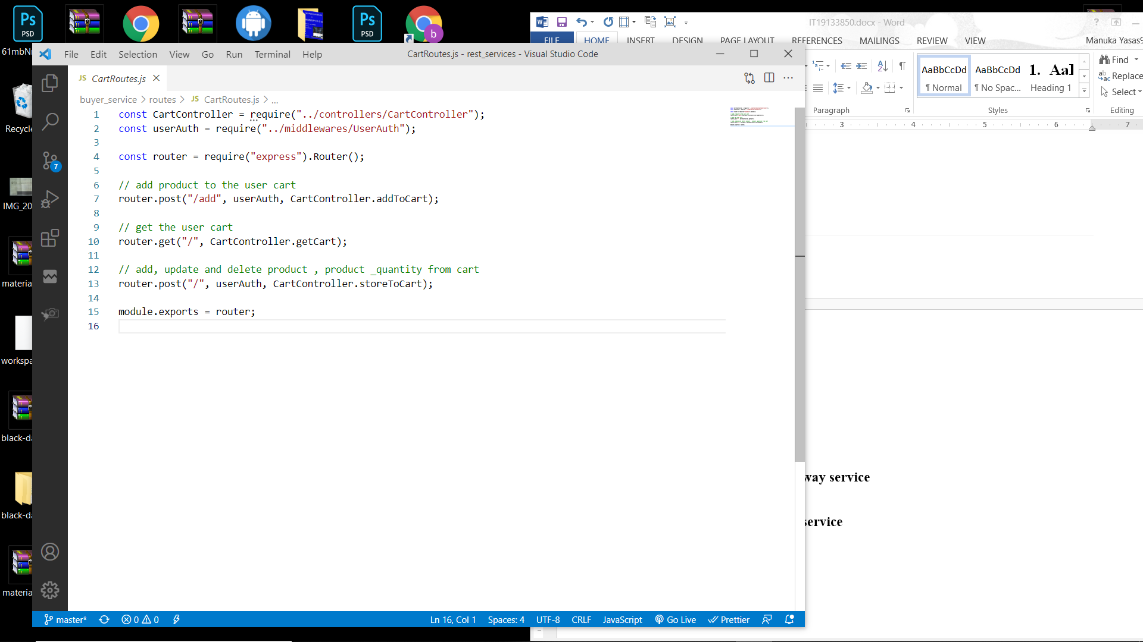

**Order interface (IT19133850)**

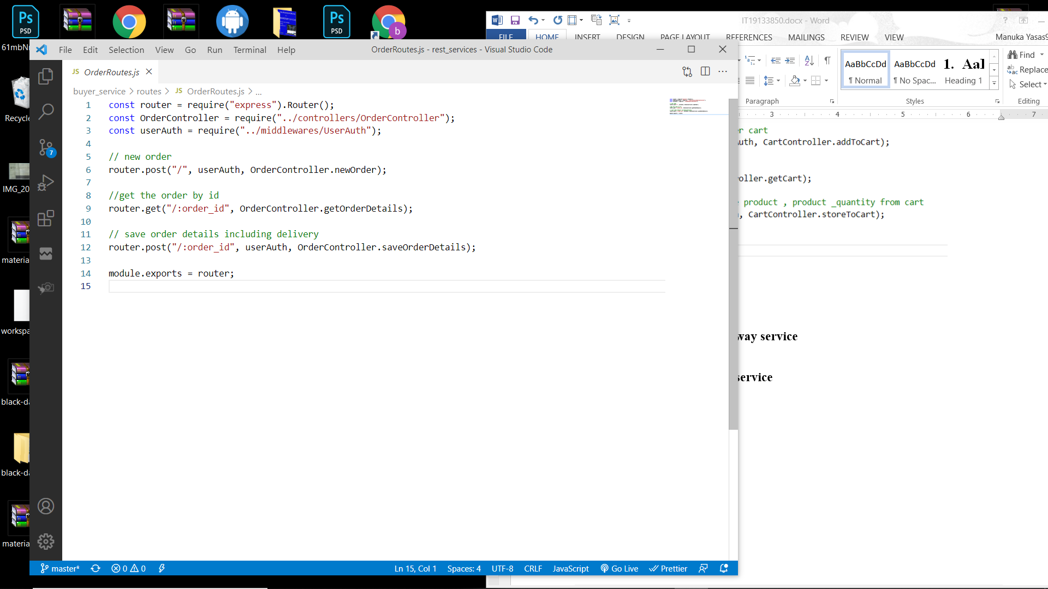

**Payment interface (IT19133850)**

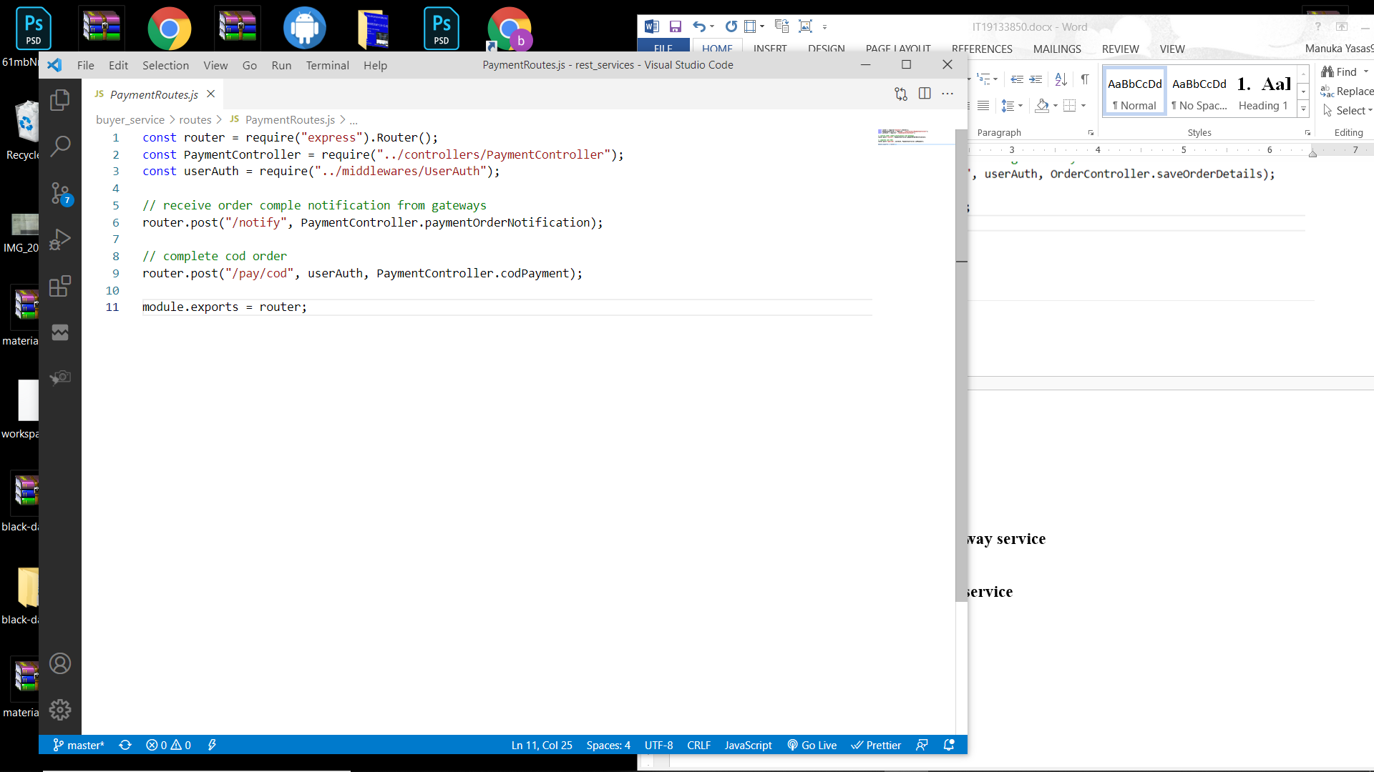

**Product interface (IT19133850)**

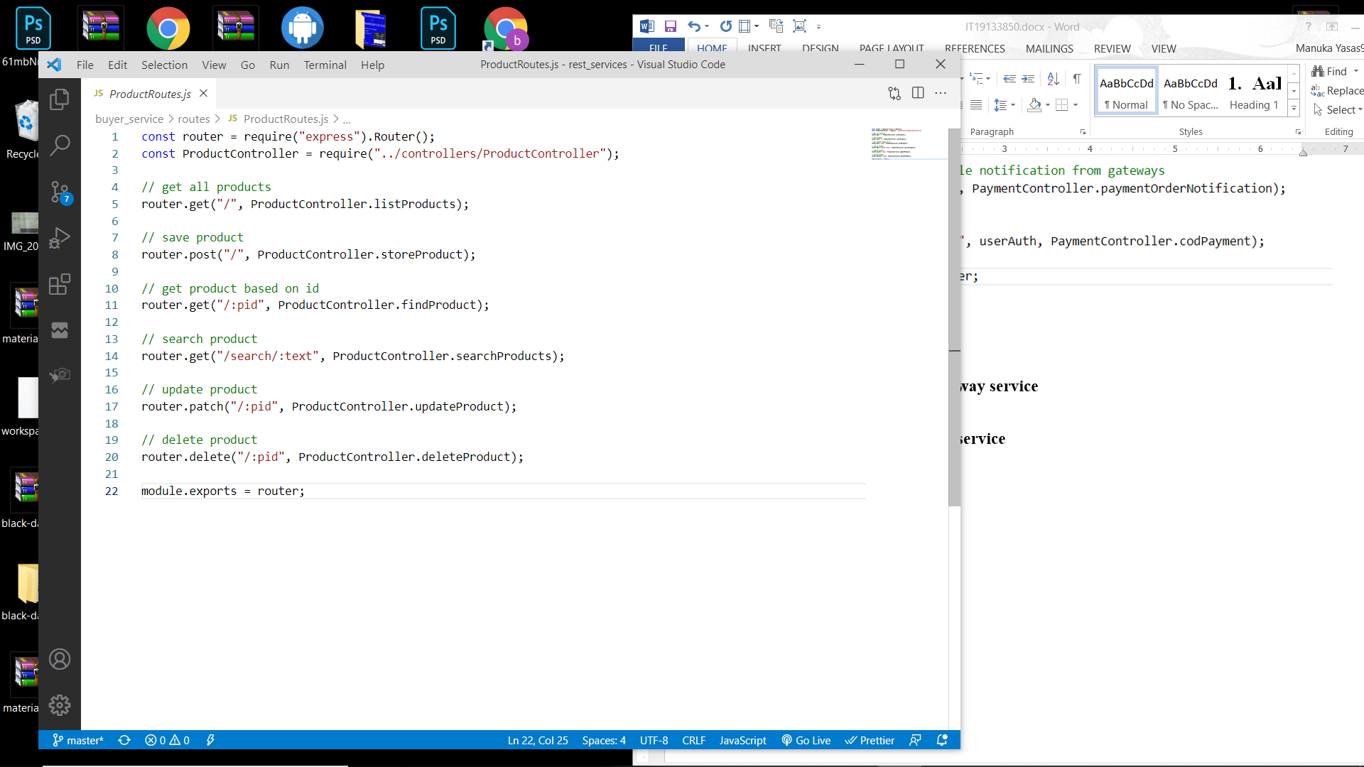

## Credit card payment gateway service (IT19133850)

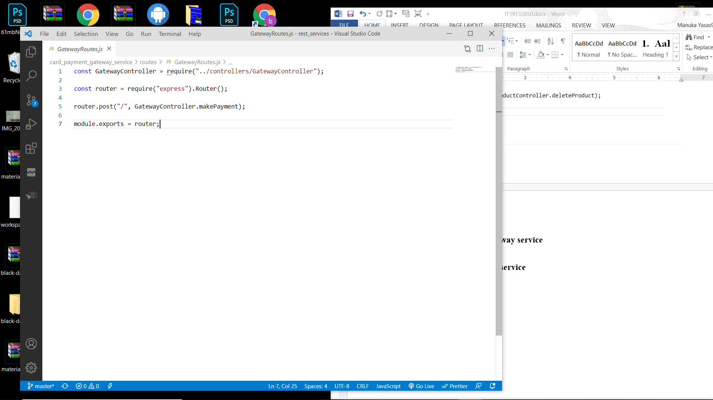

## Mobile payment gateway service (IT19133850)

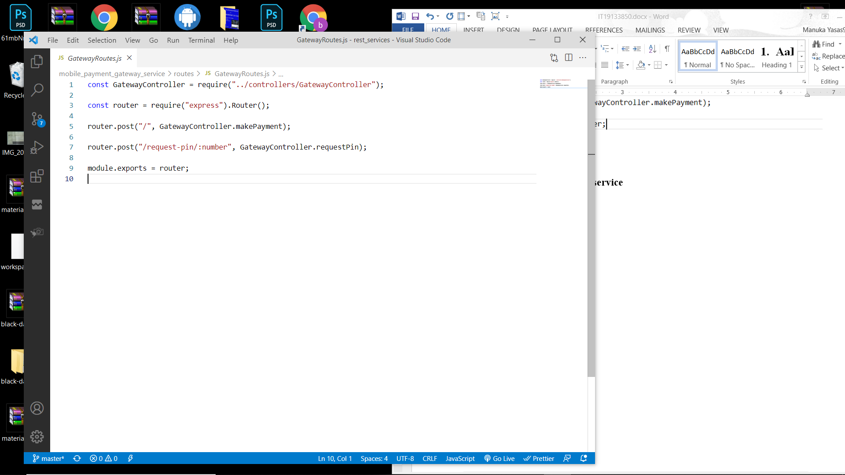

## Delivery service

**Delivery authentication interface** (**IT19133850**)

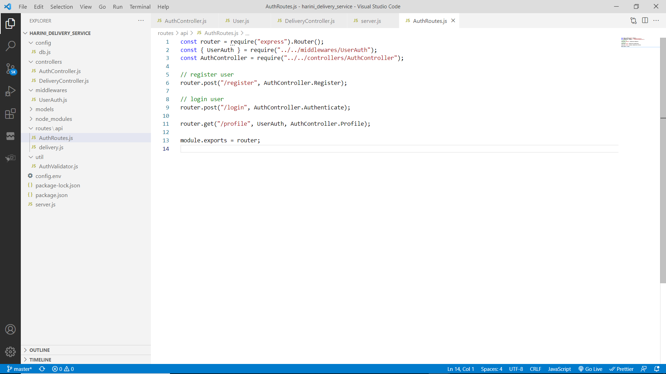

**Delivery interface** (**IT19215884**)

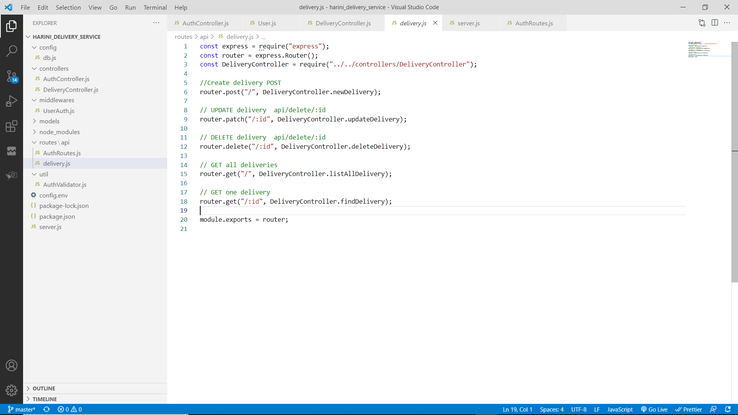

# Workflows explained with code Snippets

## Process of registering a new user

Workflow diagram

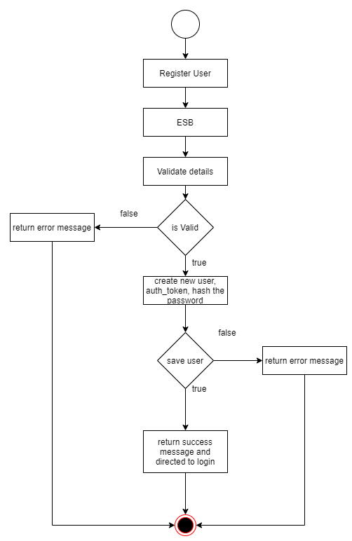

A POST request with the details (first name, last name, username, email, password, and user role) will be sent to the authentication service through ESB ( WSO2 E1). The email should be unique, and it will be checked in exports.register in auth.js. If the request is valid, a new user is created by adding new JSON document to the collection in mongoDB. Simultaneously a token for authentication also created (auth_token) . It will be used for the authentication of the user when login to the system .

The password is converted to a hash code for better privacy using bcrypt and stored. When querying, password is not passing unless specially asked for it. Once the registration is successful the user will be directed to the menu by considering the user role, as a seller to the seller dashboard and a buyer to the online store.

Creation of the token

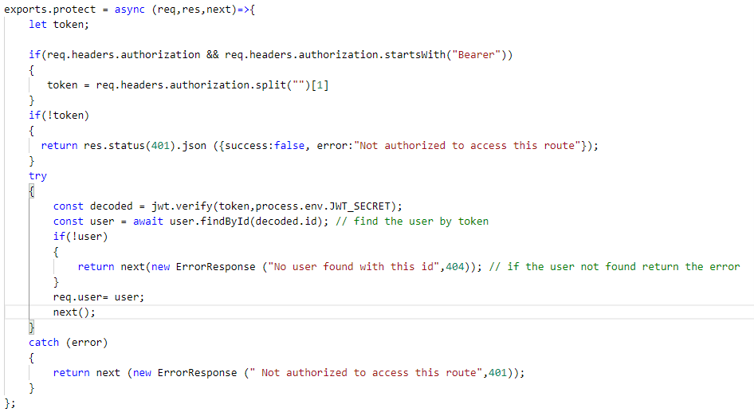

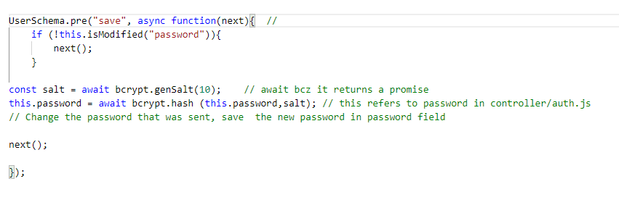Converting password into hash cod

## Process of login

Workflow diagram

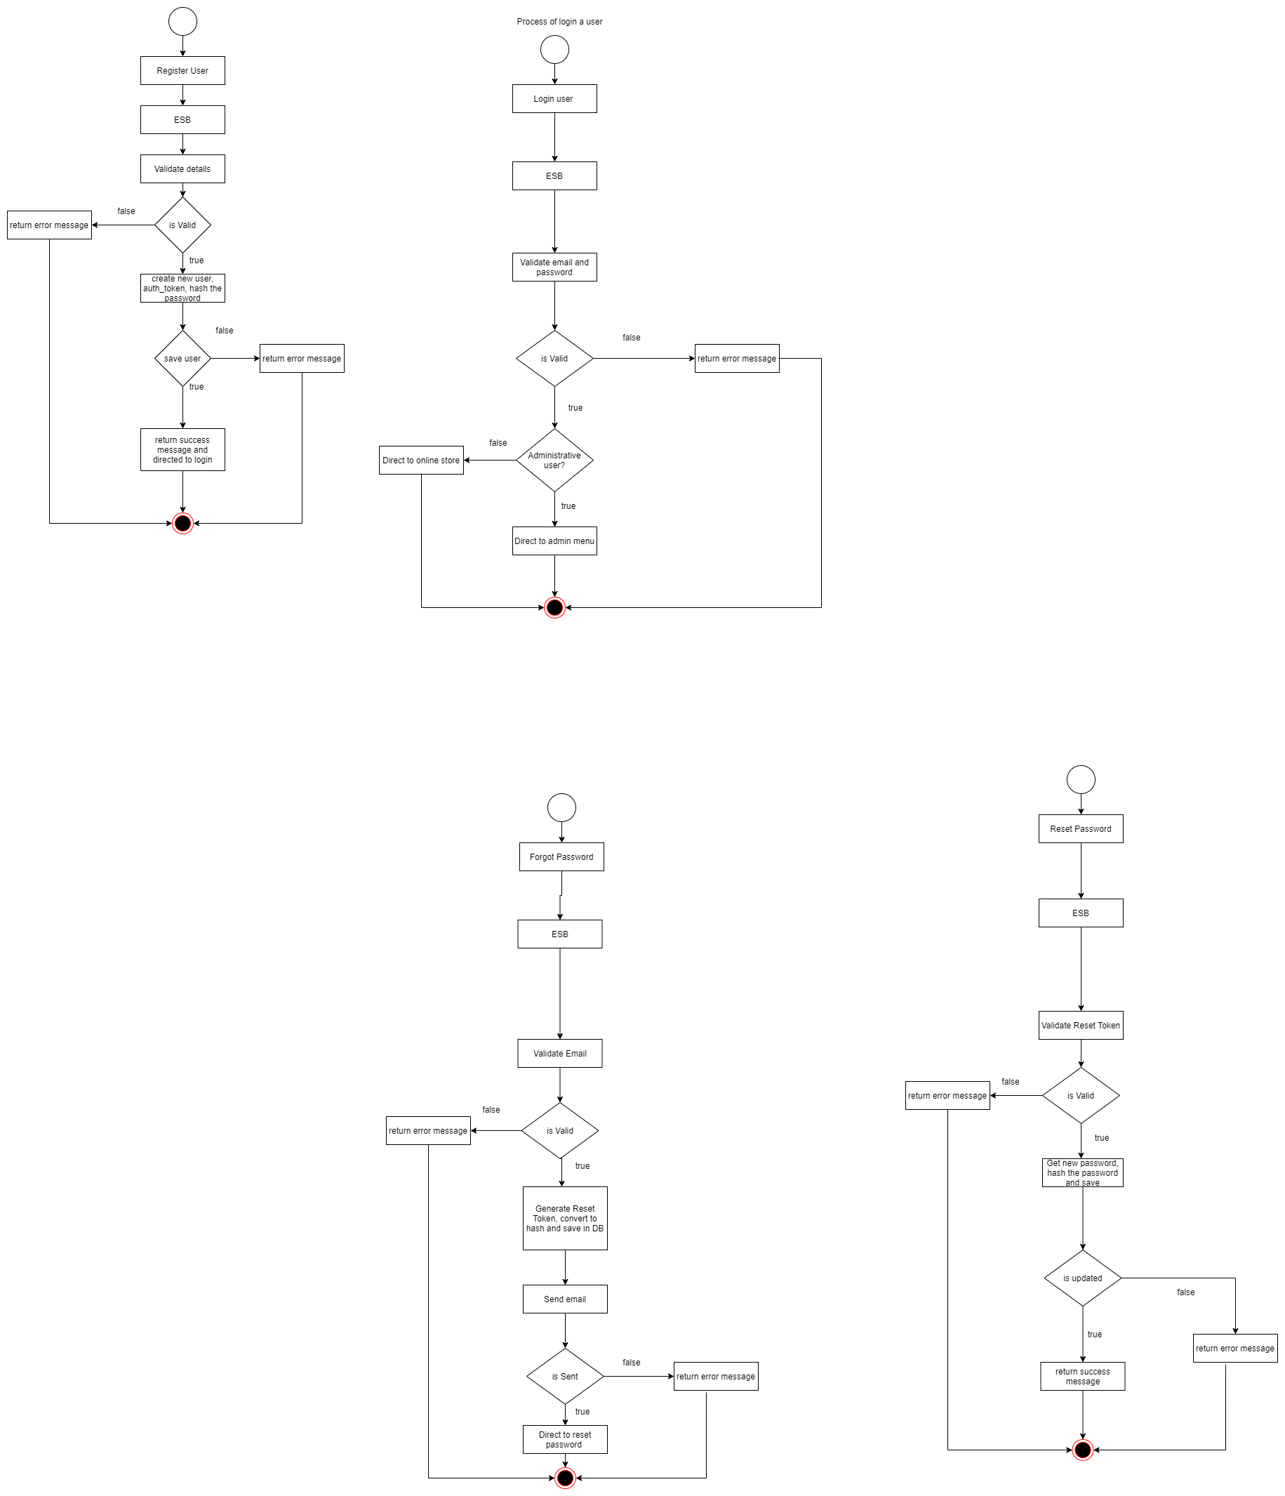

A POST request with email and password will be sent to the authentication service through ESB (WSO2 E1 ). Once request is received the system check the availability of the user by searching for the email and match the passwords. If the passwords match a sign in token will be generated and the user is directed to the respective menus based on the user role. Otherwise, an error message will be generated and if the user is not found , the user will be directed to the registration to create new user. If in case, user forgot the password, then the user will be directed to the forgot password to reset the password.

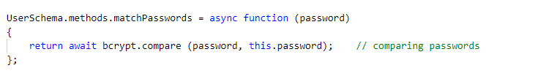 Comparing Password

Generating Sign in Token

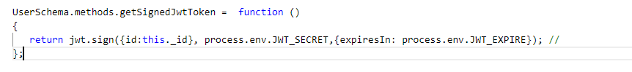

## Process of forgot password

Workflow diagram

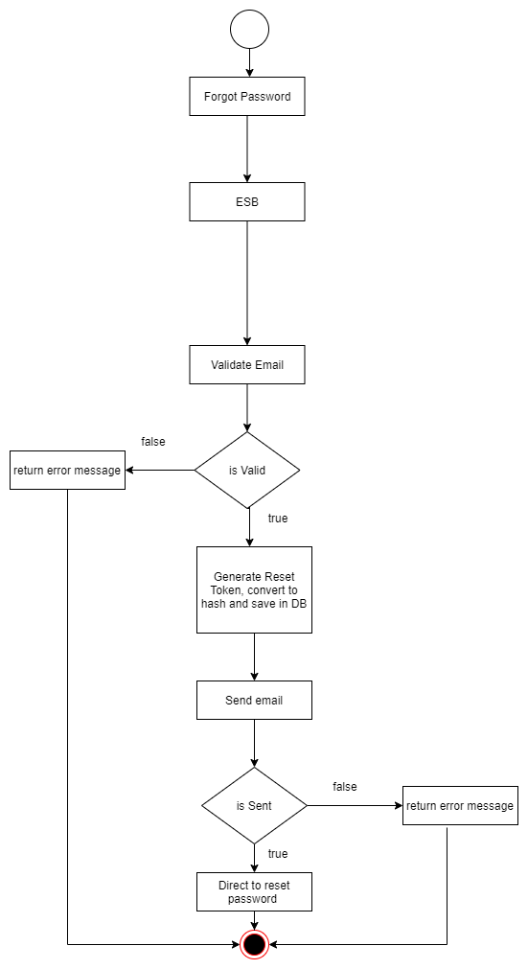

If the user forgot password, a POST request with the email will be sent to the authentication service through the ESB (WSO2 E1). export.forgotPassword in auth.js checks whether that email is existing in the database. If the email exists a reset token is created which is expired in 10mins, and the hashed version of the token will be stored in the database. An email with the http message embedded with the reset url and the reset token will be sent to the provided email address. Nodemailer and sendGrid is used for this purpose. Once the email sending procedure is successfully done, success message will be generated. Otherwise, it will generate error messages.

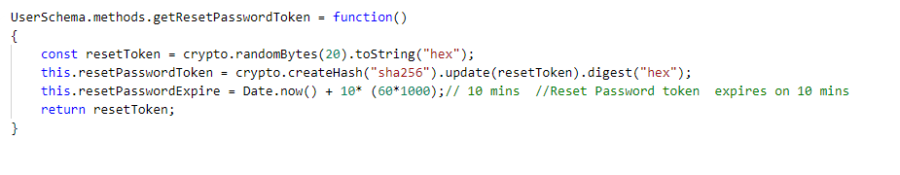Generation Reset Password Token

Creation of Email Service with Nodemailer and SendGrid

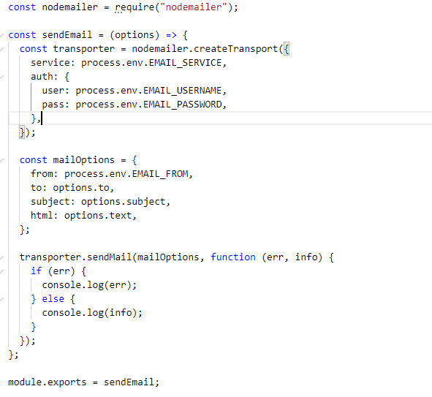

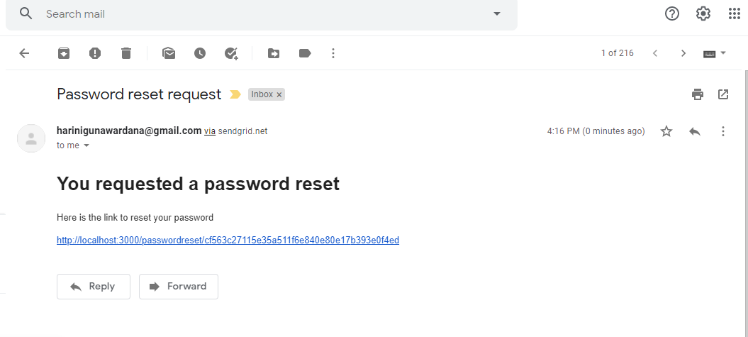

## Process of resetting user password

Workflow diagram

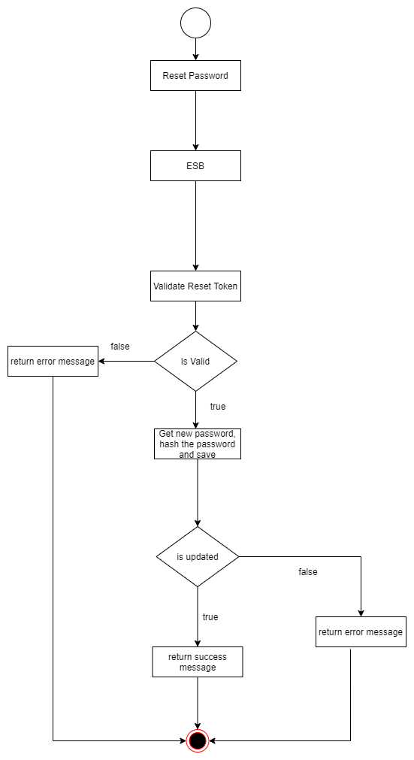

A PUT request with a reset token will be sent to the authentication service through the ESB ( WSO2 E1) when user click on the link in the password reset request email. export.resetPassword compares the token in the URL parameters with the hashed token. If the validation is success, a user interface to reset the password will be appeared. User can reset the password through that UI and after the new password created it will be hashed and the database the JSON document will be updated with the new password. After a successful password reset, the user will be again directed to the login. If some error occurred during the process, an error message will be created.

## Process of validating the token

Workflow diagram

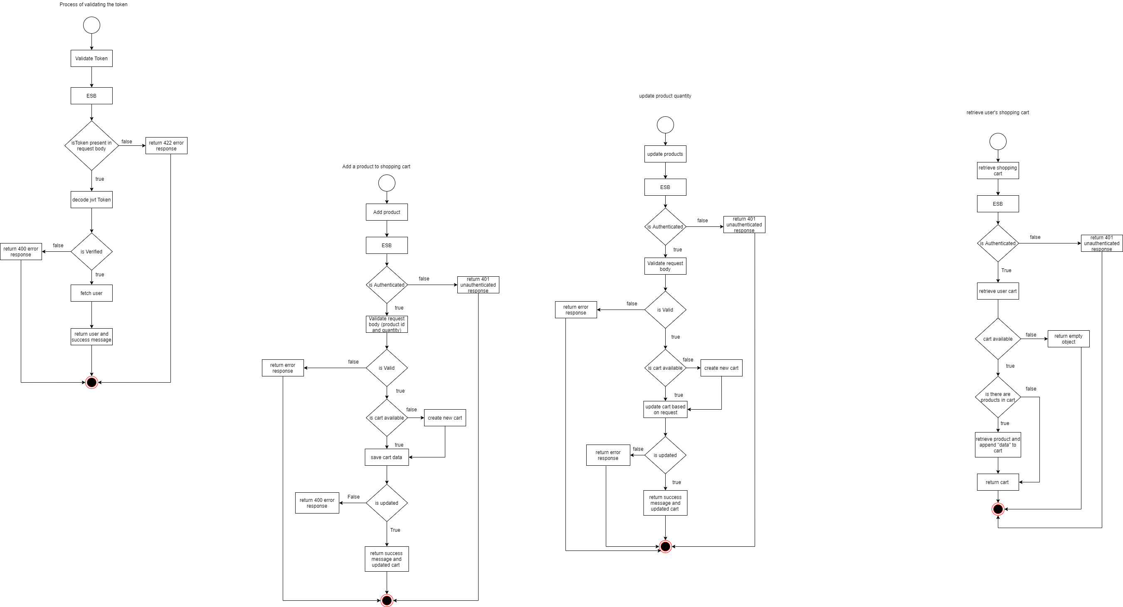

Service interface

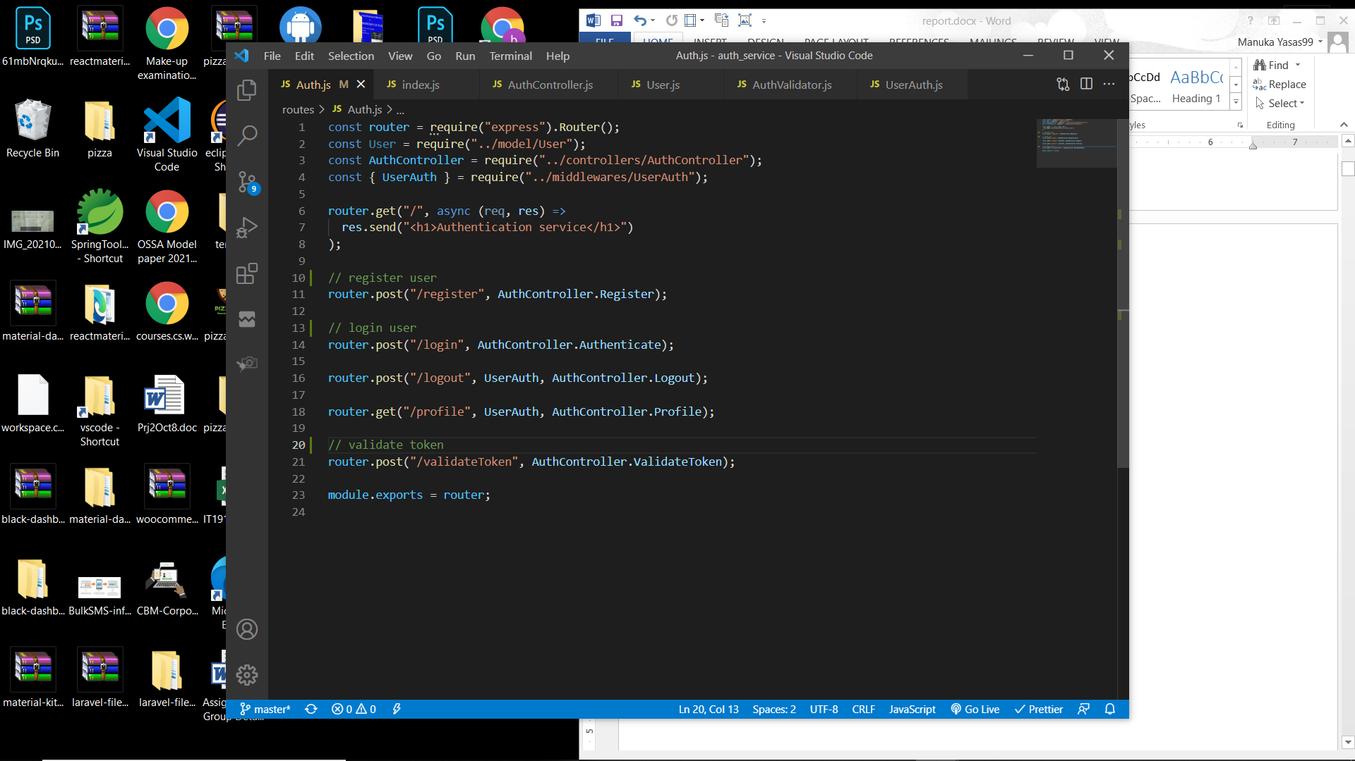

Service function

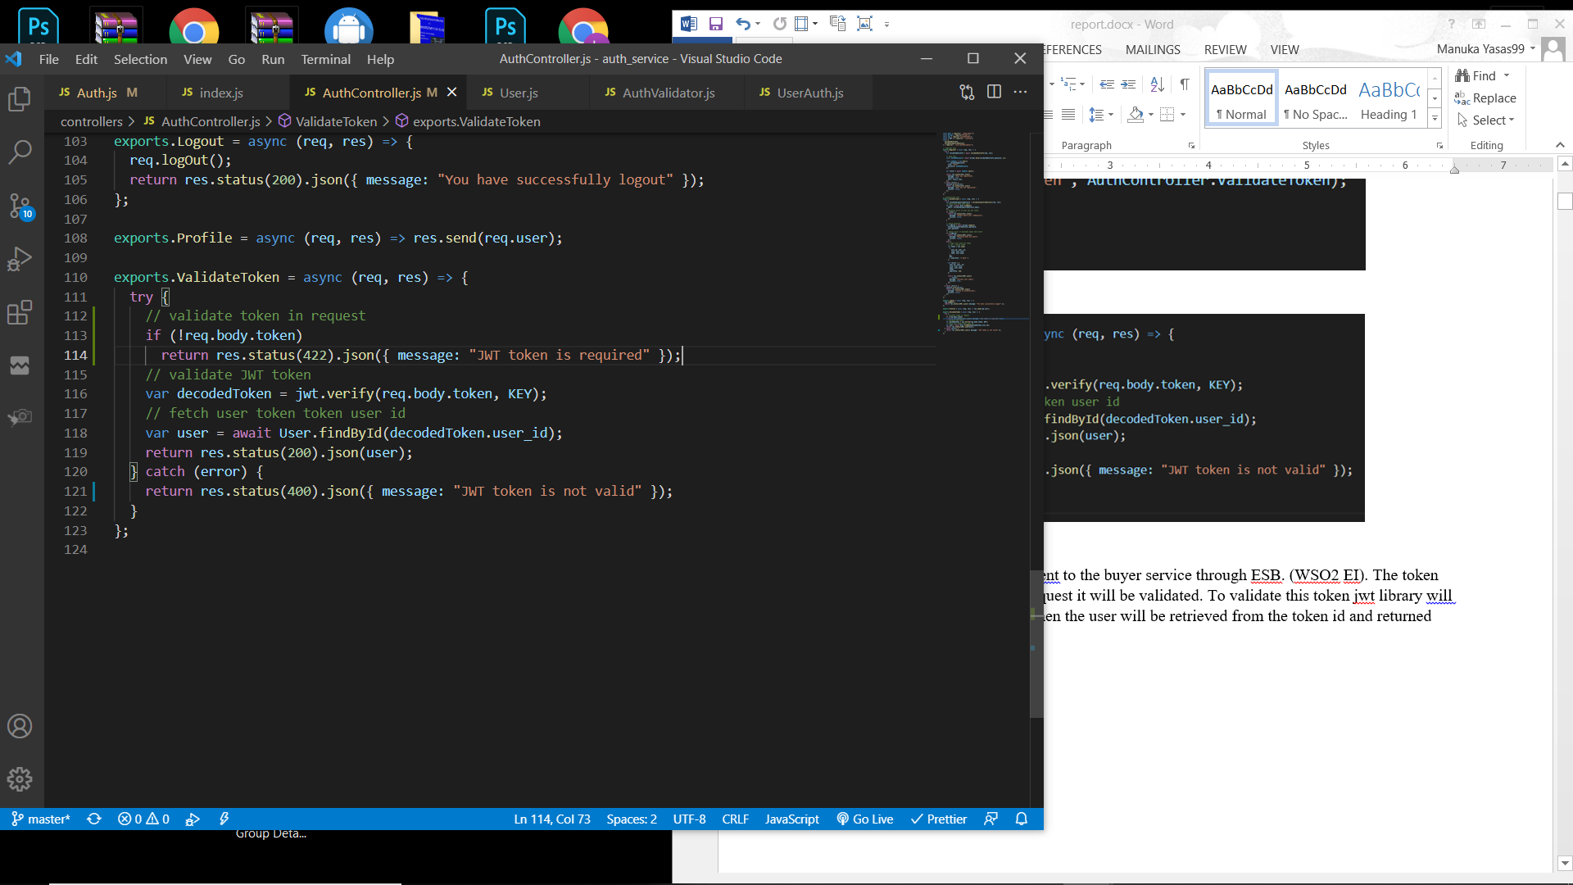

The initial POST request will be sent to the authentication service through ESB. (WSO2 EI). The token will be sent as a property in the request and it will be validated. If the token is not present then an error response with status code 422 will be returned.

To validate this token jwt library will be used. If the token is validated then the user will be retrieved from the token id and returned back. Else, an error response with status code 400 will be returned.

## Process of creating a new product

Workflow diagram

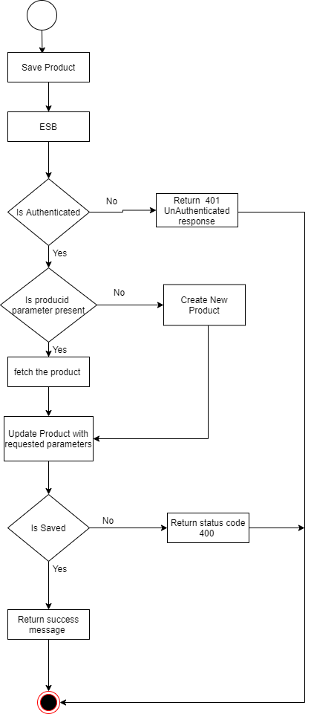

POST request will be sent to the seller service through the ESB. An authenticated user with role seller can save and update the products.

The request body must have name, image, description, price, sku, size, stock, and category. If there is a parameter with product id then product will be fetched. If there is no product id then new product will be initialized and data will be appended to product model we created and data will be saved. If there is product then the fetched product will be updated with the requested data.

If an exception occurred then it will return an error response with 400 status code. If data is saved then a response with 200 status code will be send back with the product data. If any error occurred during saving product (invalid data types or character length), then a error response will be sent with status code 422. Error messages are mentioned in the product model.

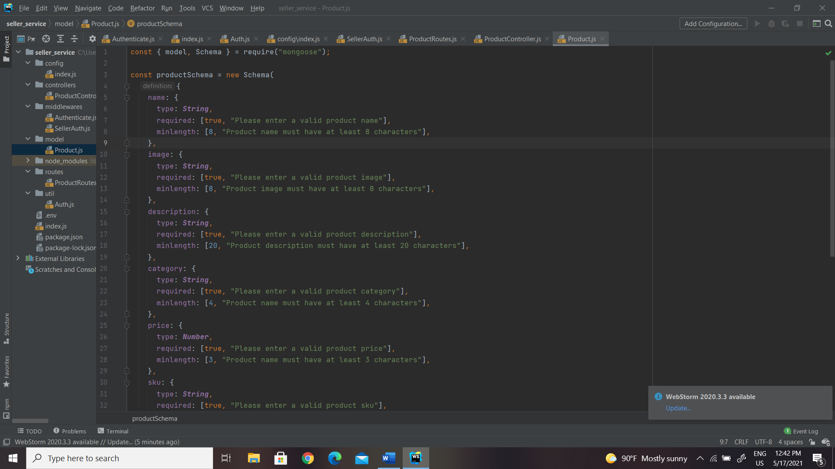

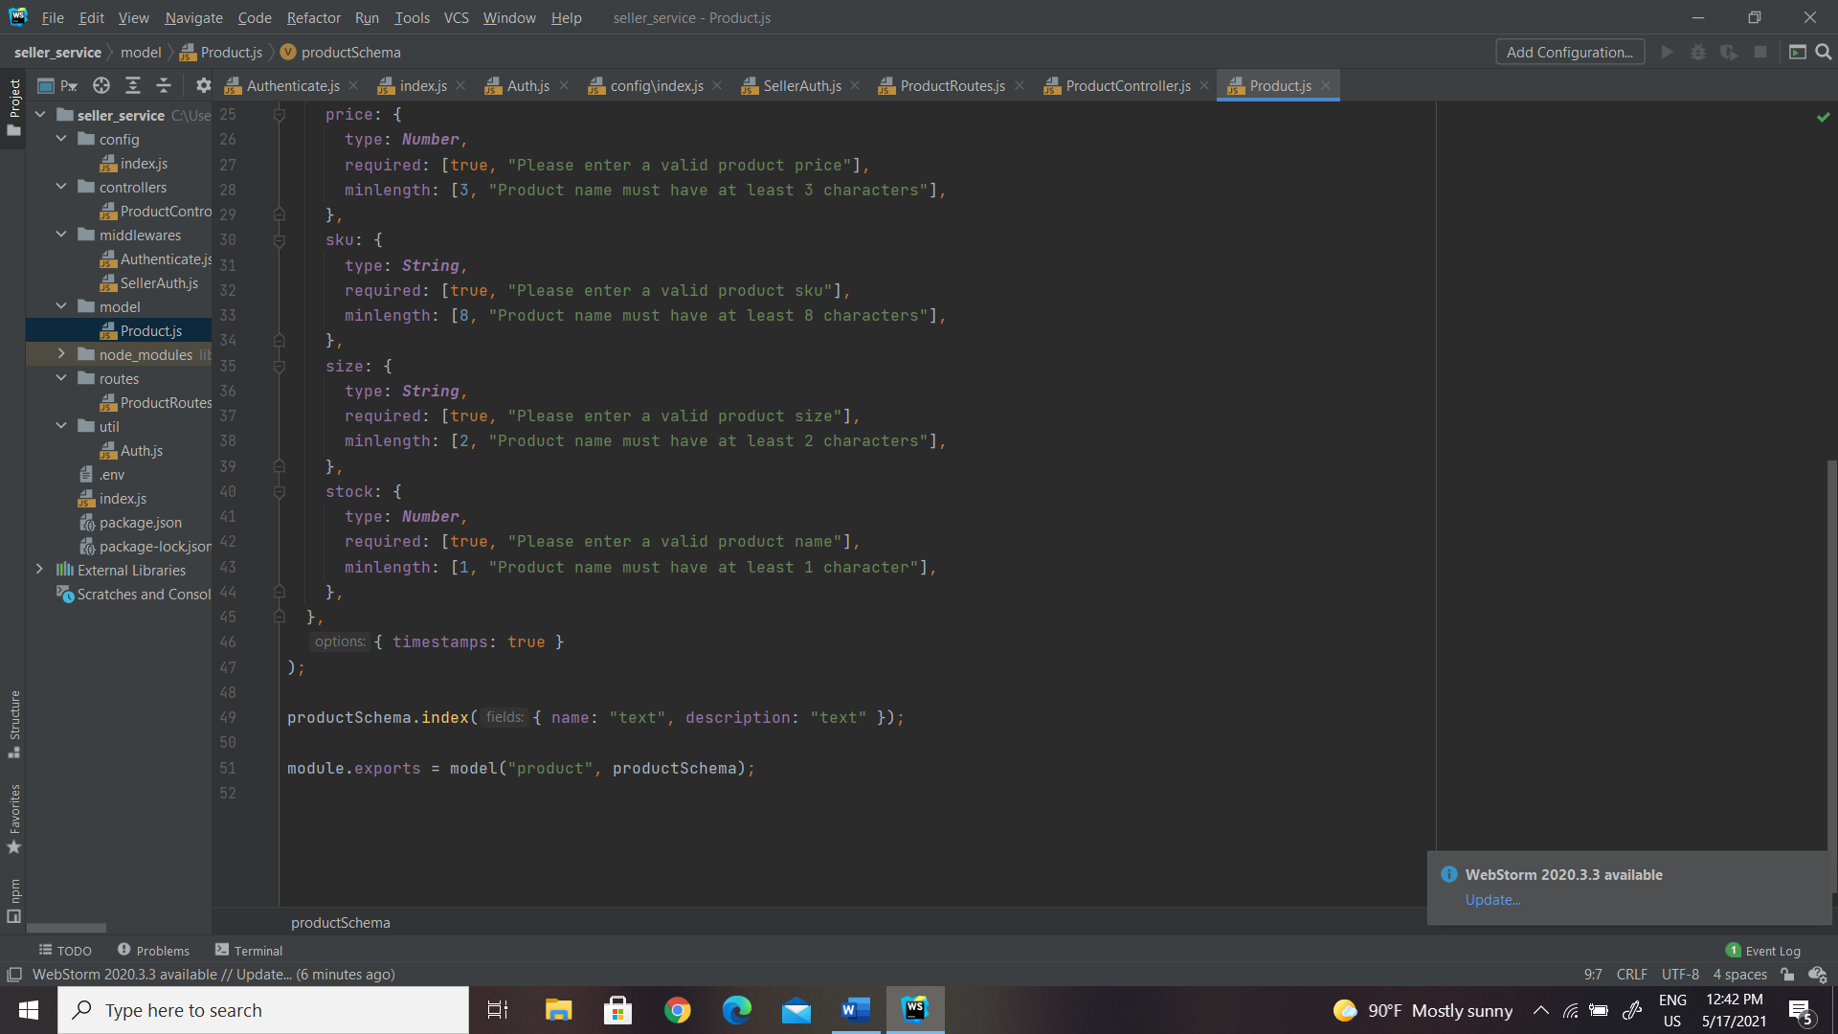

## Process of updating a product

To update product PUT request will be send to the seller service through the ESB. An authenticated user with role seller can update the products. The request must have a parameter productid. and then save product function will be invoke in order to update product. Creating the product and updating the product will be done using the same function to facilitate reusability.

Since the productid is present in request parameter it will be used to fetch the product and request new body data will be appended to this and then updated or else error message will be send back.

## Process of retrieving all products

Workflow diagram

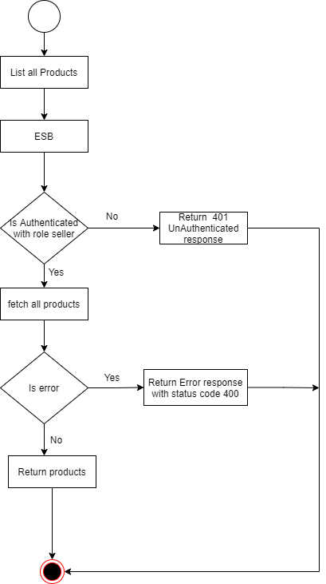

GET request will be sent to list products toward the seller service through the ESB. An authenticated user with role seller can list all the products. The products will be fetched from the product model. If the product is available successful message with 200 status code will be sent back. If there is error it will return error message with 400 status code.

## Process of retrieving a product

Workflow diagram

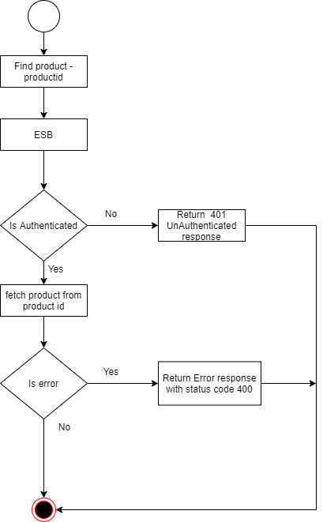

GET request will be sent with product id as a parameter toward the seller service through the ESB. An authenticated user with role seller can view a product. The products will be fetched from the product model using the parameter send in the request. If the product is fetched return successful message with 200 status code. If there is error it will return error message with 400 status code.

## Process of deleting a product

Workflow diagram

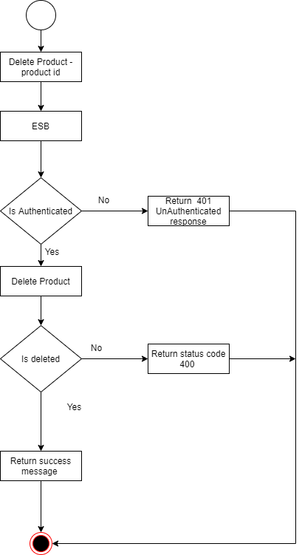

DELETE request will be sent with product id as a request parameter toward the seller service through the ESB. An authenticated user with role seller can delete a product. The products will be deleted from database. If product was deleted successfully message with 200 status code will be send back. Else error response will be sent.

## Process of searching the products

Service interface

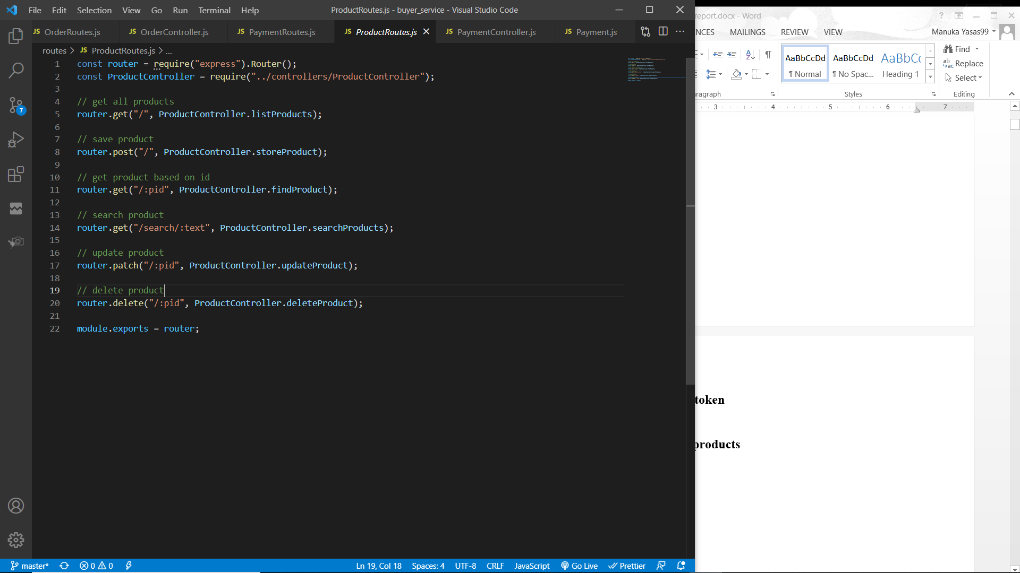

Service function

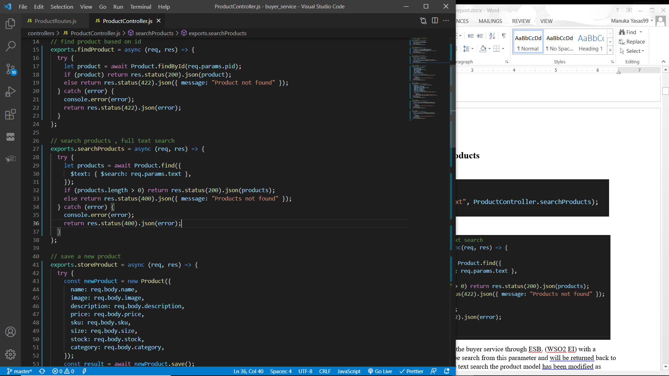

The initial GET request will be sent to the buyer service through ESB. (WSO2 EI) with a parameter (search text). Products will be search from this parameter and will be returned back to the client through ESB. To perform the text search the product model has been modified as below.

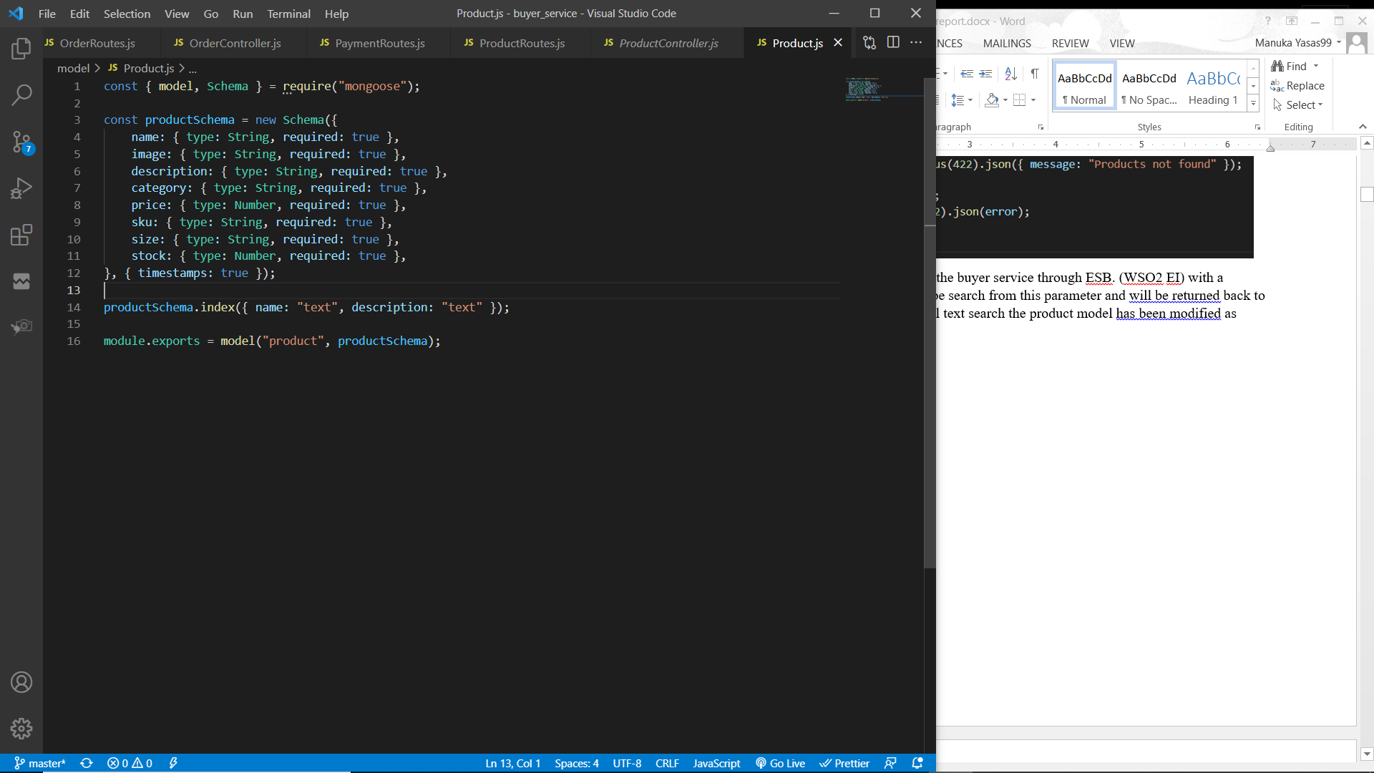

When searching products, it will match the text with product names and descriptions. If no products were found an error response with status code 400 will be sent back.

## Shopping cart management

Service functions / interfaces to manage the shopping cart.

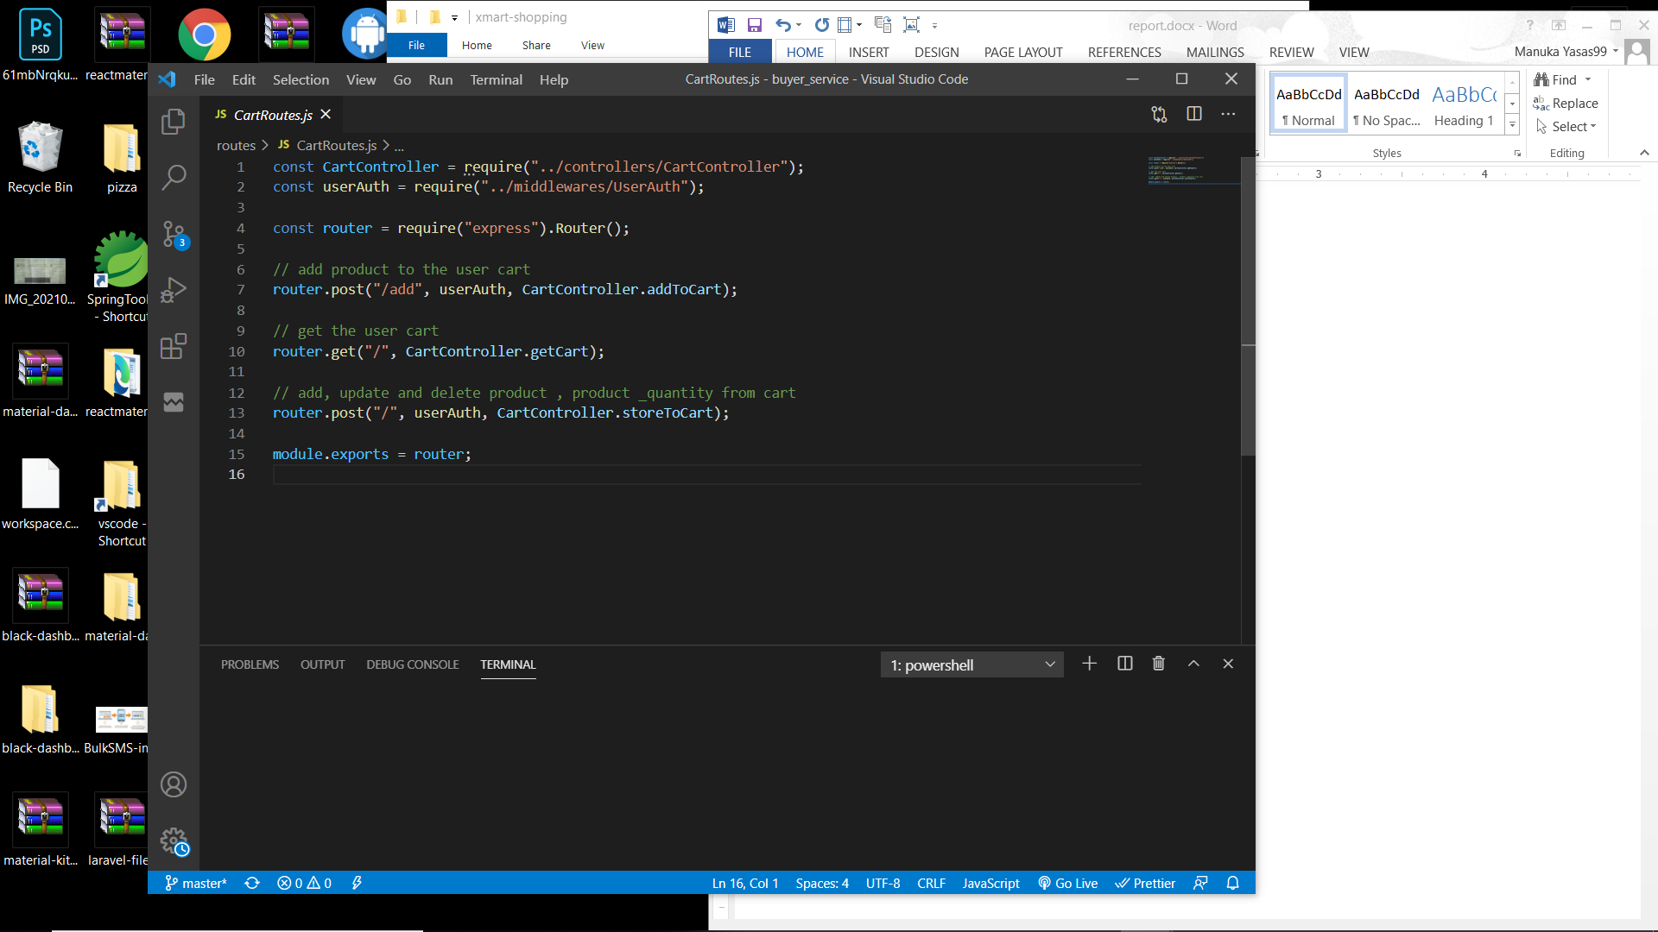

There are three routes in cart management in the buyer service.

1. A POST request with product and its quantity to add a product to shopping cart.
2. A GET request to retrieve user’s cart details with products.
3. A POST request to save / update product quantities in the shopping cart.

All these routes are mapped using the WSO2 Enterprise Integrator.

### Add a product to shopping cart

Workflow diagram



Service function to add a product to cart

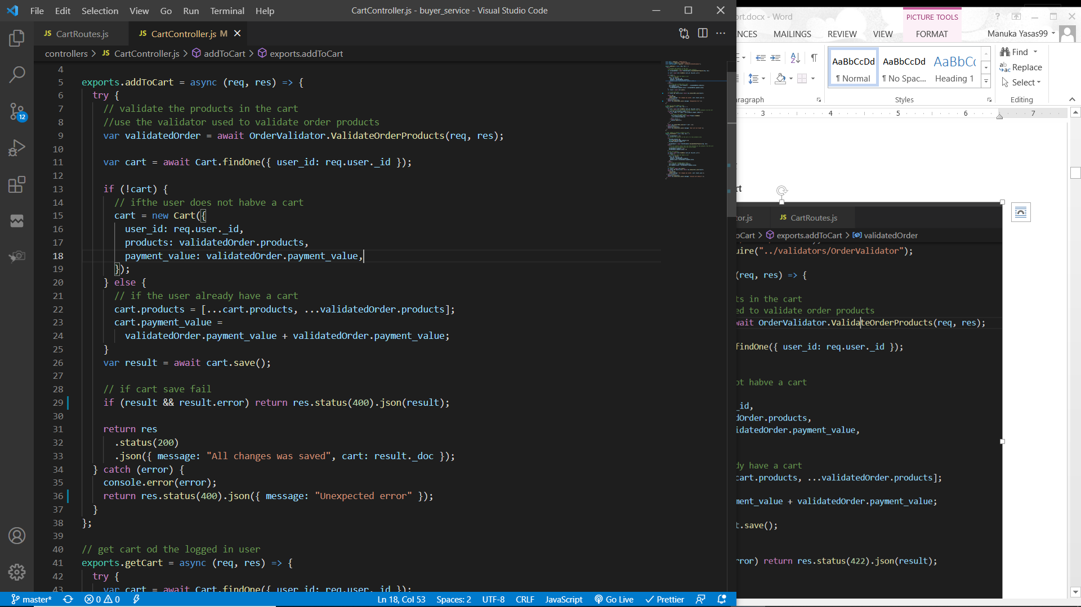

Validator function to validate request body such as valid products, products have stock (validateOrderProducts)

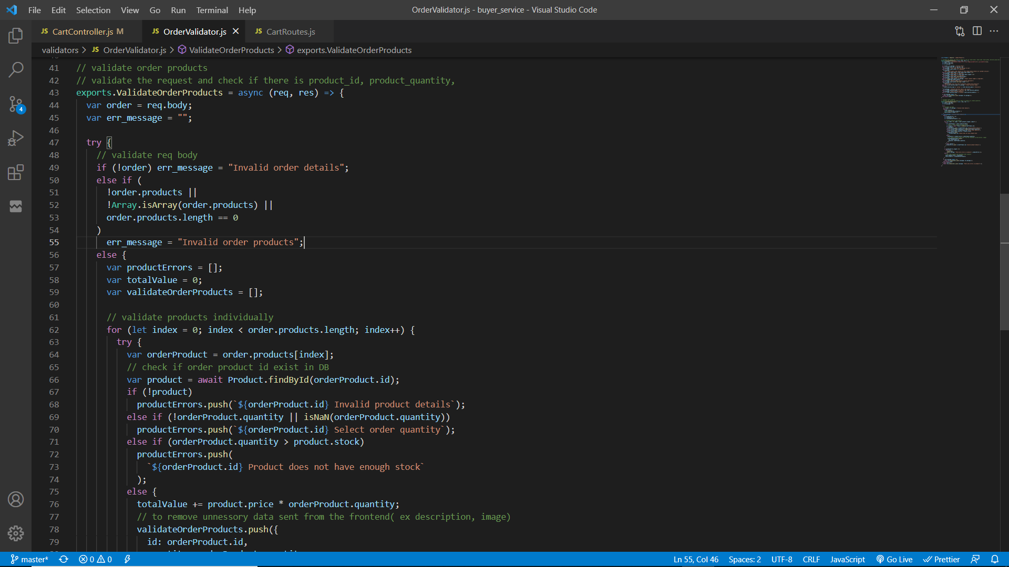

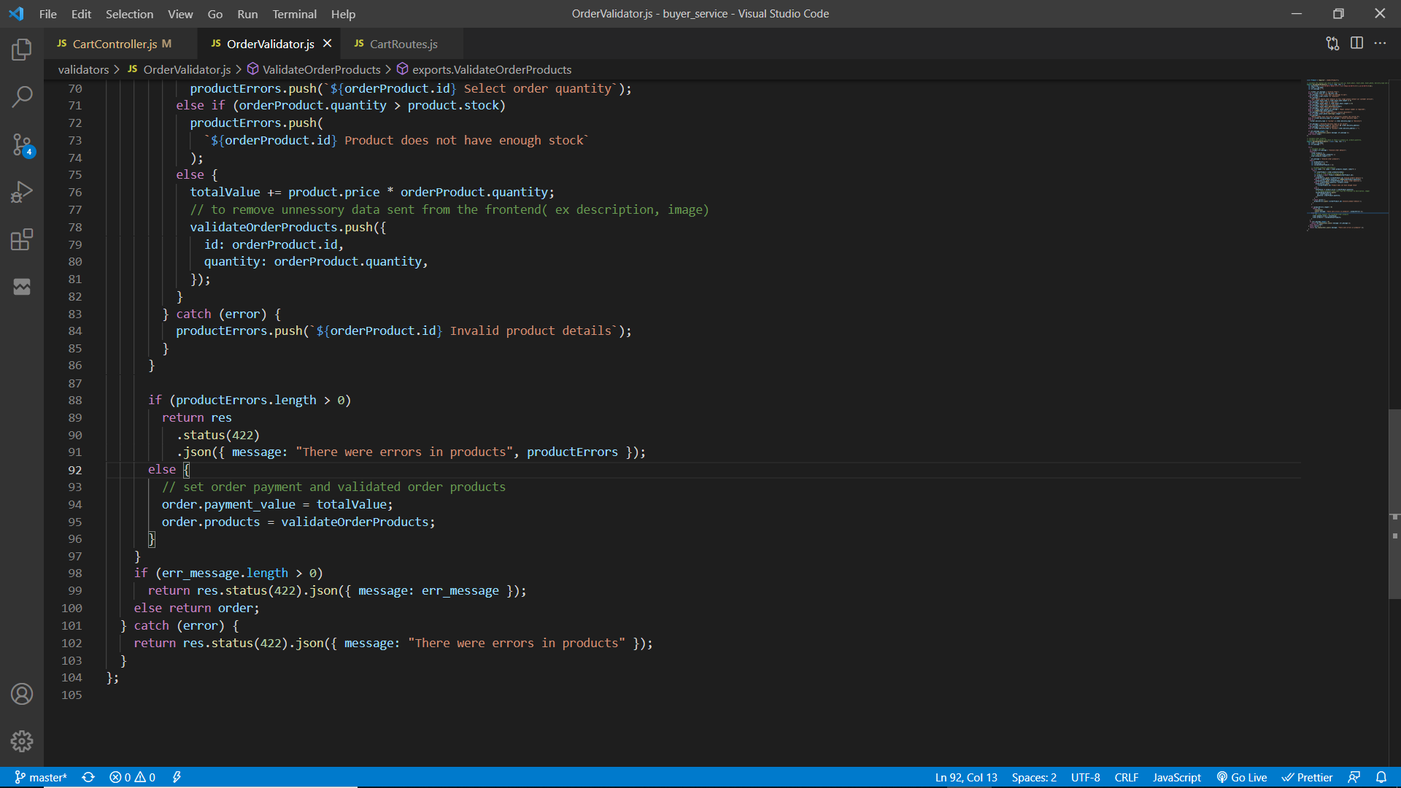

POST request will be sent to the buyer service through ESB. (WSO2 EI).

To add a product to cart, user must be authenticated for this “userAuth” middleware is used to filter the request and allow only authenticated users. Request body must have product id and its quantity. Then the request is validated to check if it contains product data that exist in database also the product quantity requested is less than or equal with its stock else relevant error messages are sent back to the client through ESB. If the request body is validated, it will return the total cart value(value of products * quantity) with the products.

Then user cart will be retrieved from the database using the user’s id. If the cart does not exist, create a new cart by providing user’s ID, products and the total cart value. Else, update the existing cart by adding the new product to cart products and the total cart value.

The cart will be saved/updated and if it fails then an error message will be sent else, the updated user cart object will be sent to the client through ESB.

### Update products quantity in shopping cart

Workflow diagram



Service function

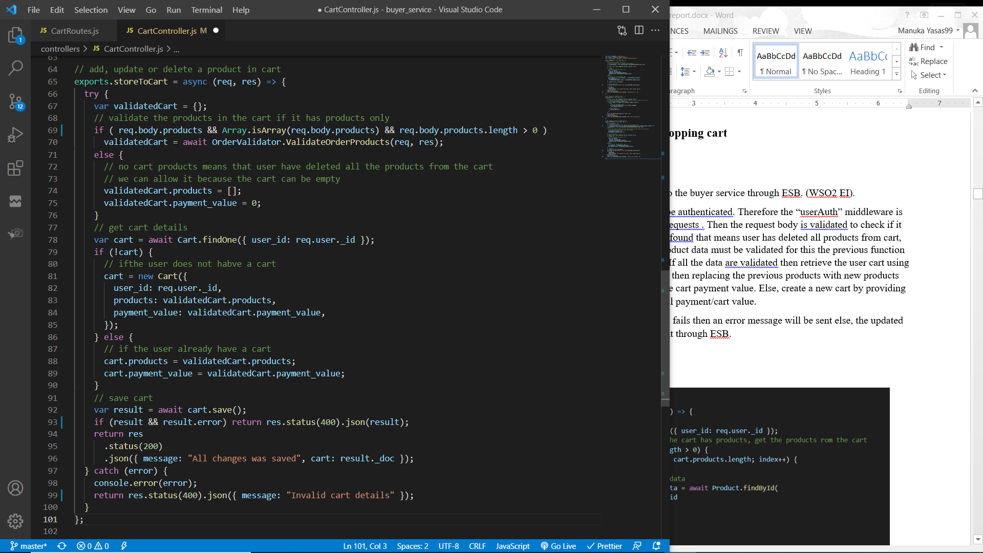

A POST request will be sent to the buyer service through ESB. (WSO2 EI).

To update product quantity user must be authenticated. Therefore the “userAuth” middleware is used to filter the authenticated users / requests . Then the request body is validated to check if it contains products. If no products were found that means user has deleted all products from cart, but if products are found then these product data must be validated for this the previous function “validateOrderProducts” will be used. If all the data are validated then retrieve the user cart using the user’s ID and then if there is a cart, then replace previous products with new products along with their quantity and update the cart payment value. Else, create a new cart by providing user’s id, products data and the total payment/cart value.

The cart will be saved/updated and if it fails then an error message will be sent else, the updated user cart object will be sent to the client through ESB.

### Retrieve user’s shopping cart

Workflow diagram



Service function

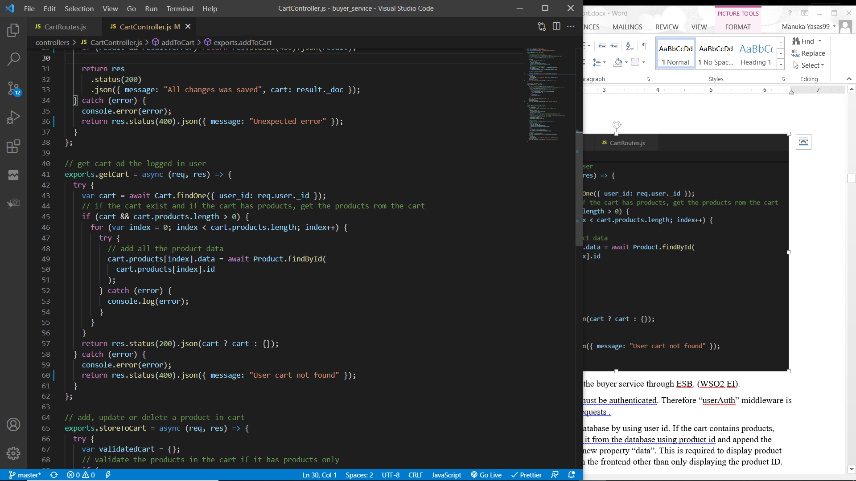

A GET request will be sent to the buyer service through ESB. (WSO2 EI).

To retrieve user’s shopping cart, user must be authenticated. Therefore “userAuth” middleware is used to filter the authenticated users/ requests .

User’s cart will be retrieved from the database by using user id. If the cart contains products, loop through each product and retrieve it from the database using product id and append the product data to the cart product with a new property “data”. This is required to display product image, category, price and other data in the frontend other than only displaying the product ID.

Return the new cart with all product data and if there is no cart found then return an empty object via ESB to the client.

## Order management

Service functions / interfaces to manage orders.

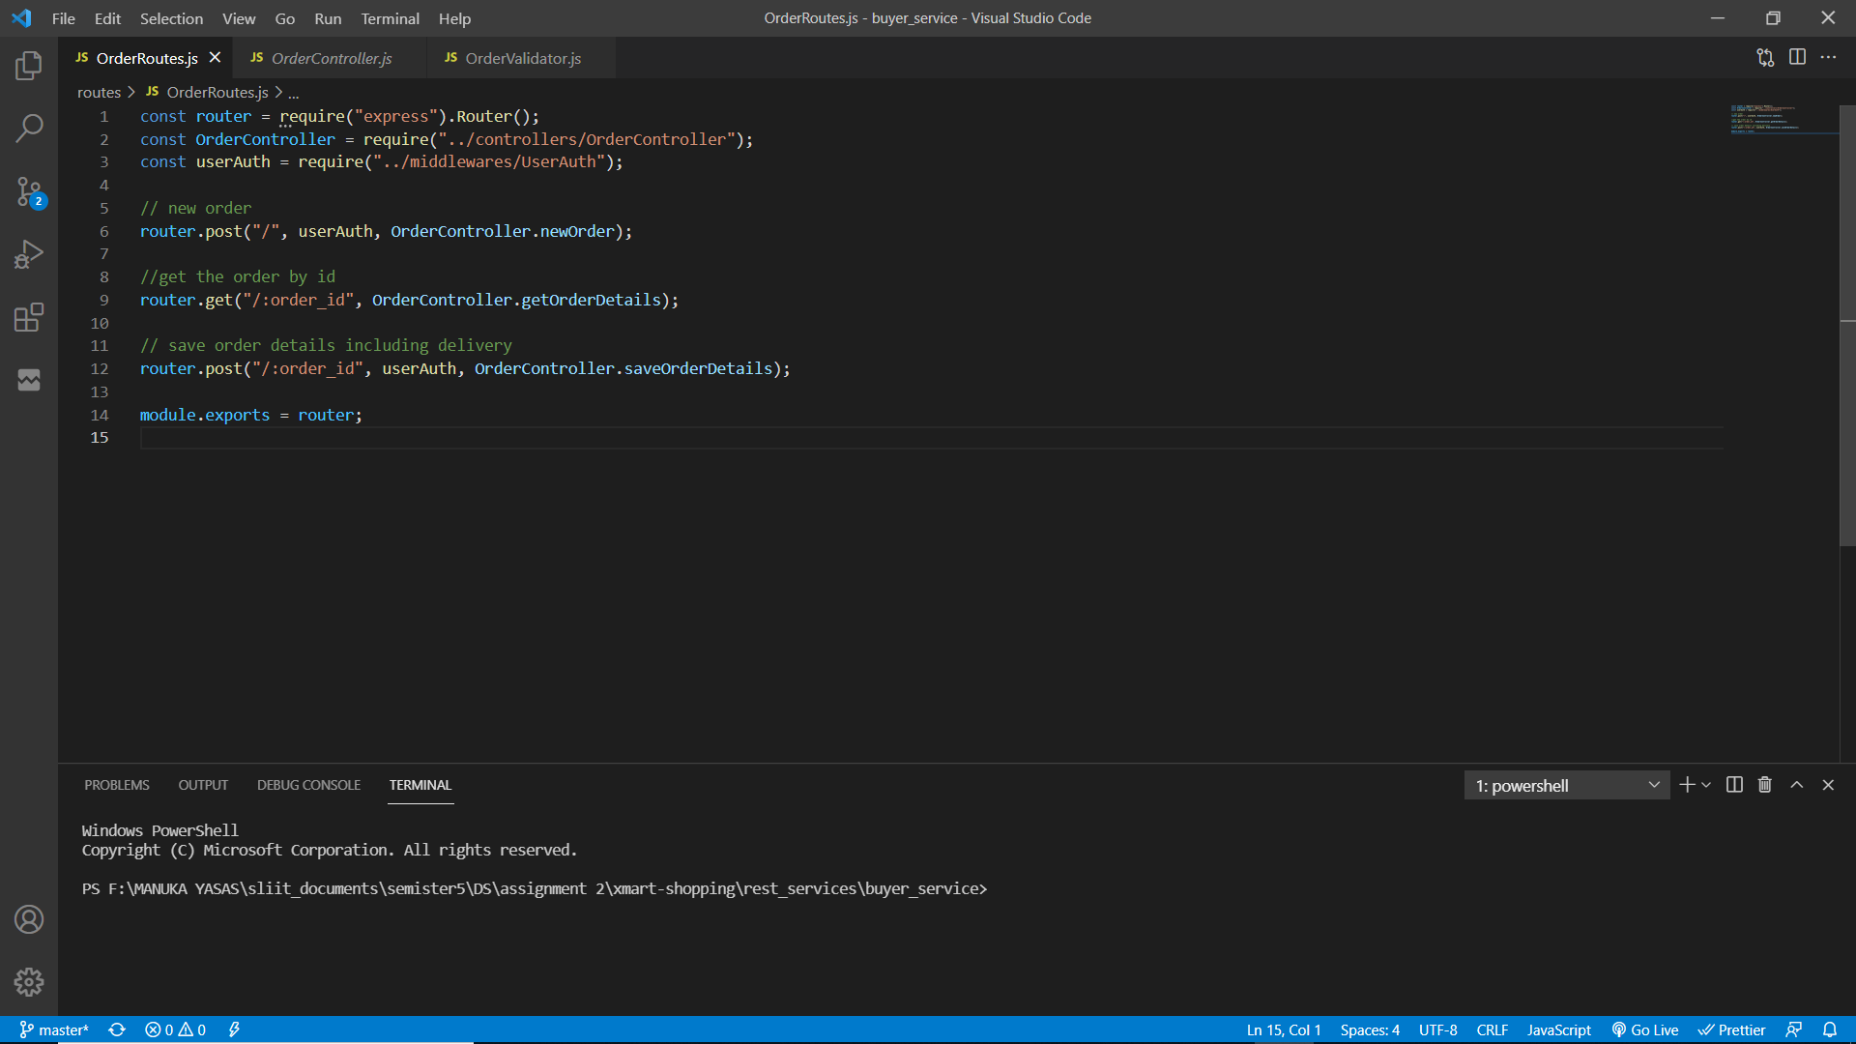

There are three routes to manage orders.

1. A POST request to create a new order with products and its quantities.
2. A GET request to retrieve an order by the order ID sent as a parameter in the request.
3. A POST request to save / update the order buyer details and delivery information.

All these routes are mapped using the WSO2 Enterprise Integrator.

To place an order there are few steps. Initially products with their quantity will be sent to the buyer service and then it will save it and return an object with the payment value and a unique order id. User will navigate to save buyer information and delivery information through the order id. After saving the above details user will navigate for the payments. Payments can be made through cash on delivery, credit / debit card (dummy service) or though mobile service provider (dummy service). After a successful payment user will get and email (through Gmail) and a SMS (though Twillio).

### Process of creating a new order

Workflow diagram

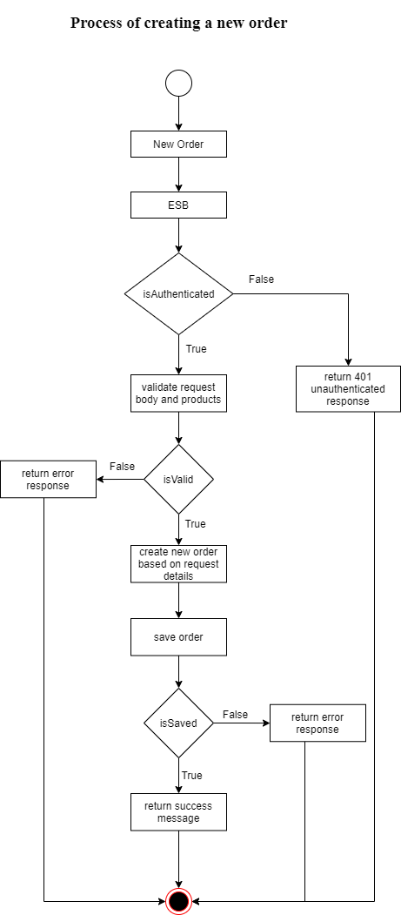

Service function

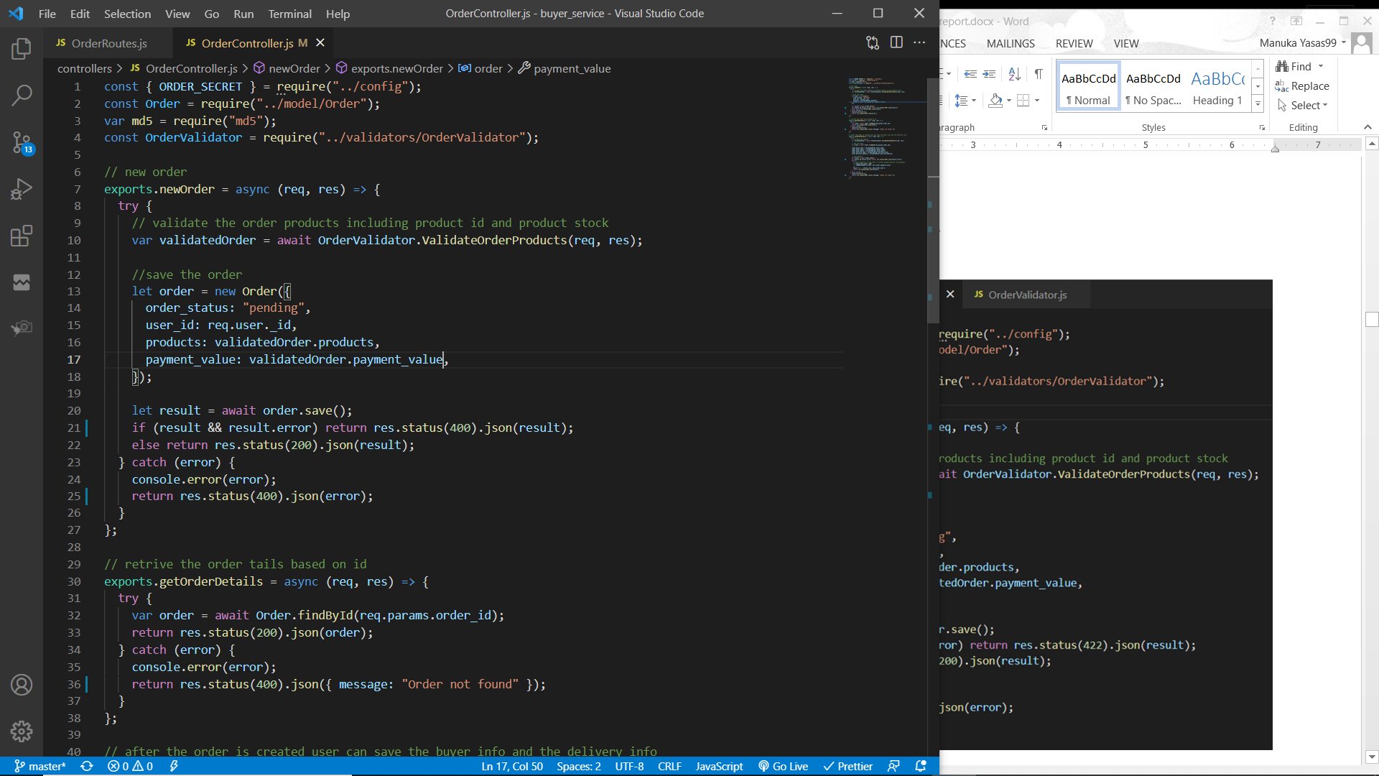

Validator function to validate request body such as valid products, products have stock (validateOrderProducts)





A POST request will be sent to the buyer service through ESB. (WSO2 EI). To create a new order, user must be authenticated. Therefore the “userAuth” middleware is used to filter the authenticated users/ requests. Request body must have an array of objects where each object must have the product id and its quantity. This request is validated using the above “validateOrderProducts” function. This function will iterate the array of objects and check if each object has a product id and then it checks if there is an existing product in the database with the product id in the object. Additionally, it validates that the product has enough stock to supply. If any of the validations fail, respective error messages will be sent back to the client through ESB. Else, an object with the validated products array and total payment value (product price * quantity) will be returned.

A new order will be created by setting the user’s id, products and payment value fields. The order status will be set to “pending”. This order object is saved and if it fails to save an error message is sent back to the client through ESB. Else, the saved object will be returned back to the client through ESB which will be required to save the delivery details and payment.

### Process of Saving / Updating buyer details and delivery in order

Workflow diagram

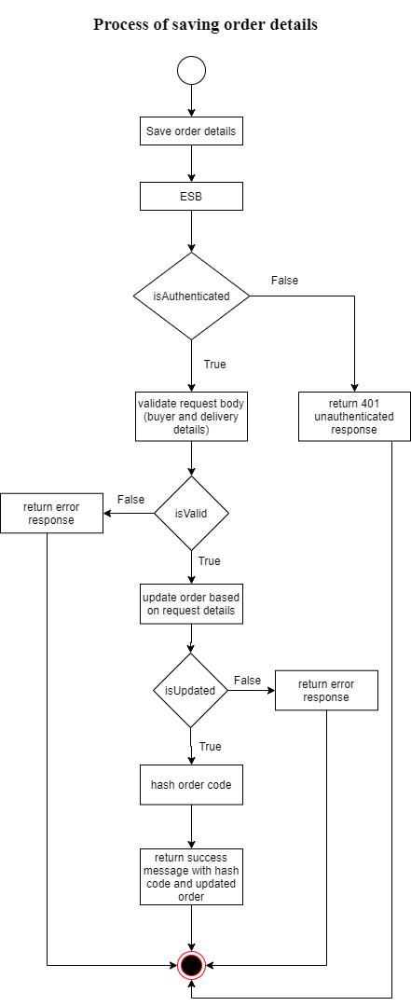

Service function

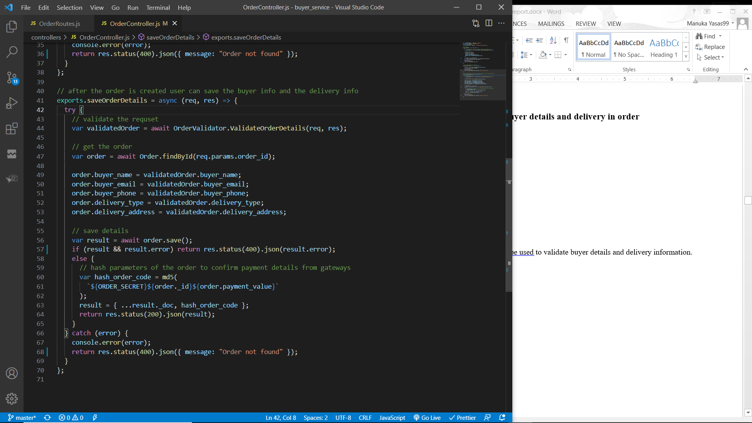

Function “ValidateOrderDetails” will be used to validate buyer details and delivery information.

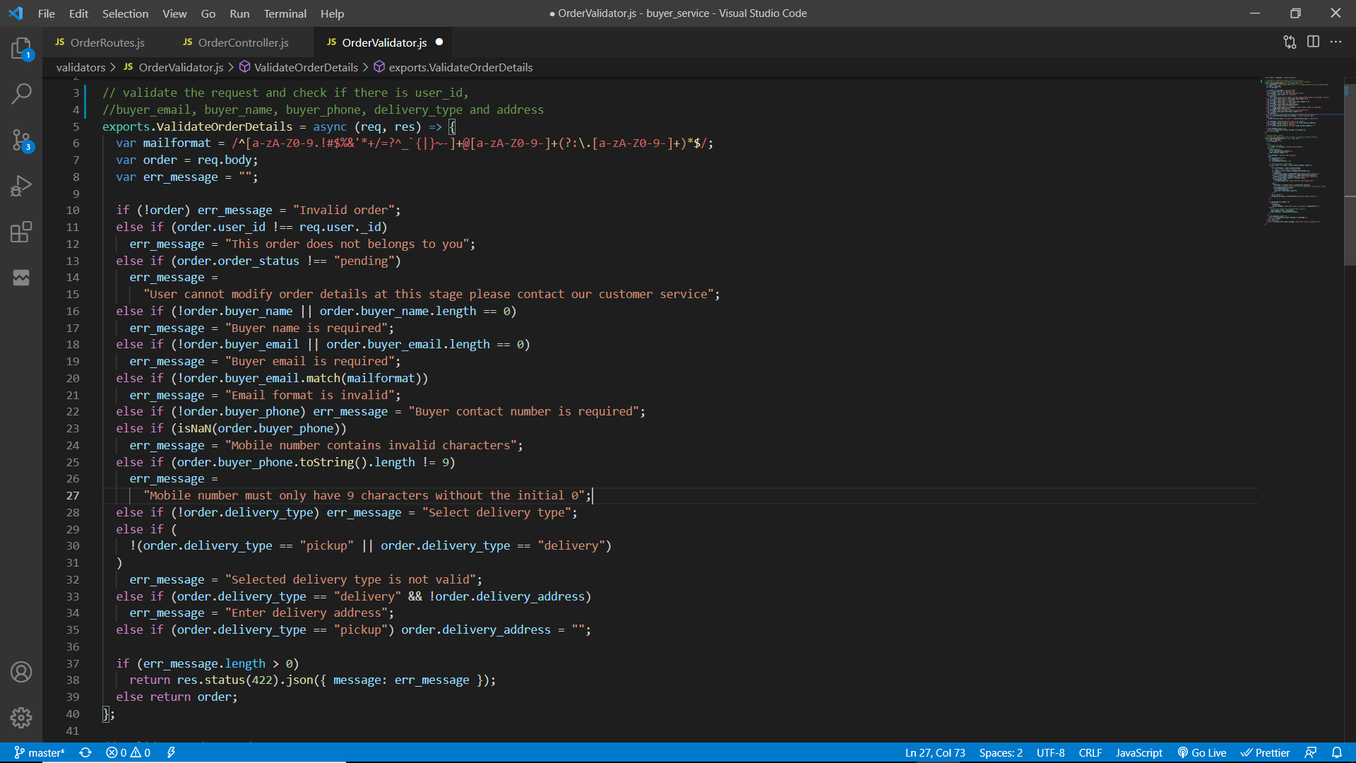

The initial POST request will be sent to the main application server through ESB. (WSO2 EI). To save / update the order, user must be authenticated. Therefore the “userAuth” middleware is used to filter the authenticated users/ requests. Request body must have the order id, buyer information such as buyer name, contact number and email; also, it must contain the delivery type mentioned. If the order needs to be delivered then delivery address field must not be empty. Delivery type can only be one of pick up or delivery. Mobile number must be a valid nine digit (Integer) number and the user email must be a valid email. All the above are validated using the function “ValidateOrderDetails” and if errors are found then respective error messages will be sent back to the client through ESB. Else, the validate request body will be returned.

Order object will be retrieved using the order id. If any error is occurred, an error message will be sent back to the client with status code 422 through the ESB.

The order object will be updated using the validated order information and saved to the database.

If it fails to update an error message will be sent back to the client.

After successfully saving the order, user can make the payment. To make the payment user can make it through credit debit card, mobile service provider or through cash on delivery. If the user select credit card payment or mobile payment, user will navigate to the respective payment gateway to make the payment. Payment gateways will accept the order id, transfer amount along with the credentials it require.

To provide extra security when validating the order id and transfer by the payment gateways, an md5 encrypted string with the order secret (environment variable), order id and transfer amount will be sent. This hashed payment code is generated and the updated order object is sent to the client through ESB.

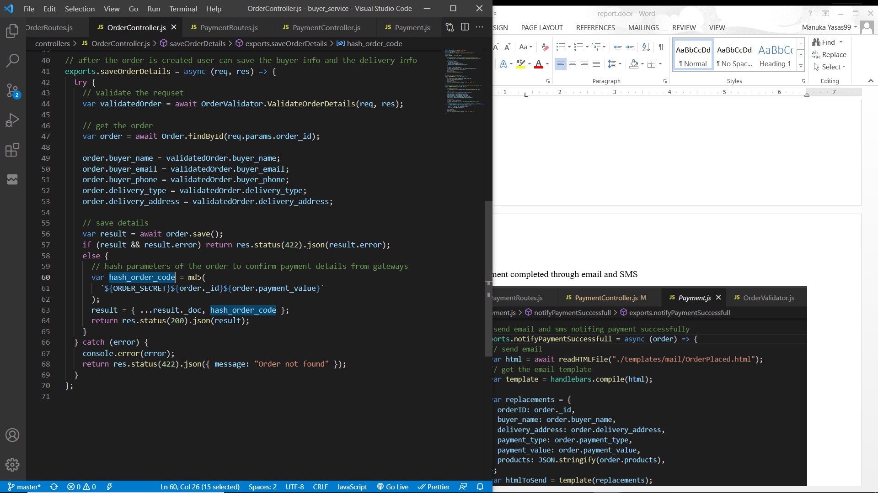

### Process of retrieving order details

Workflow diagram

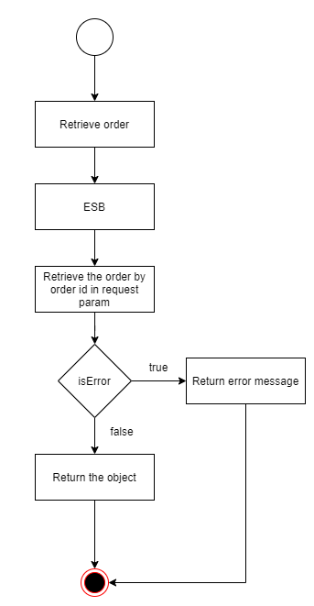

Service function

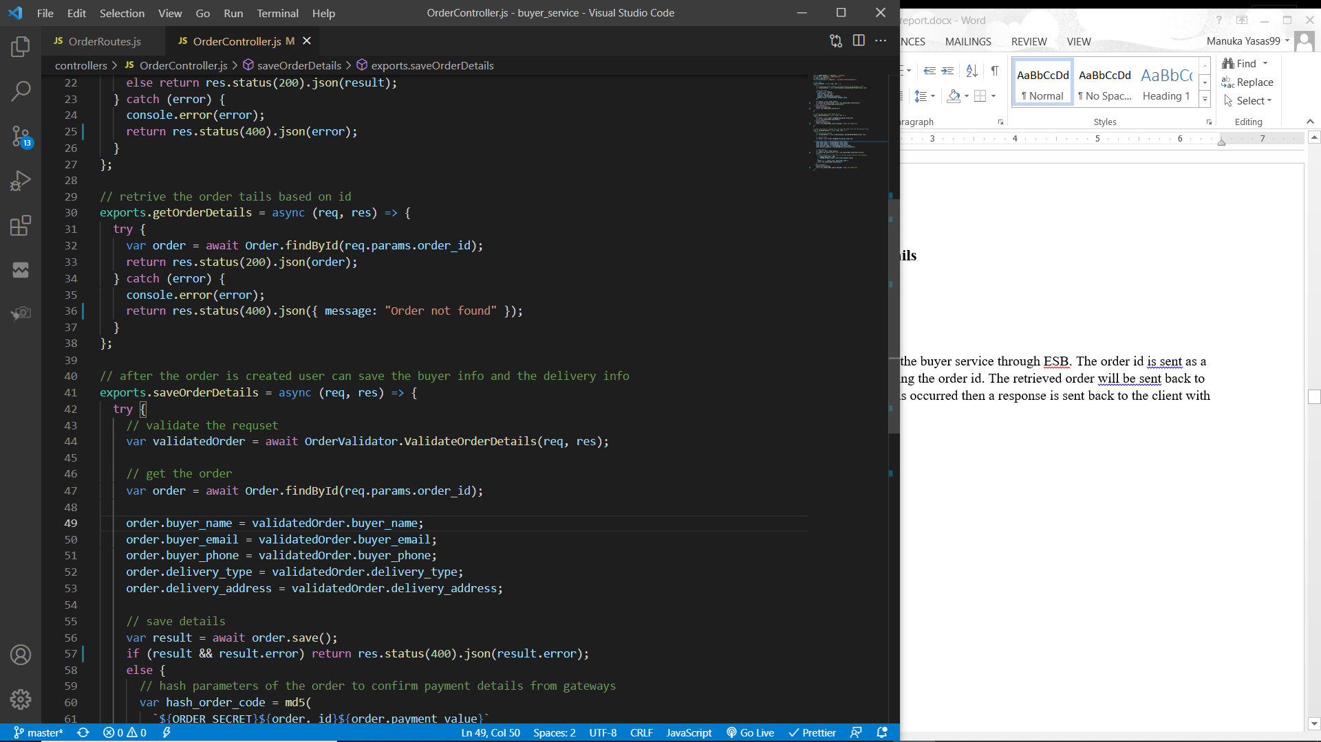

A GET request will be sent to the buyer service through ESB. The order id is sent as a parameter and the order is retrieved using the order id. The retrieved order will be sent back to the client through the ESB. If an error is occurred then a response is sent back to the client with 422 status code.

## Processing payments

To process payments request must have a parameter with the payment type. Based on this parameter user will be route to the required service. There are three payment types, cash on delivery, credit card payment and mobile payment.

If the payment type parameter is “COD”, the ESB will route the request to the buyer service to process the cash on delivery payment.

If the payment type parameter is “bank”, the ESB will route the request to the credit card payment gateway service to process the payment.

If the payment type parameter is “mobile”, the ESB will route the request to the mobile payment gateway service to process the payment.

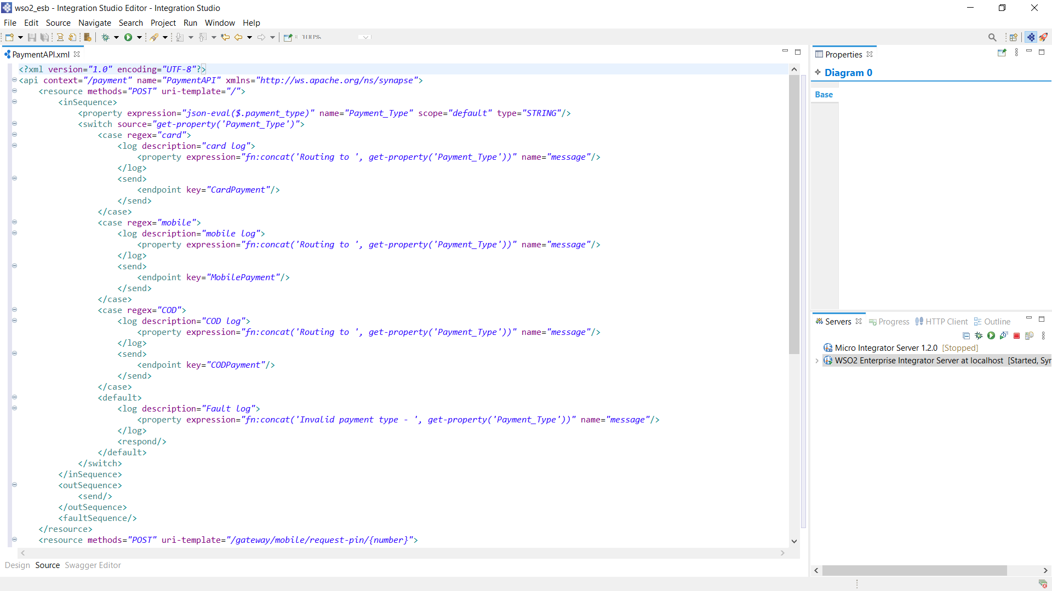

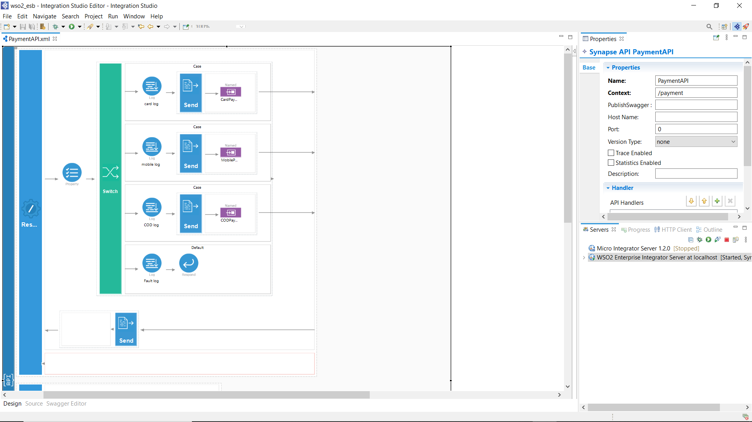

### Process of payment through credit card

Workflow diagram

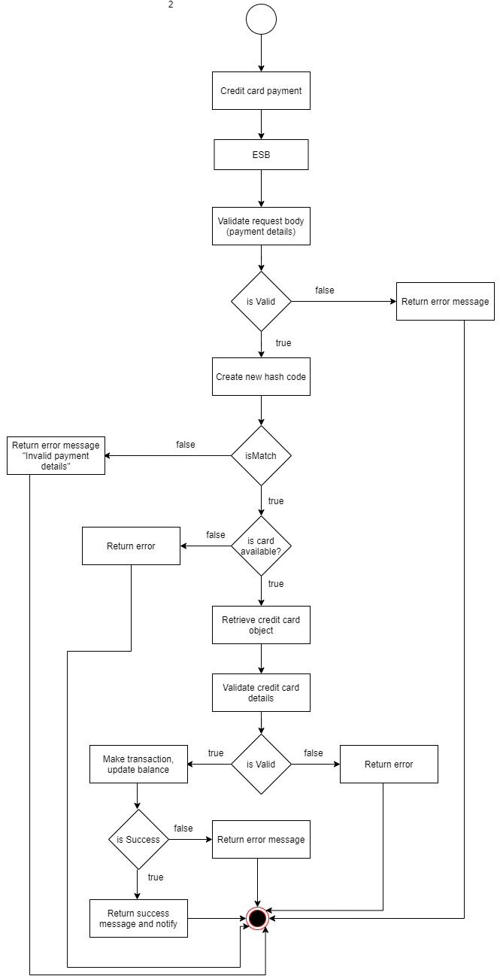

Service interface

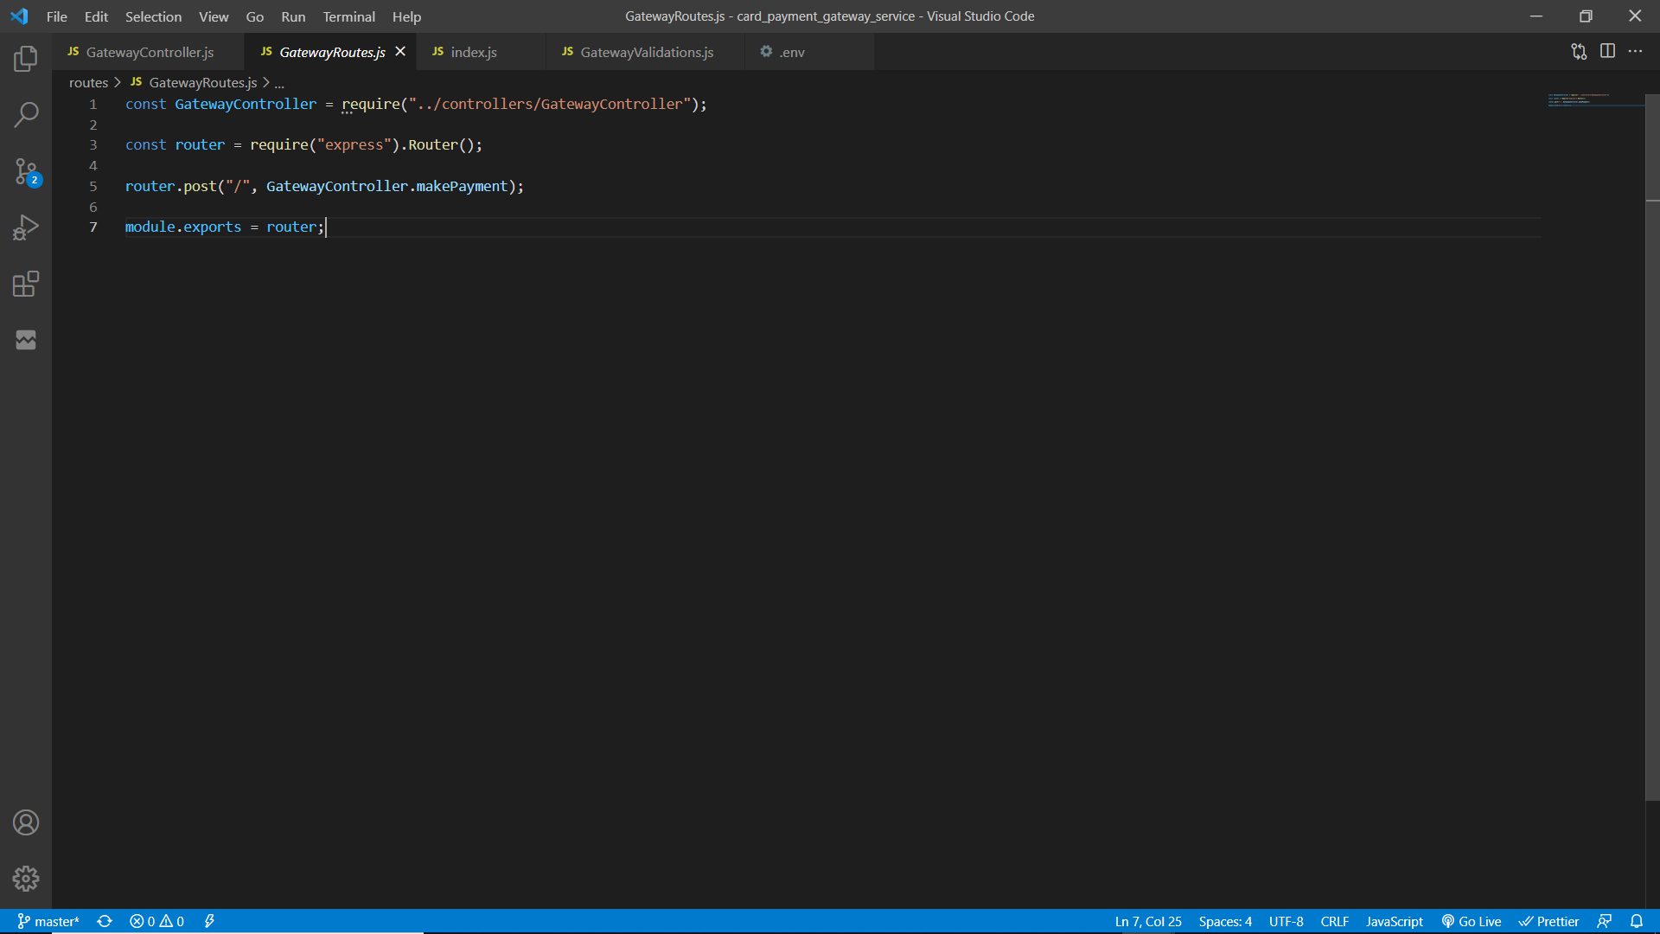

Service function

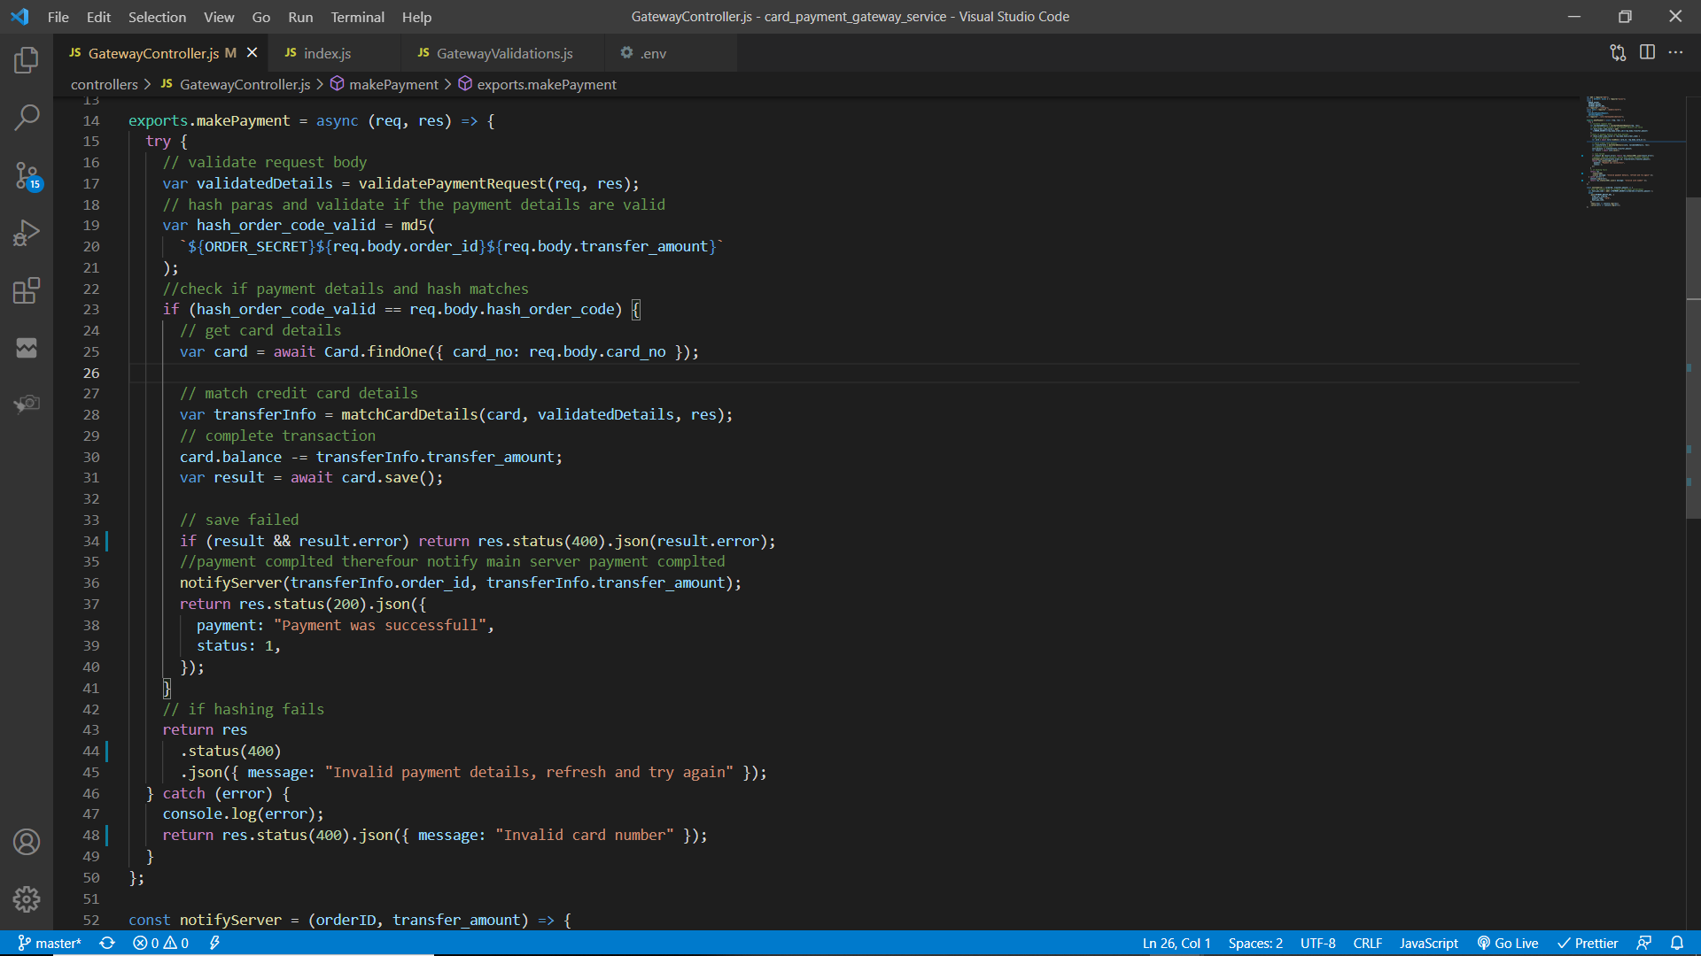

A POST request will be sent to the credit card payment gateway service through ESB if the request has a parameter “payment_type” with its value “card”. The request body will be validated by the “validatePaymentRequest” method to check if it has order id, order hash code, transfer amount, credit card number, CVC number and a card holder name.

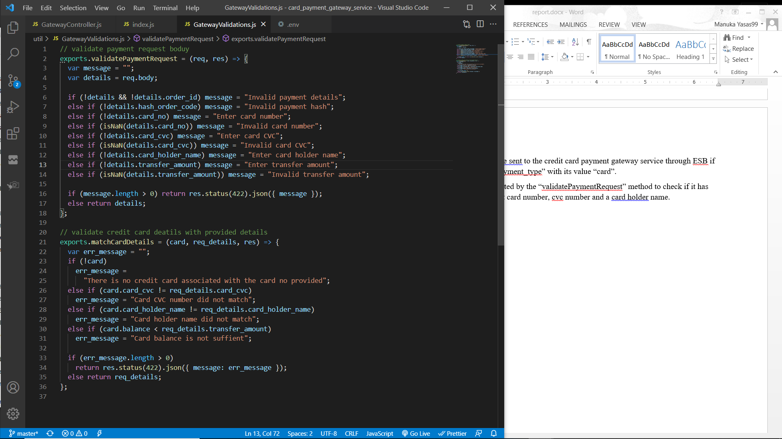

If the validation fail an error response with the respective message will be sent back to the client via ESB. Else, the order hash will be validated. To validate the hash sent from the request, a new hash will be created by using the order secret string constant along with the order id and transfer amount.

If the newly created hash string does not match with the hash code sent by the request that means the payment details does not match with the order details therefore an error response will be sent back to the client.

If hash matches credit card object will be retrieved from the database based on the credit card number. If there is no credit card object then an error response will be sent back. Else then the credit card details will be validated.

To validate credit card details “matchCardDetails” function will be used. Credit card number, CVC number and the card holder name must be matched with the request data and also the remaining balance of the account must be greater than the transfer amount.

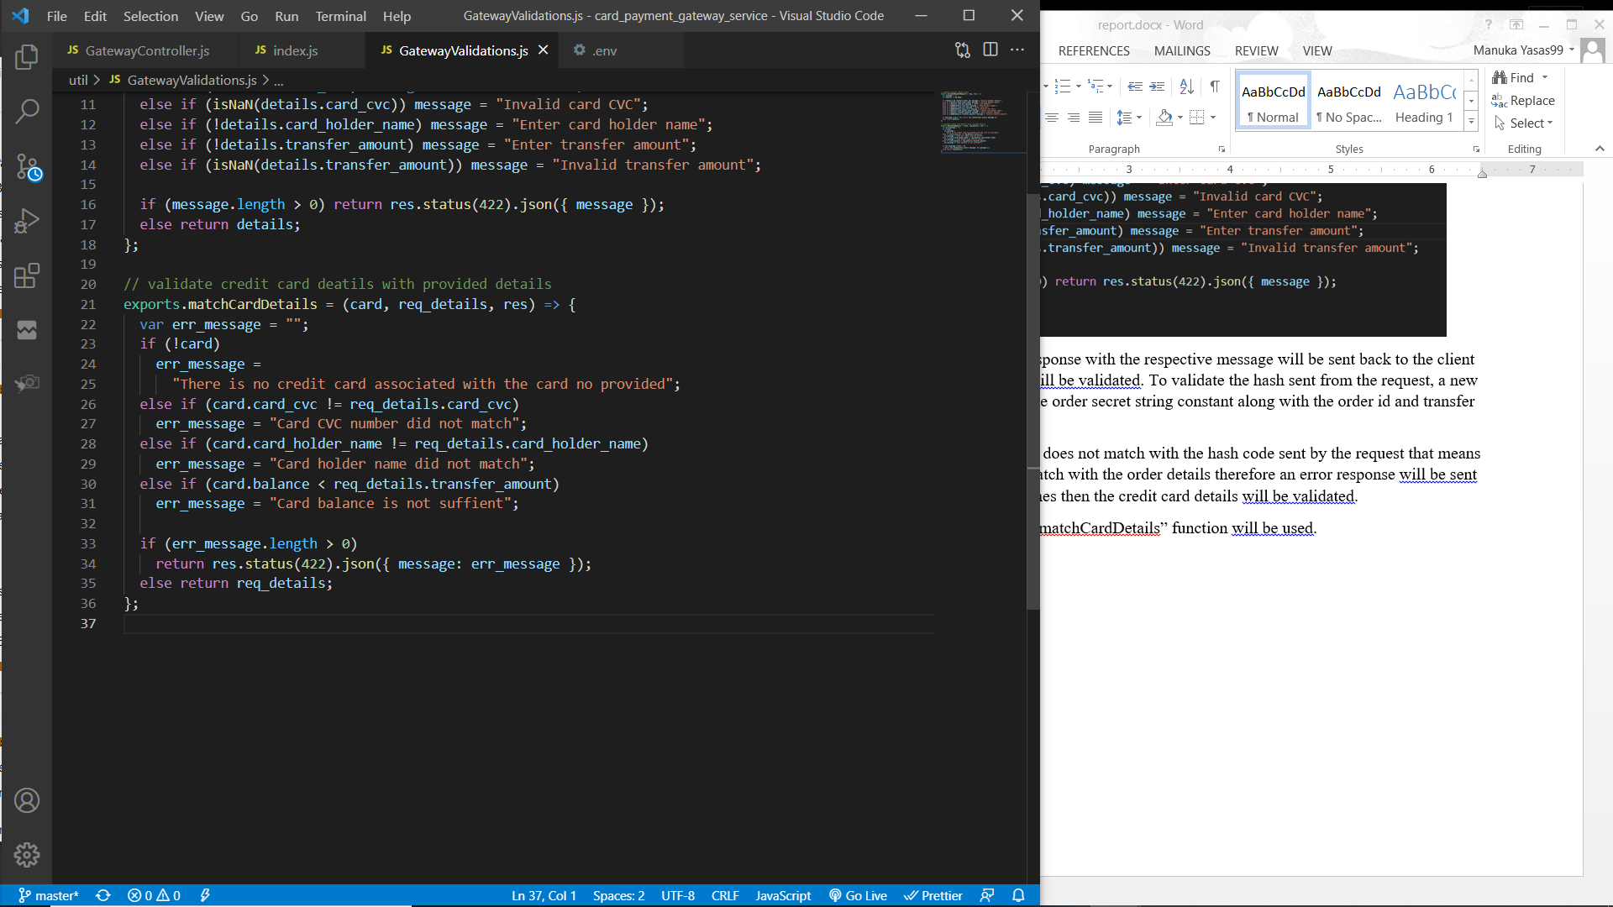

If the validation fail an error response with the respective message will be sent back to the client via ESB. Else the transaction will be made updating the credit card balance. If the transaction failed then an error response will be sent back. Else a success message will be sent back via ESB and the buyer service will be notified that the order was completed.

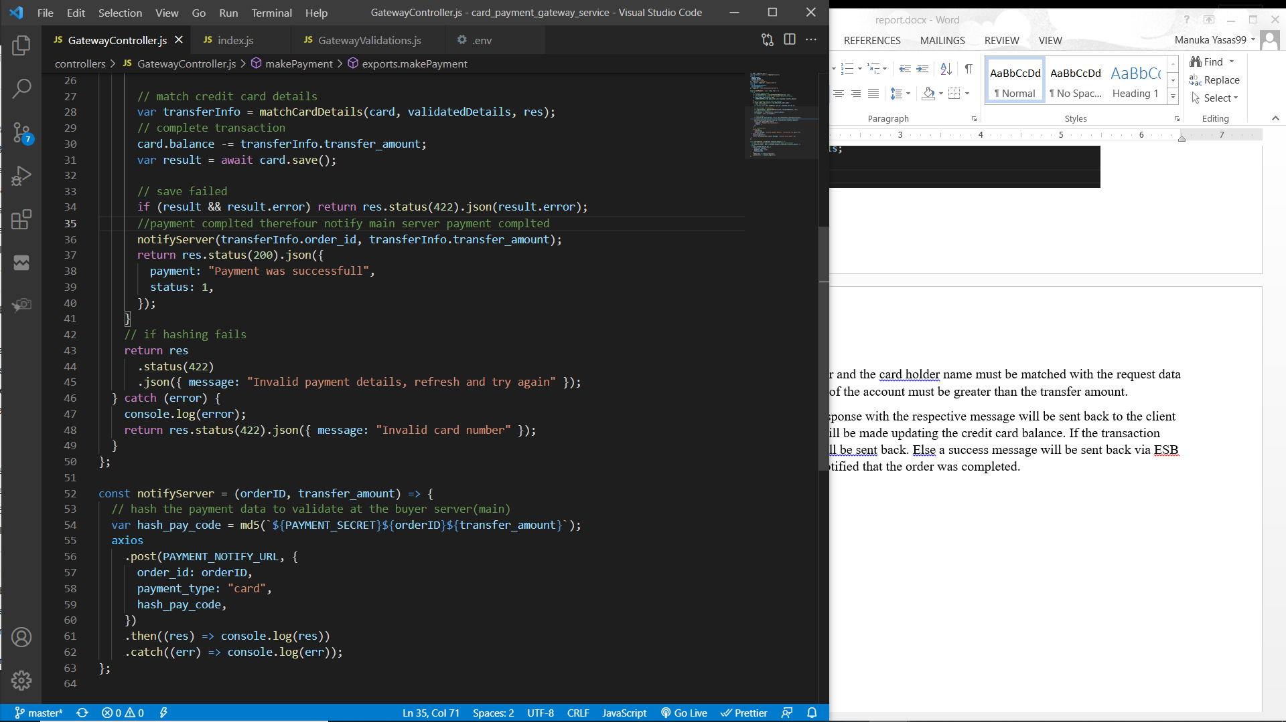

Notify server method will send a POST request to the buyer service with data such as order id, transfer amount and payment hash code. Payment hash code is generated using payment secret (string constant in the environment configuration), order id and the transfer amount. This hash code is useful to validate that the payment was completed through the payment gateway.

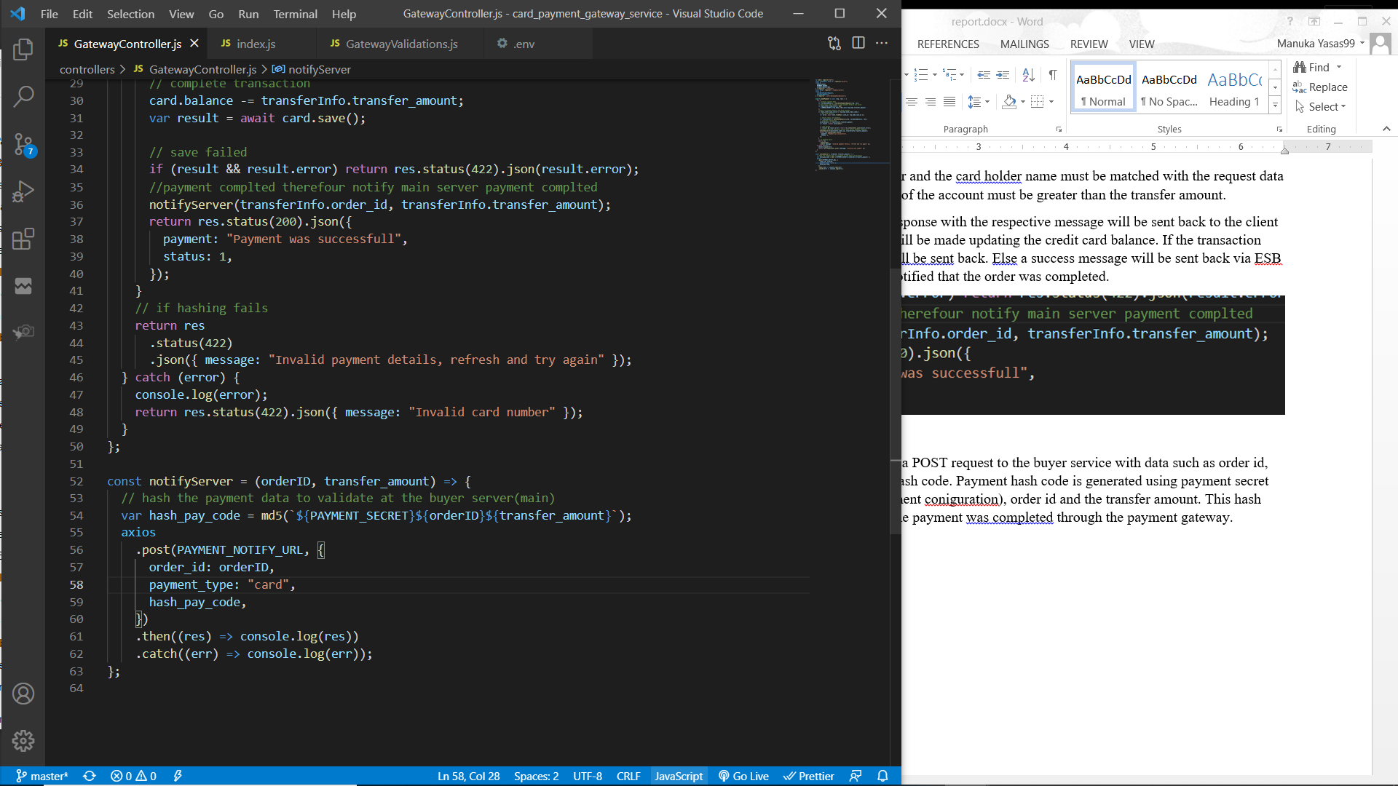

### Process of payment through mobile payment gateway

Workflow diagram

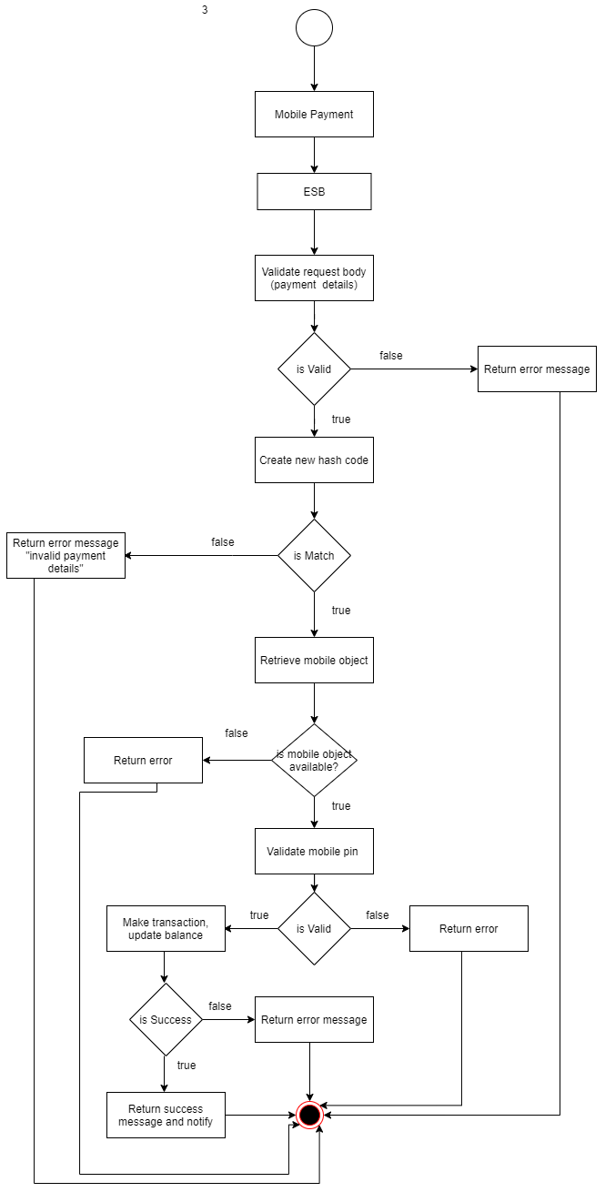

Service interface

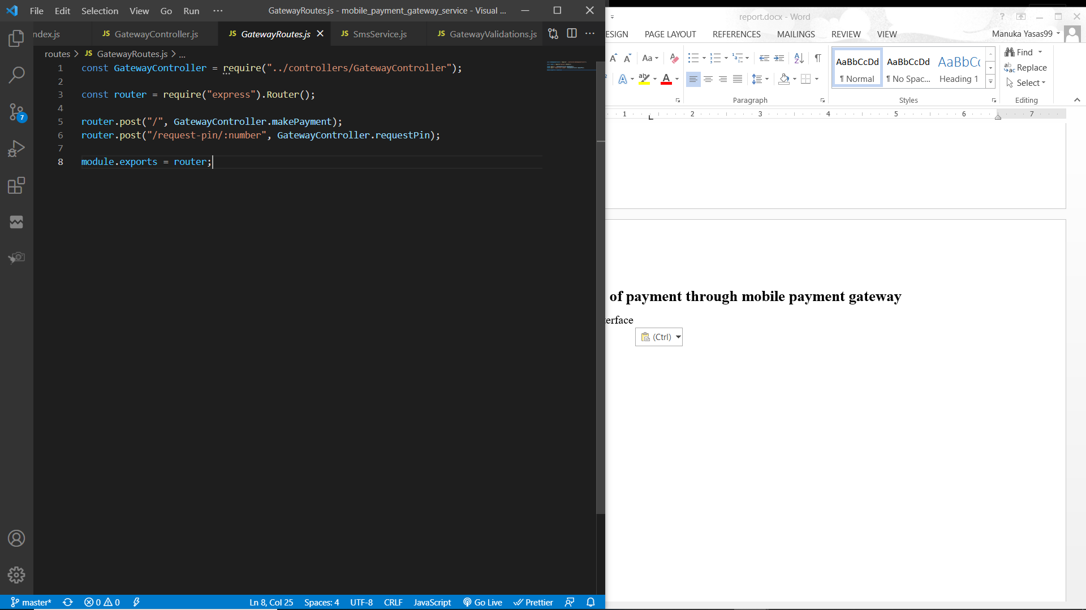

Service function

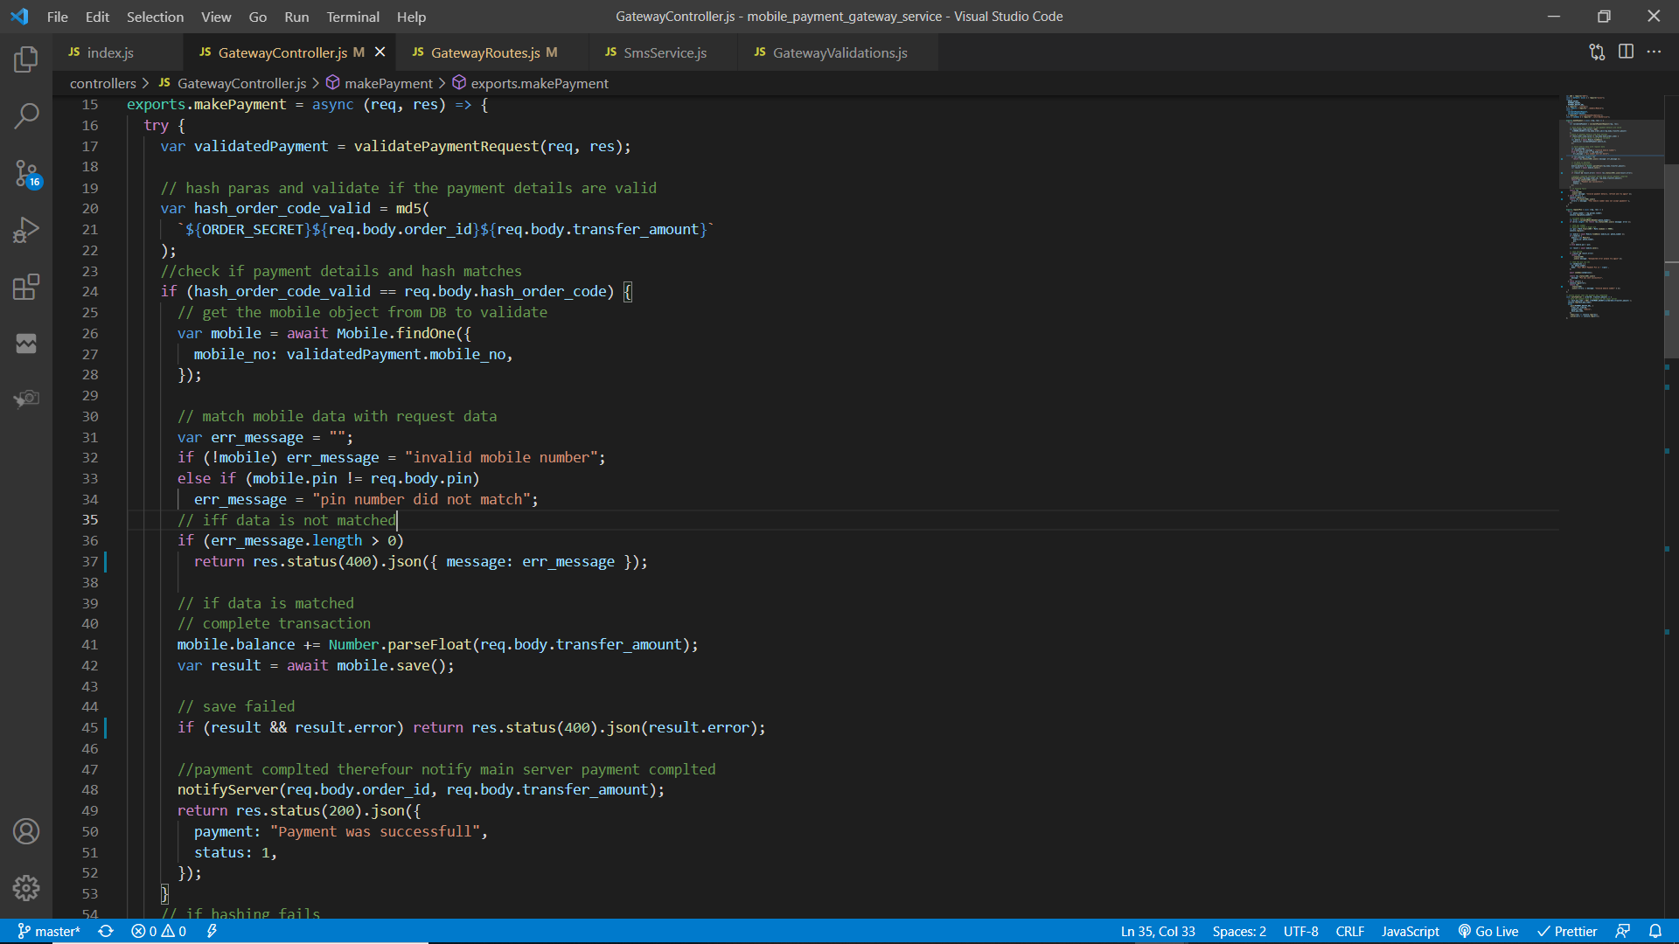

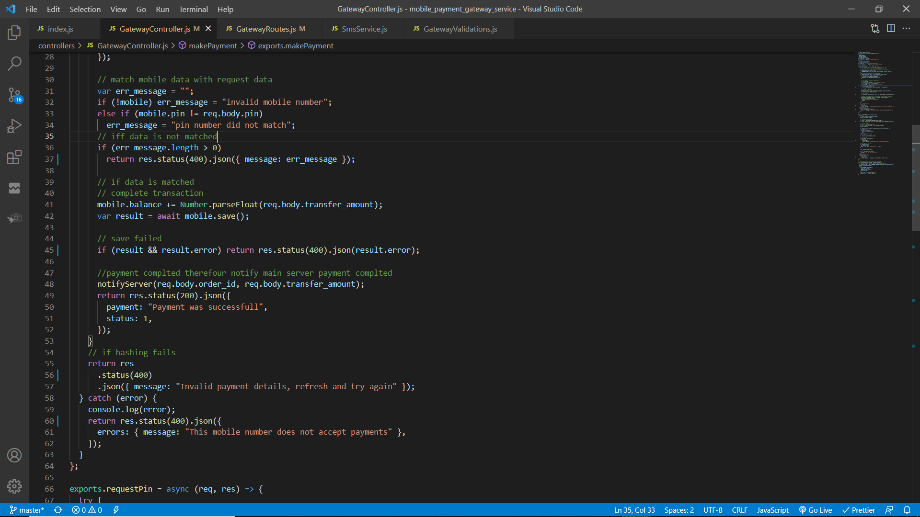

A POST request will be sent to the mobile payment gateway service through ESB if the request has a parameter “payment_type” with its value “mobile”. The request body will be validated by the “validatePaymentRequest” method to check if it has order id, order hash code, transfer amount, mobile number and mobile pin number.

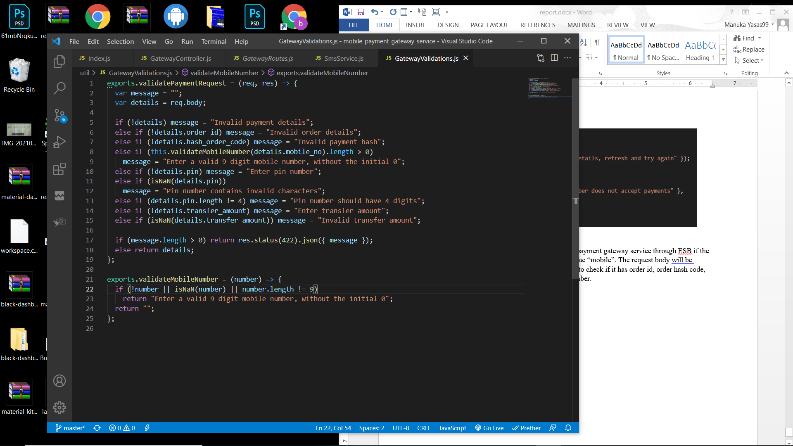

If the validation fail an error response with the respective message will be sent back to the client via ESB. Else, the order hash will be validated. To validate the hash sent from the request, a new hash will be created by using the order secret string constant along with the order id and transfer amount. If the newly created hash string does not match with the hash code sent by the request that means the payment details does not match with the order details therefore an error response will be sent back to the client. If hash matches then the mobile payment details will be validated.

To validate the mobile payment, mobile object will be retrieved from the database based on the mobile number. If the mobile object does not exist then an error response will be sent. Else, mobile pin will be validated. If the validation fails then an error response will be sent back. Else, the mobile balance will be updated (transfer amount will be added) and saved. If the payment fail then an error response will be sent back. Else, a success message will be sent back via ESB and the buyer service will be notified that the order was completed.



Notify server method will send a POST request to the buyer service with data such as order id, transfer amount and payment hash code. Payment hash code is generated using payment secret (string constant in the environment configuration), order id and the transfer amount. This hash code is useful to validate that the payment was completed through the payment gateway.



### Process of requesting mobile pin number

Workflow diagram

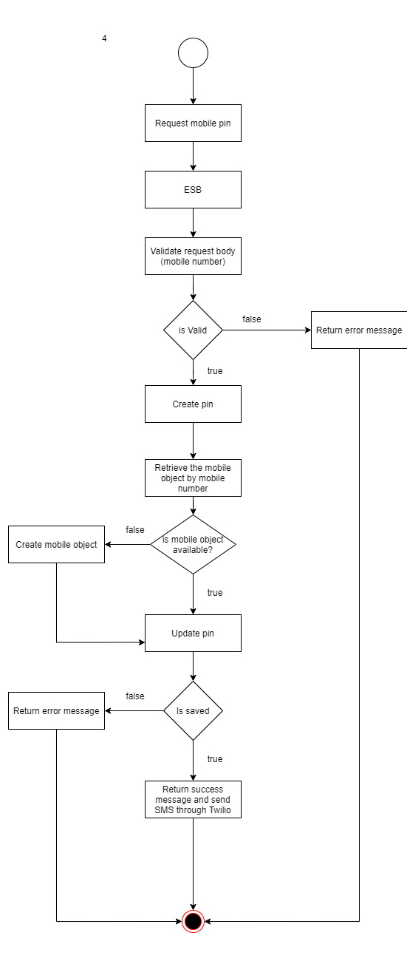

Service interface



Service function

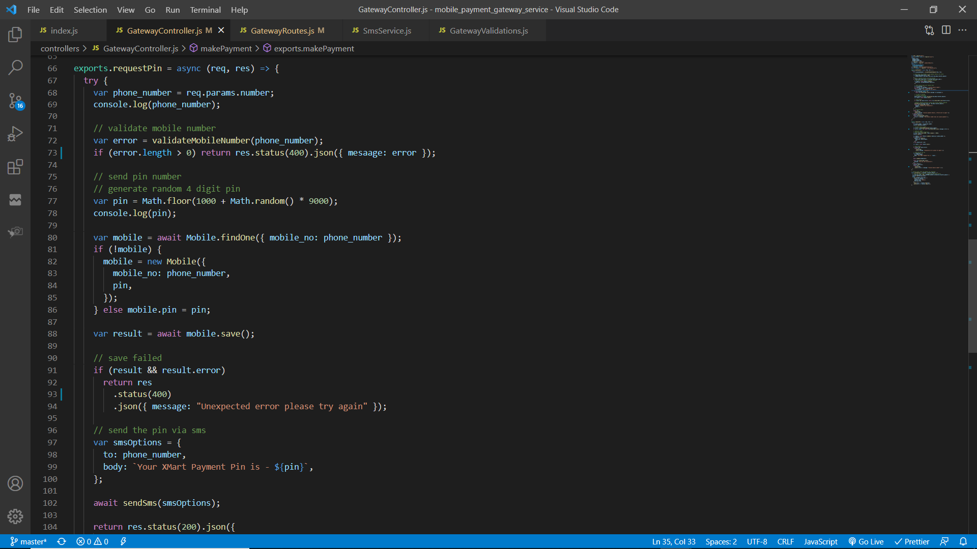

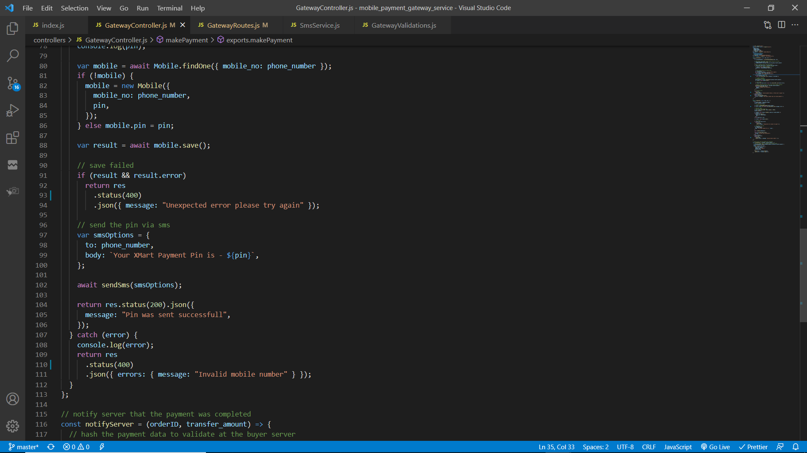

A POST request will be sent to the mobile payment service through ESB. The mobile number is sent as a parameter. Mobile number will be validated from the below function and if any errors were found an error response will be sent back.

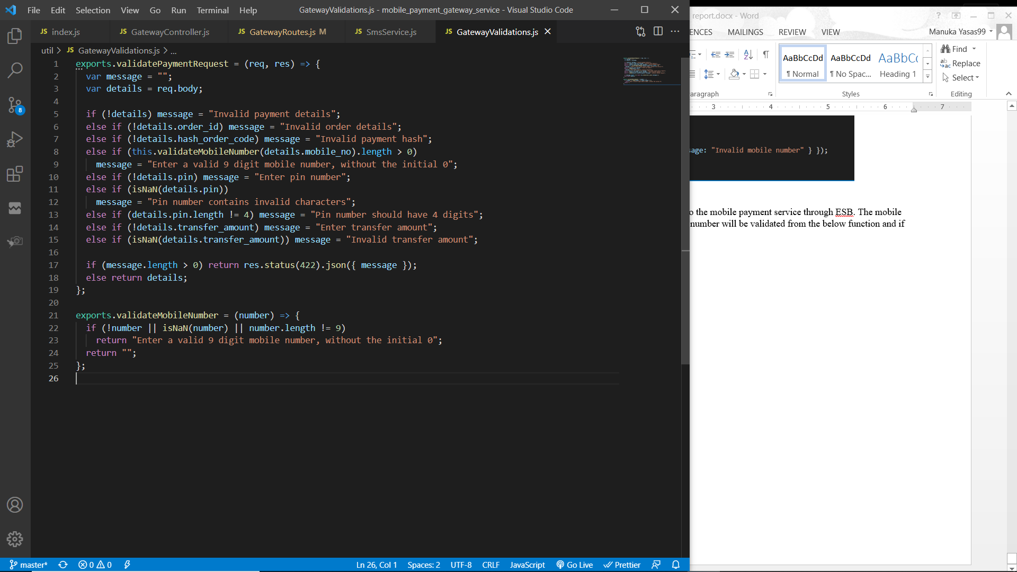

After the validation was completed successfully then a four digit pin number will be created.

The mobile object will be retrieved based on the mobile number from the database and the pin number will be updated and saved. If there is no object in the database then a new mobile object will be created and the pin number will be saved.

If an error is caught while saving an error response will be sent back to the client through the ESB. Else, a success message will be sent back and a SMS will be sent to the number with the pin number. SMS will be sent using Twilio.

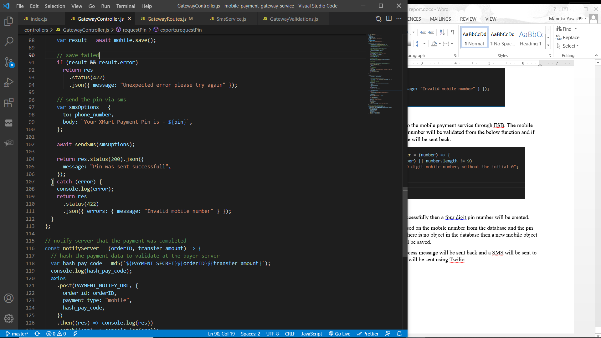

SMS service

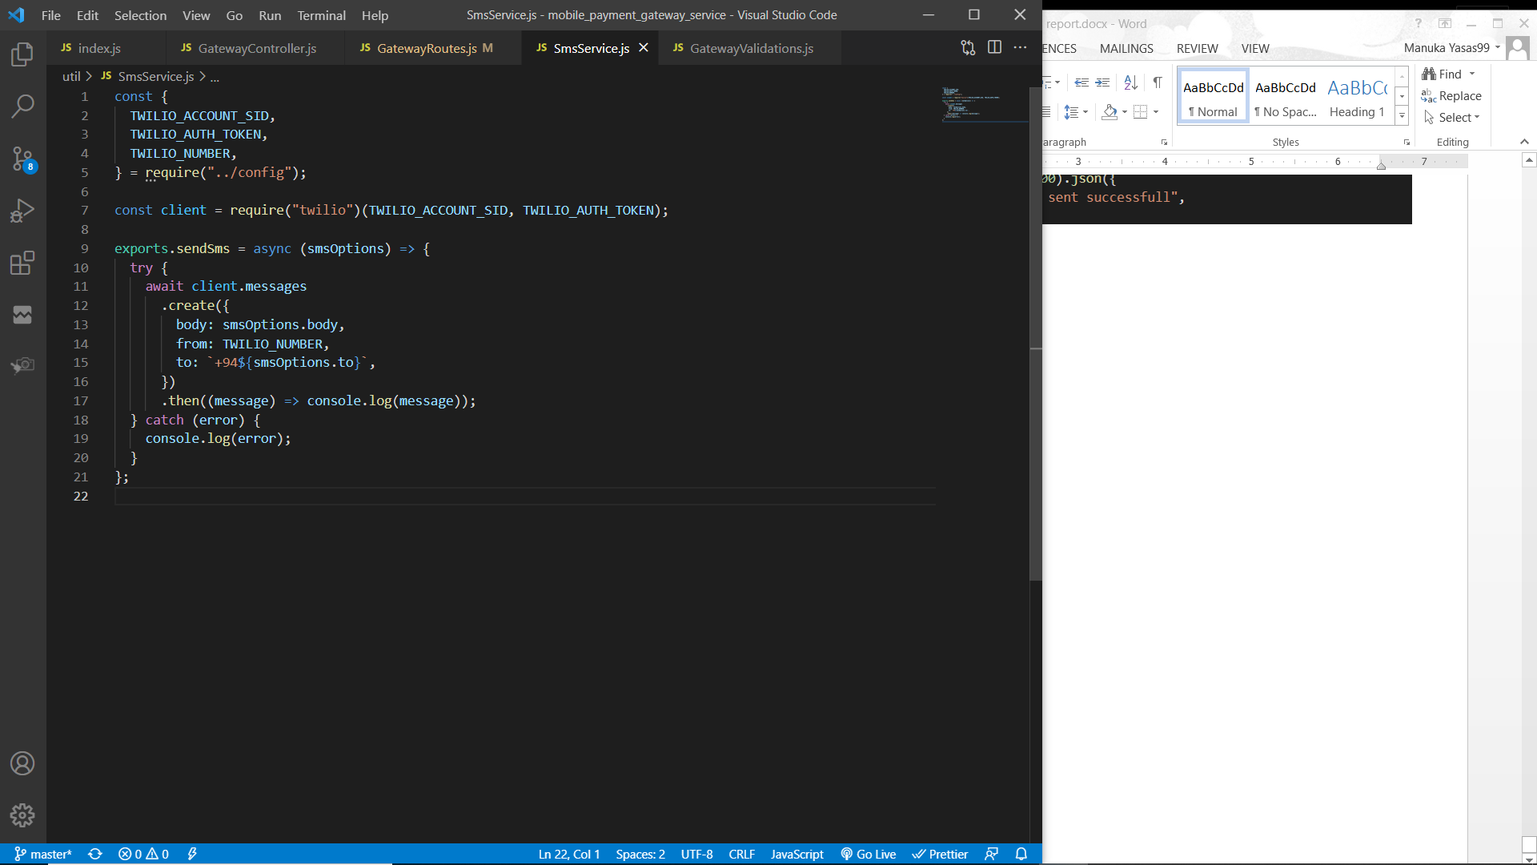

### Process of listening to payment notifications

Workflow diagram

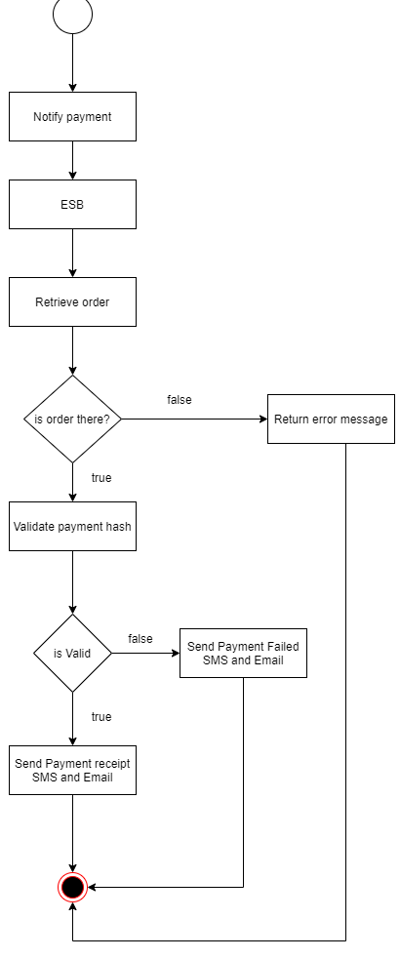

Service interface

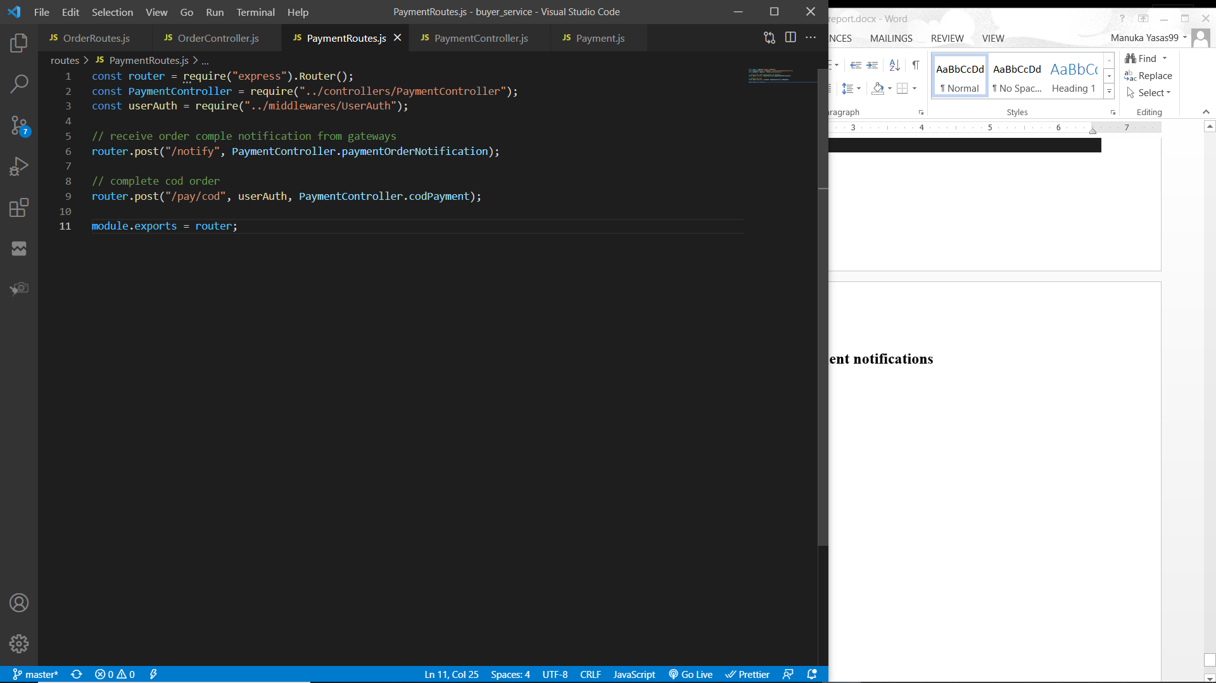

Service function

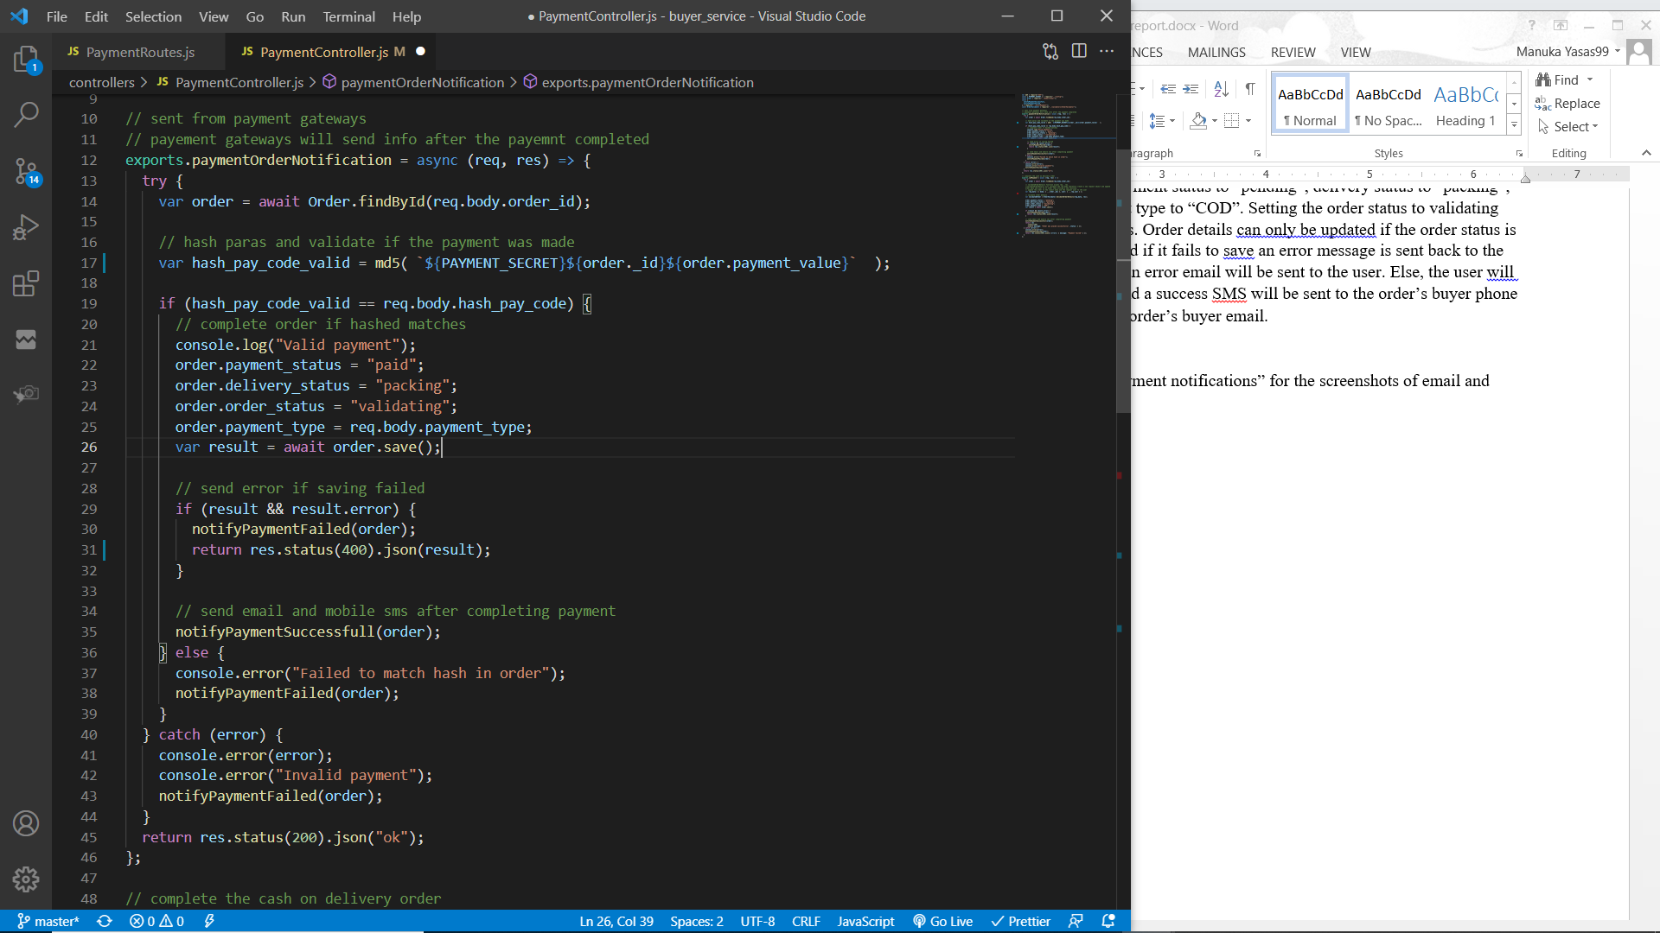

After completing the payment by payment gateways (credit card / mobile ) it will notify the buyer service. A POST request will be sent through the ESB to the buyer service with order id, transfer amount and the payment hash. Order will be retrieved from the order id and if there is an order then the payment hash needs to be validated.

To validate the payment hash, a new md5 hash will be created from the payment secret (Environment variable), order id and order payment value. Then if the payment hash from the request and the newly created hash from the order object matches, the payment is validated.

If the payment was not validated, “notifyPaymentFailed” method will be called and an unsuccessful email and SMS will be sent based on the order buyer information. Else, “notifyPaymentSuccessful” method will be called and a successful email and SMS will be sent based on the order buyer information.

SMS service through TWILIO

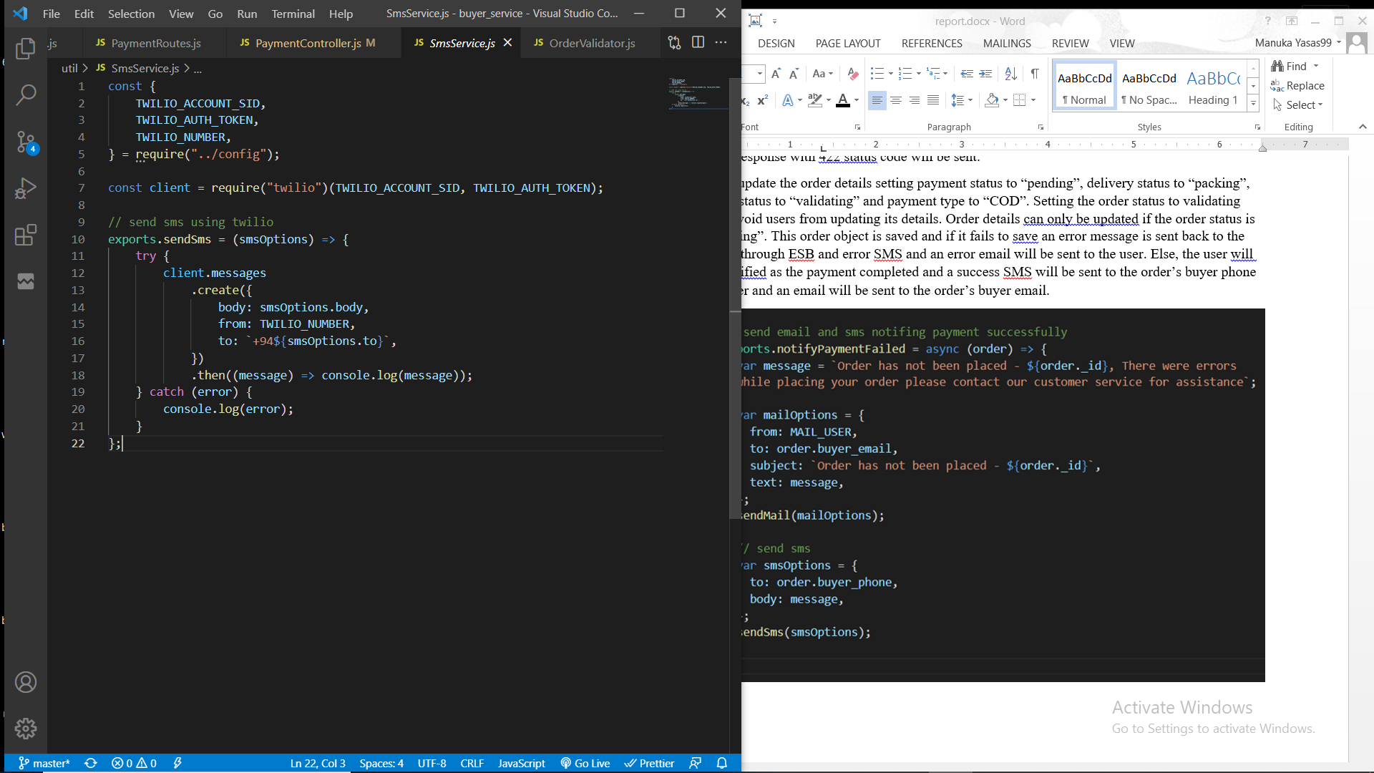

Mail service through Gmail

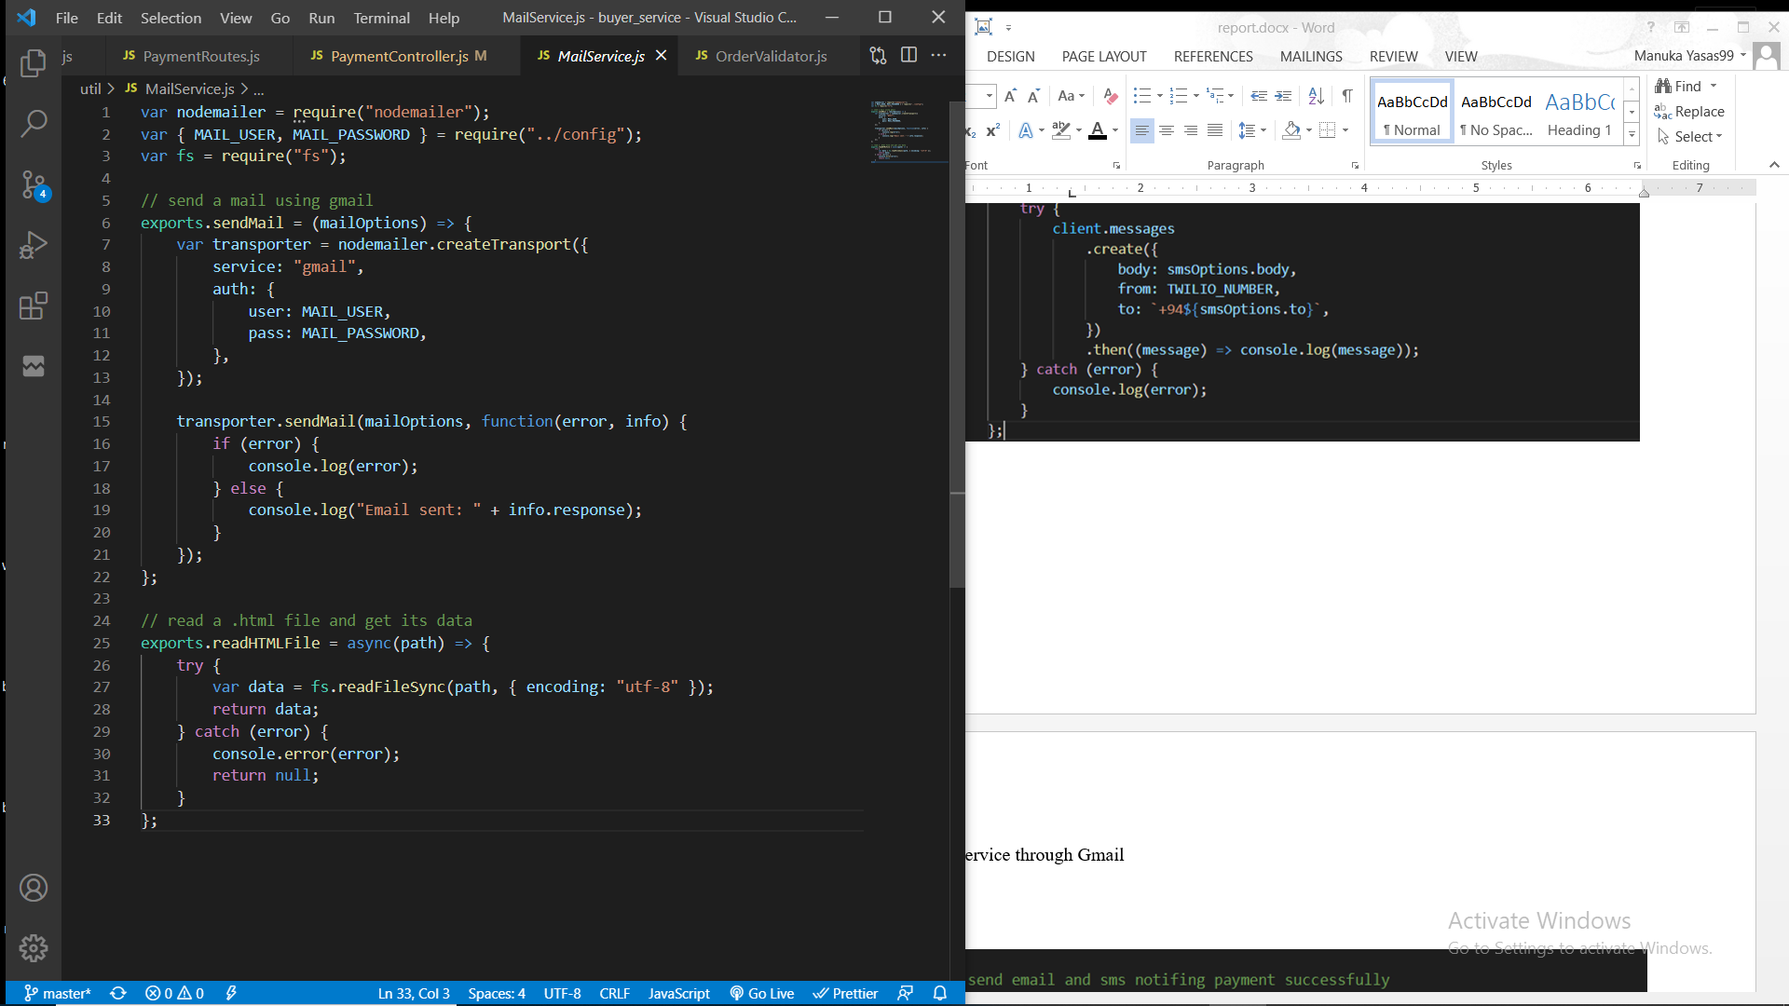

Notify payment completed through email and SMS

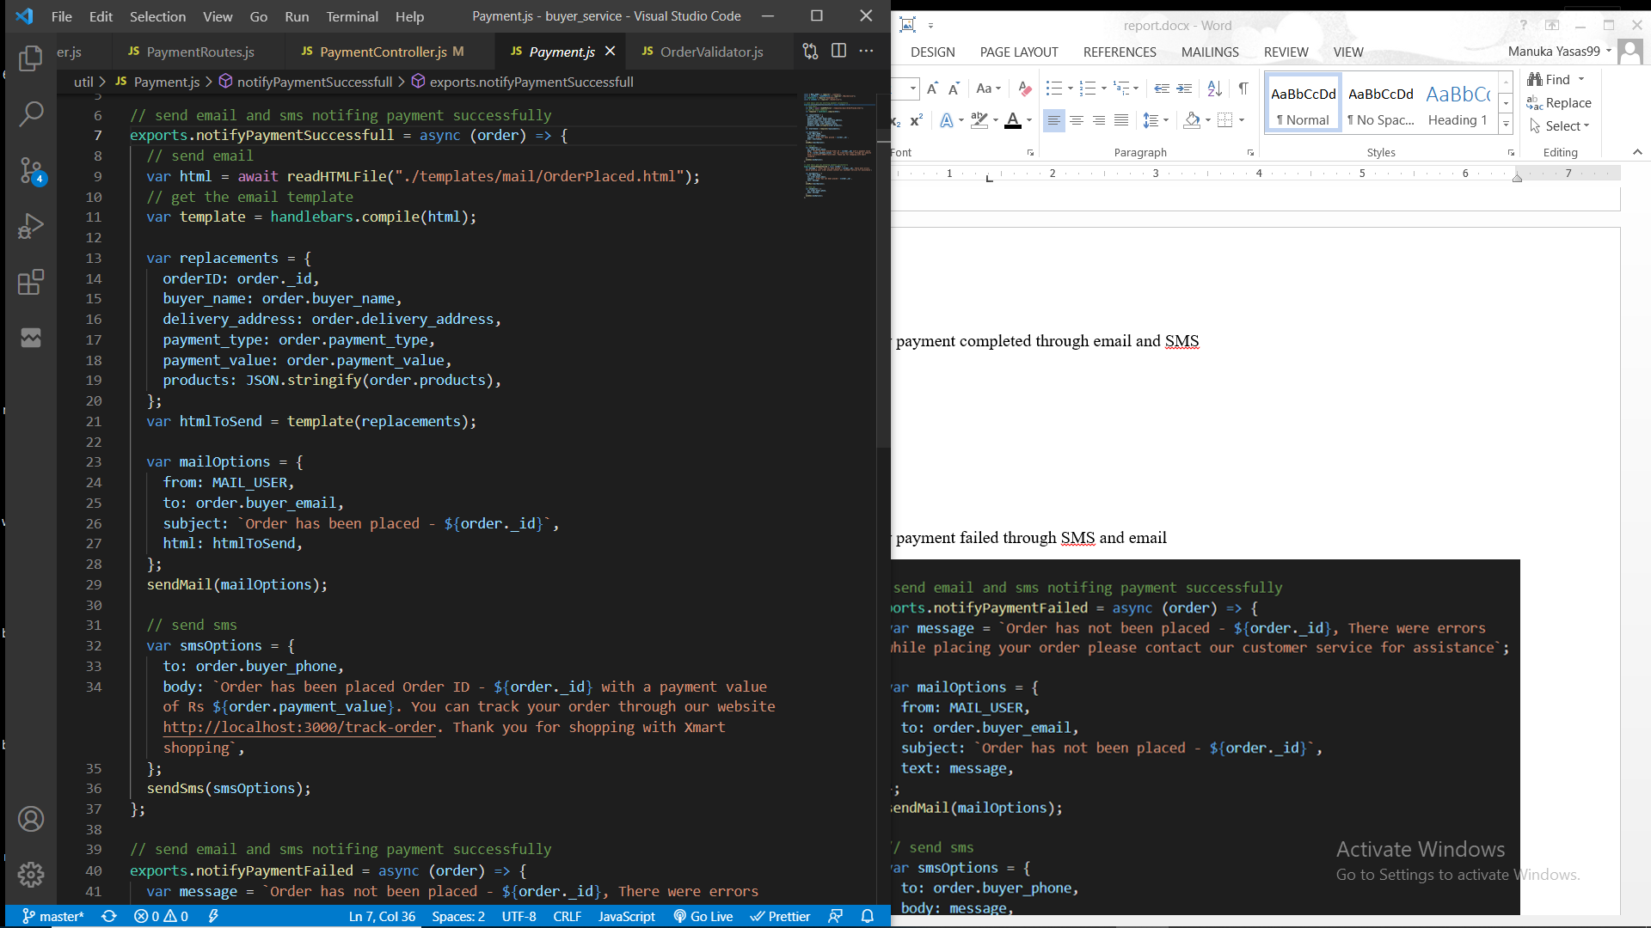

**Email template with data sent through Gmail**

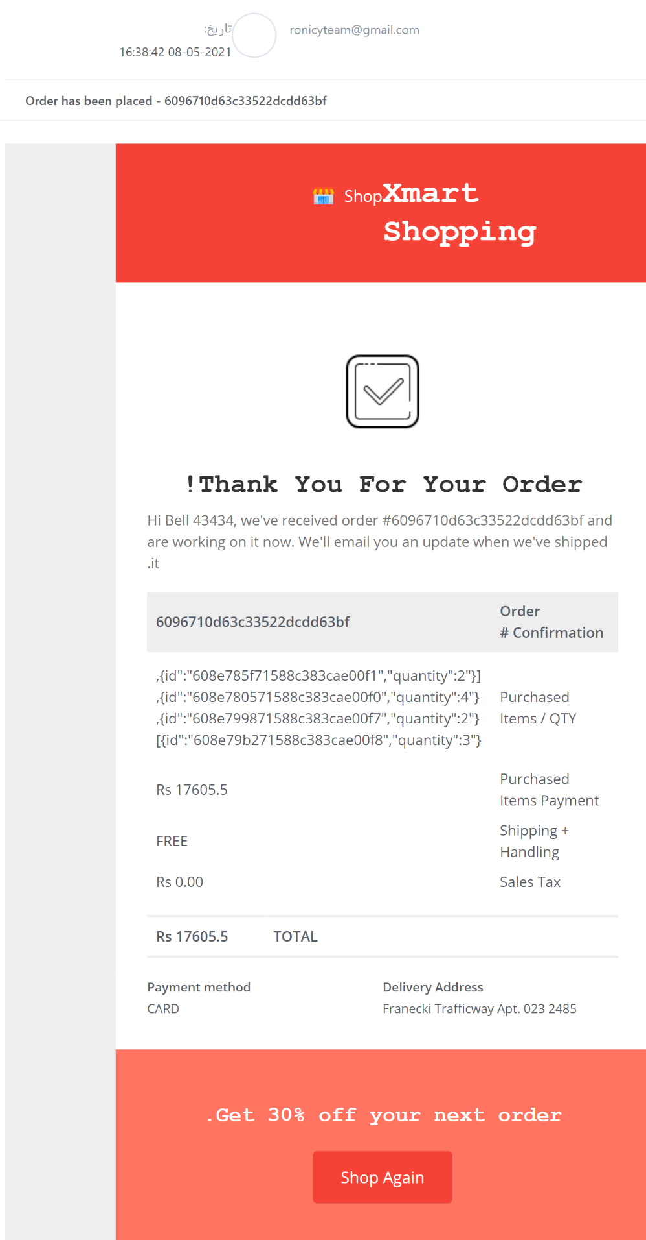

**SMS sent through Twilio**

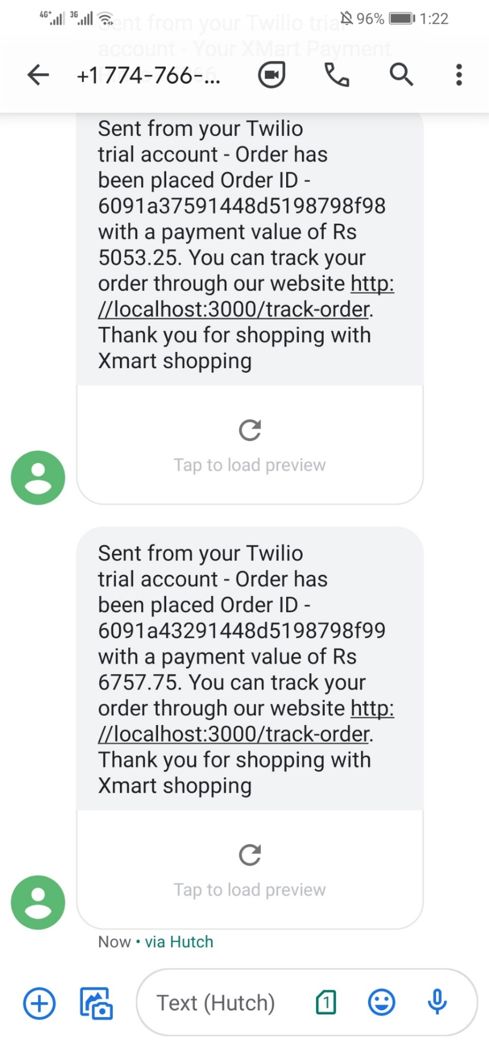

Notify payment failed through SMS and email

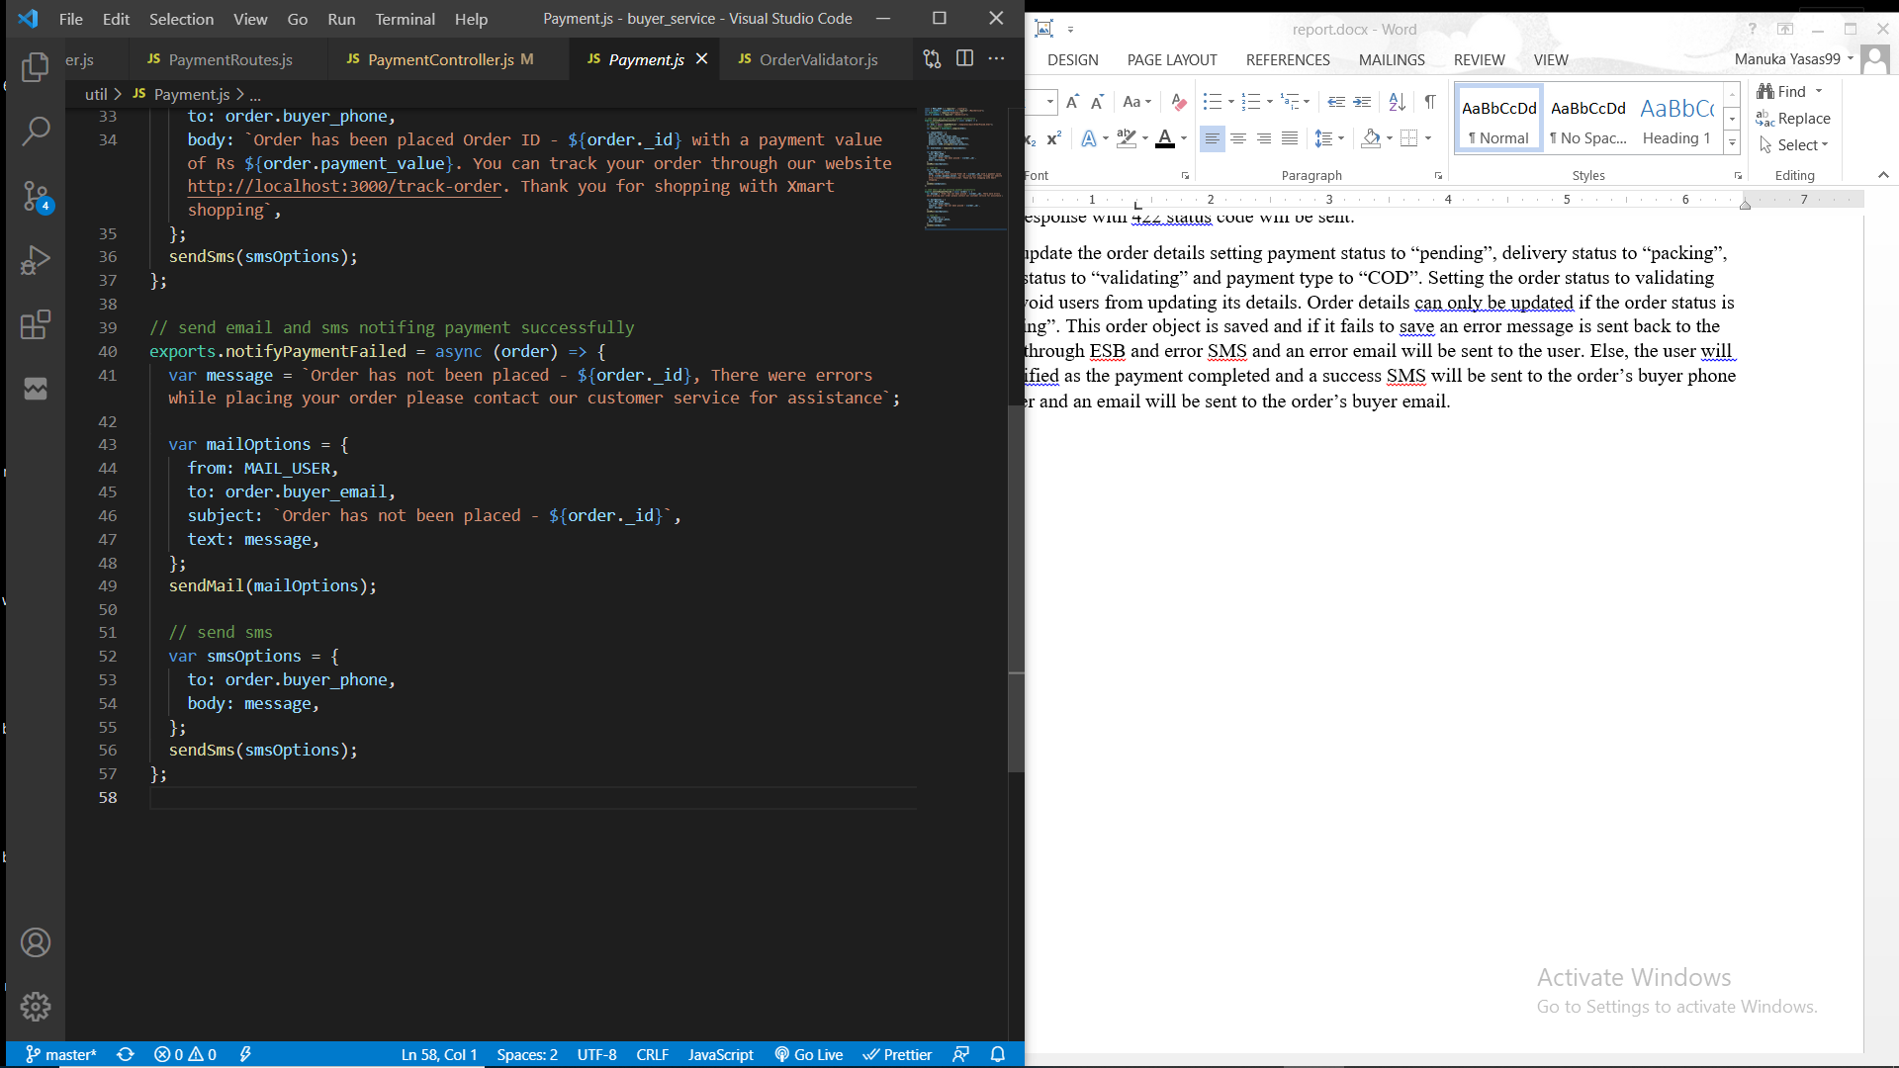

### Process of placing cash on delivery order.

Workflow diagram

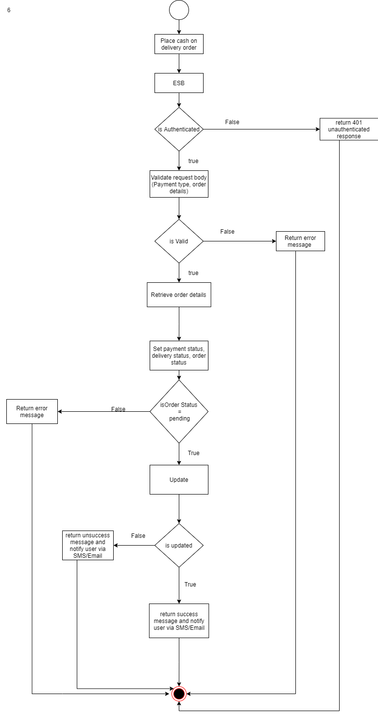

Service function

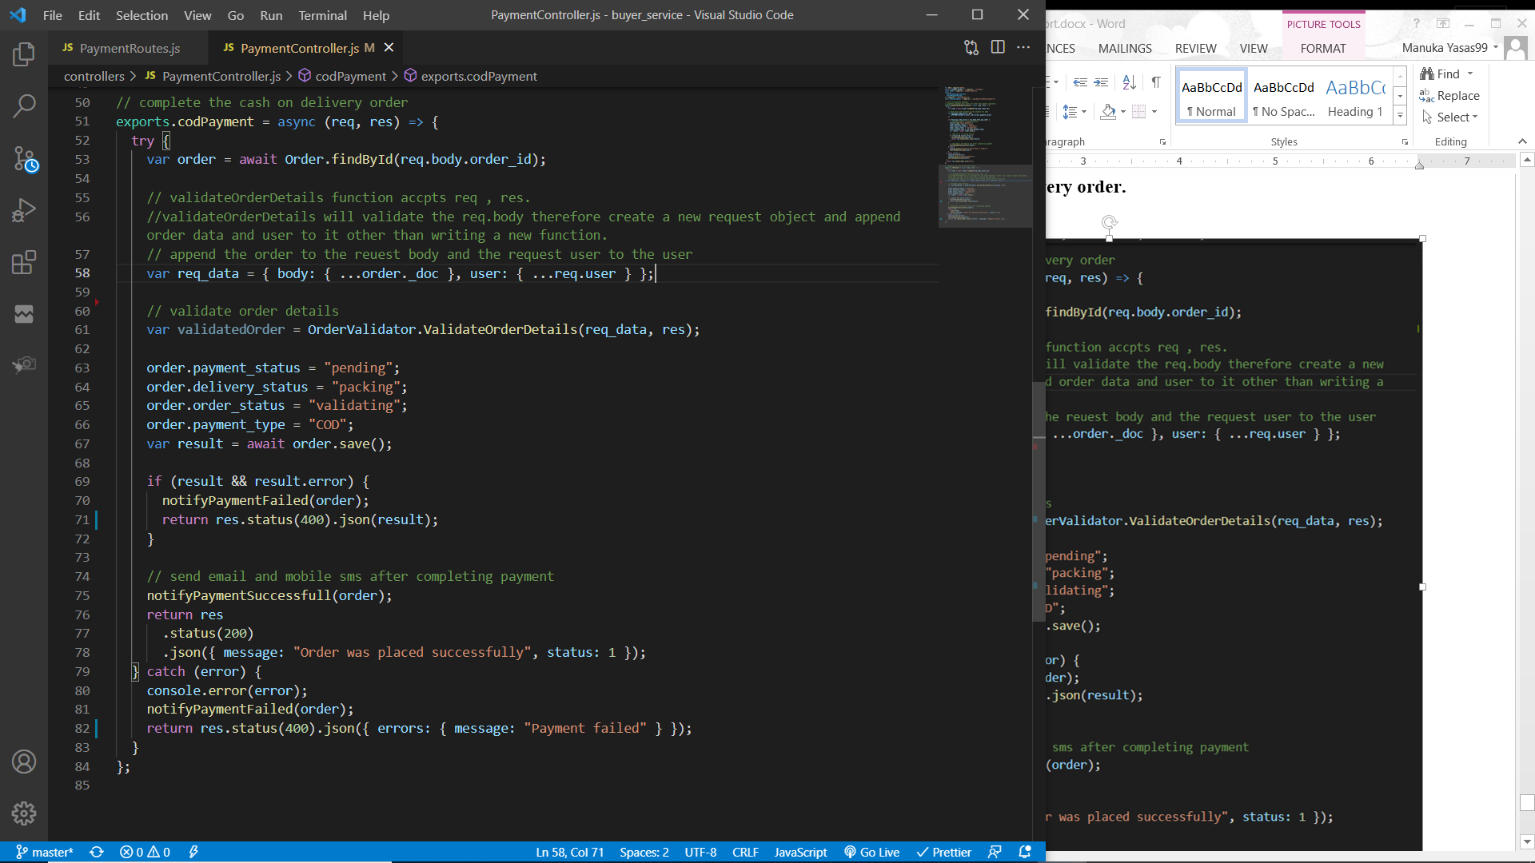

A POST request will be sent to the buyer service through ESB if the request has a parameter “payment_type” with its value “COD”. User must be authenticated to place a Cash on delivery order for this “userAuth” middleware is used to filter the request and allow only authenticated users.

The request is required to send the order ID. Then the order object will be retrieved. Order details including the buyer and delivery information must be validated before placing the order. As in above functions “ValidateOrderDetails” function is used to validate the request. If any errors are found then an error response with 422 status code will be sent.

Then update the order details setting payment status to “pending”, delivery status to “packing”, order status to “validating” and payment type to “COD”. Setting the order status to validating will avoid users from updating its details. Order details can only be updated if the order status is “pending”. This order object is saved and if it fails to save an error message is sent back to the client through ESB and error SMS and an error email will be sent to the user. Else, the user will be notified as the payment completed and a success SMS will be sent to the order’s buyer phone number and an email will be sent to the order’s buyer email.

(please refer “Process of listening to payment notifications” for the screenshots of email and SMS and the code)

## Delivery service

A third party rest service was developed to deliver products which were ordered through the Xmart shopping platform. After an order was placed, seller will manually validate the order details and payment details. If necessary seller will contact the user (buyer). After the order was validated, the seller will add delivery details to the Express delivery web application. Through this application, drivers will pick up the product from store and deliver to the location provided by the buyer. Sellers needs to register with this third party application and delivery is free of charge for orders placed through Xmart Shopping.

### Process of creating a new delivery

Workflow diagram

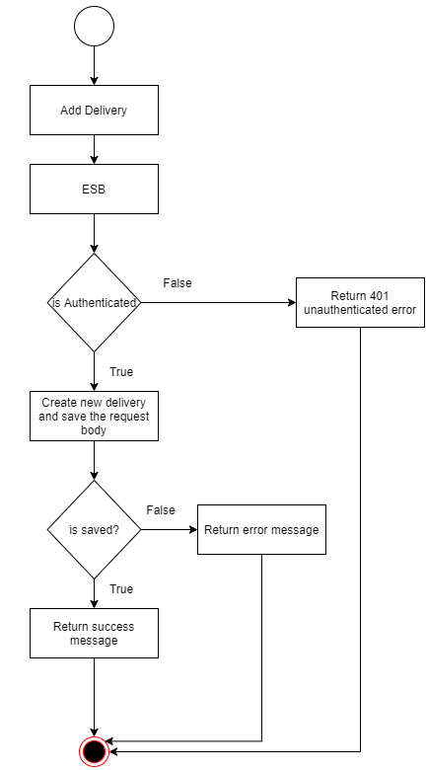

A POST request with the details (Buyer name, Buyer email, buyer telephone, address, payment type, payment value) will be sent through ESB ( WSO2 E1) to the delivery service. The user should be an authenticated user, so that user id will be gone through an authentication checkup. If there is an error, an error message will be returned. If the buyer is an authenticated user, the provided data in the request body will be validated. If there is no error occurred in validation, a new delivery will be created in and saved in the DB. If an error occurred, the user will be informed by an error message. After the new delivery saved in the DB successfully, a success message will be returned. Otherwise, an error message will be returned.

### Process of updating a delivery

Workflow diagram

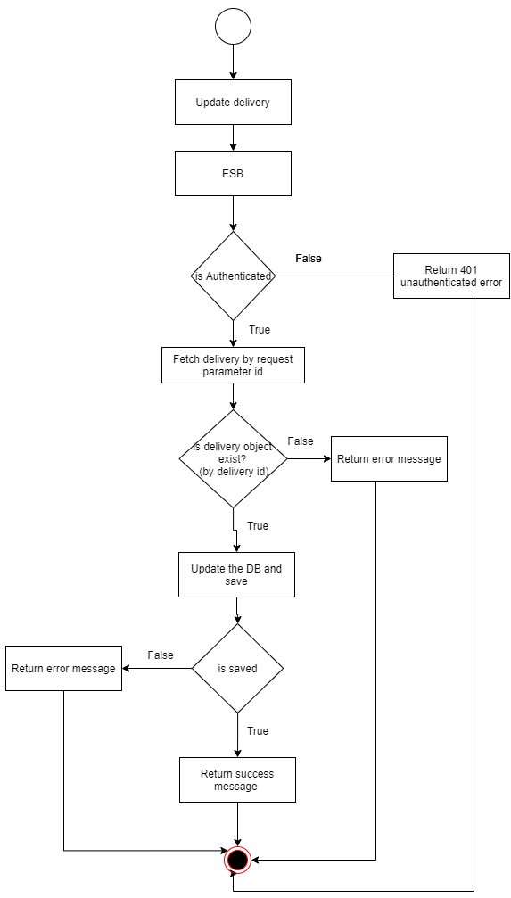

A PATCH request with the delivery id and updated details will be sent through ESB ( WSO2 E1) to the delivery service. After the authentication, the request will be validated. Then the availability of the delivery object is checked and if available delivery will be updated and saved in the DB. If there is error in the process error message will be returned.

### Process of deleting a delivery

Workflow diagram

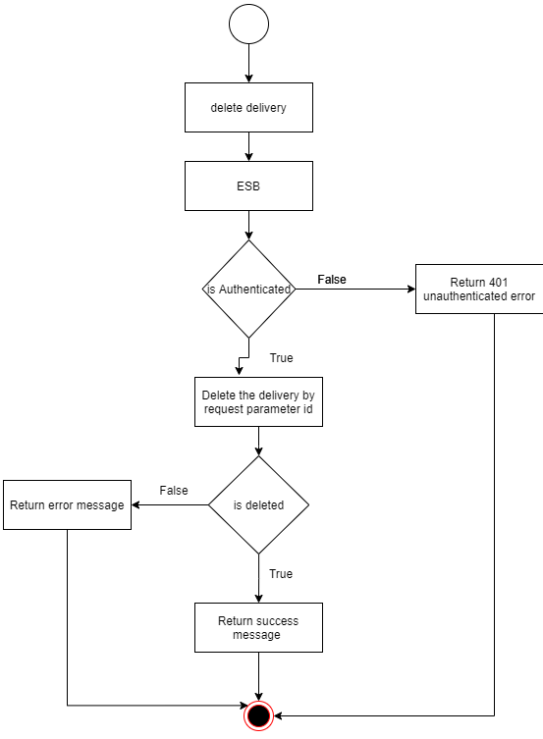

A DELETE request with the delivery id will be sent through ESB ( WSO2 E1) to the delivery service. After the authentication, the request will be validated. Then the availability of the delivery object is checked and if available the delivery will be deleted. If there is error in the process error message will be returned.

### Process of finding a delivery

Workflow diagram

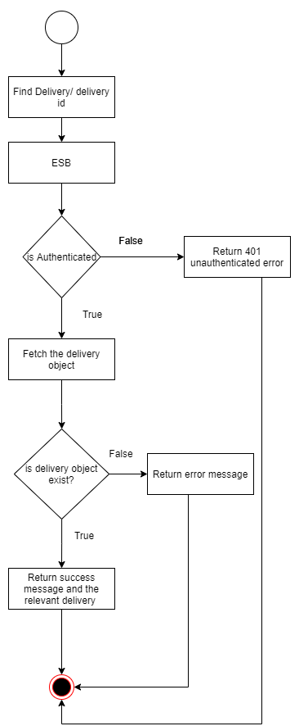

A GET request with the specified id will be sent through ESB ( WSO2 E1) to the delivery service. After authentication, the delivery id will be validated and if there is no error, the delivery corresponding to the id will be fetched. In case if an error occurred, error message will be returned.

### Process of listing all deliveries

Workflow diagram

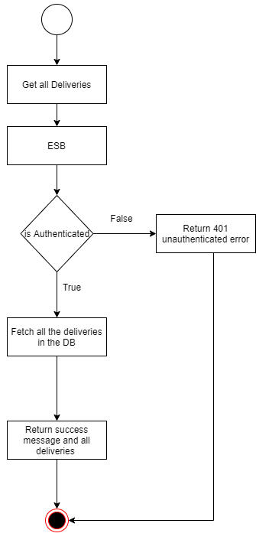

A GET request will be sent through ESB ( WSO2 E1) to the delivery service. After authentication, the validation check will be taking placed and if it is successfully validated, all the deliveries in the DB will fetched. In case if an error occurred, error message will be returned.

# Authentication and Security Mechanism adopted with system

## User Authentication

Json web token based authentication mechanism is used to verify user identity by returning a unique token. Guest have to verify the credential once and in return they will get a unique token which is allowed to access for 10 minutes. The token will have user’s basic details and role details.

When registering a user and resetting a password the password entered is encrypted (using bcrypt) and stored in the database. Even when querying we can get only the highest version of the password unless specially quarried for the real password.

User can request to reset the password then a hashed reset token will be generated and an email will be sent to the user’s email address along with the reset URL. Once user visit the reset URL, server checks the validity of the reset token and allows to change the password.

## Service Authentication

Since the authentication is developed as a service, the buyer service and the seller service requires to be authenticated externally. For this the buyer service and the seller service will be using a middleware to send a request to the authentication service to validate the bearer token sent in request headers through the WSO2 EI (ESB).

“Authenticate” middleware in the buyer/seller service is used to validate the response that is returned after requesting the authentication service with authorization token in request headers. If the response sent from the authentication service has a user, it will be added to the request object and the next function will be invoke.

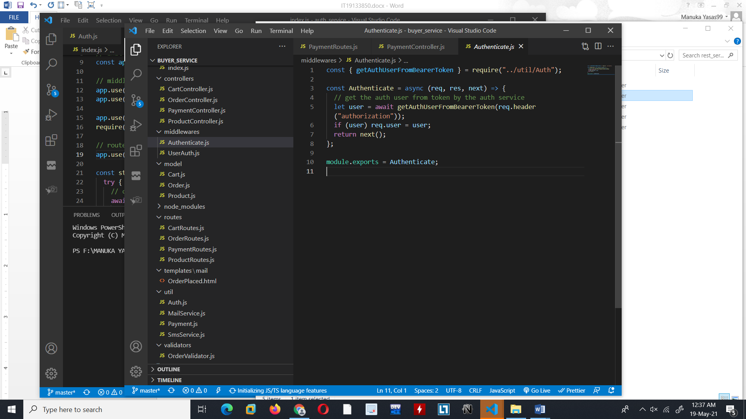

Function “getAuthUserFromBearerToken” is used in the buyer/seller service to request the authentication service with the authorization token(JWT) and return back the response. The request will be sent through the ESB.

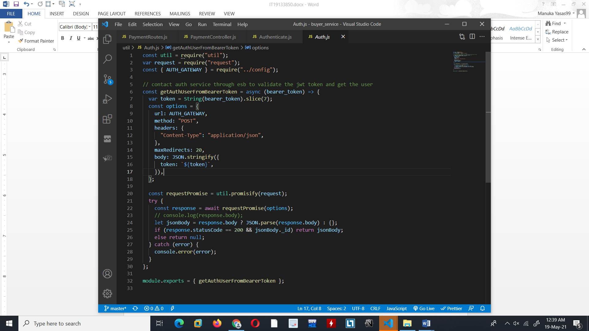

Function “validate token” is used in the Authentication service to validate the token sent in the request body and if the token is verified, user will be retrieved and returned.

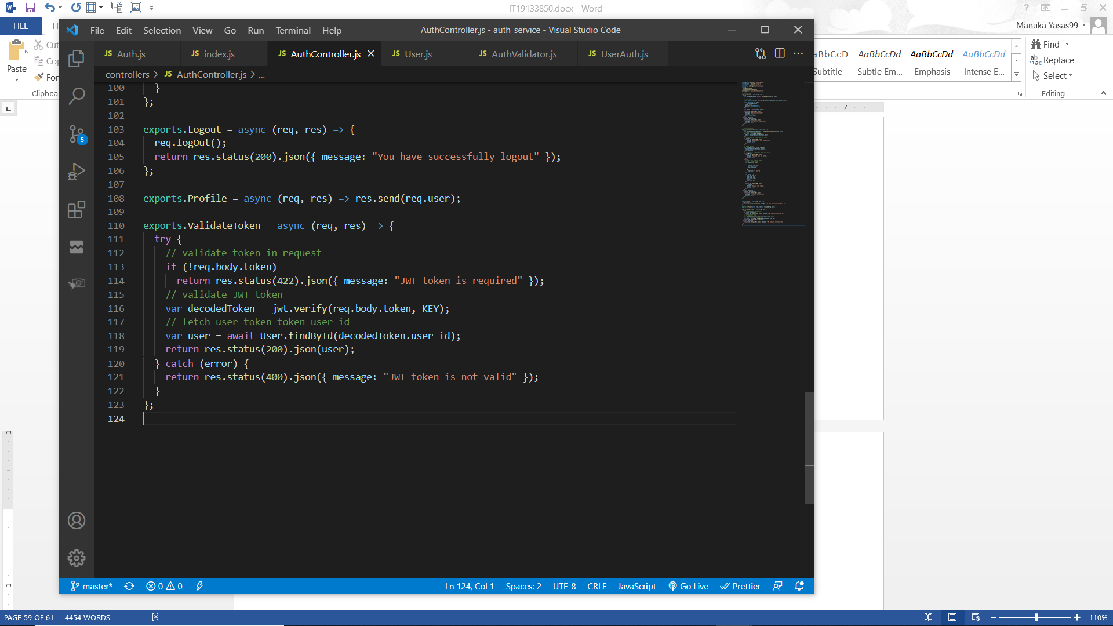

If the token is valid then the user will be added to the request object in the Buyer and Seller service.

Since the role “seller” must be validated in the seller service another middleware is used to validate the role in the request user.

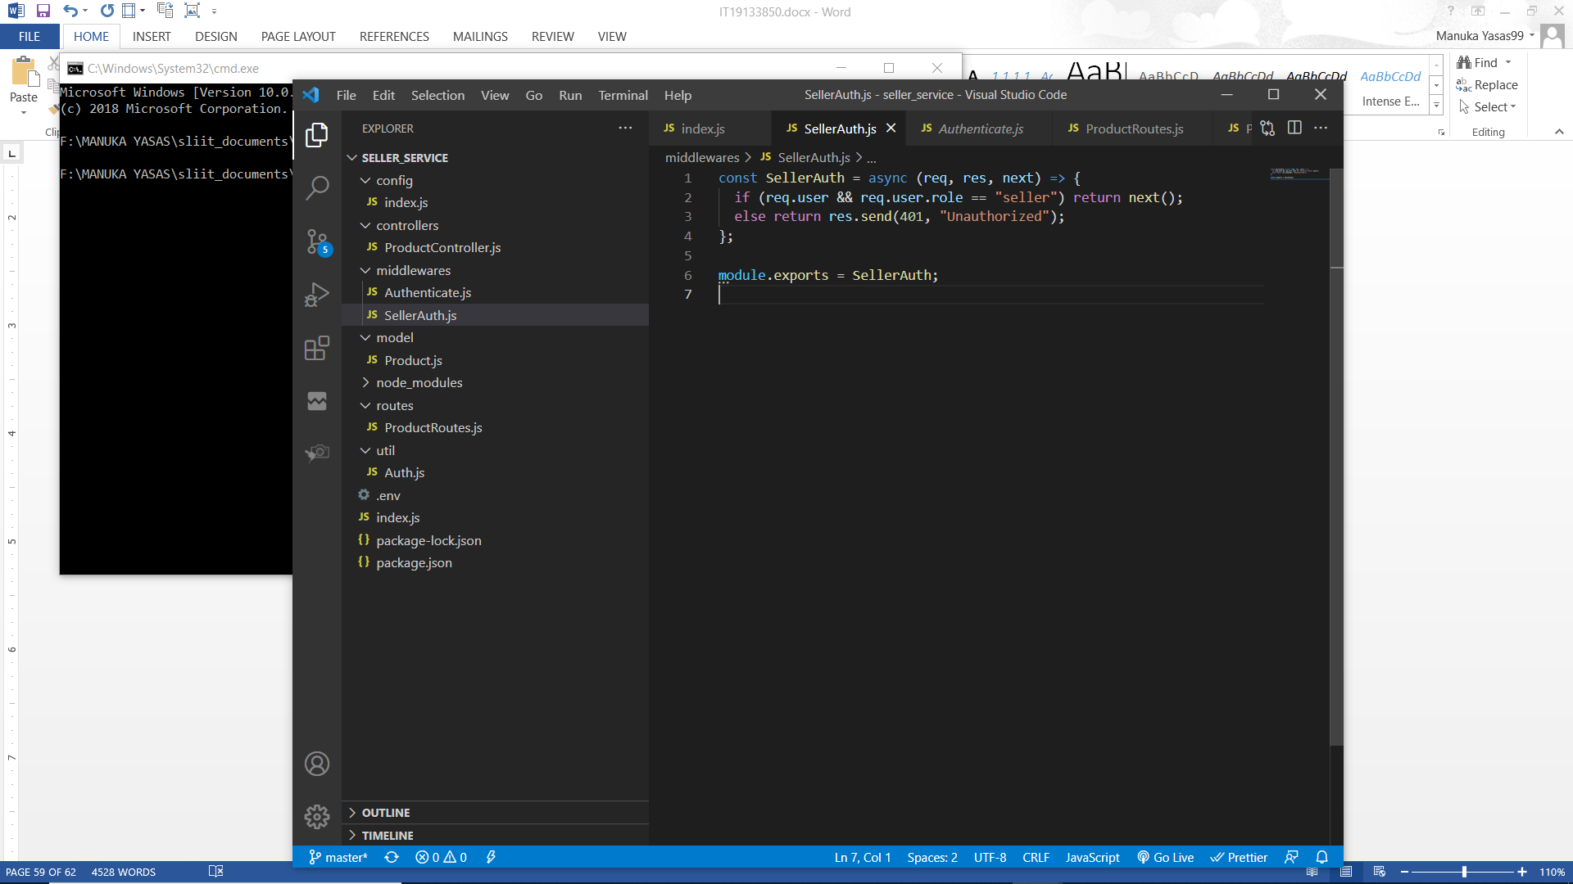

These middlewares will be used as bellow.

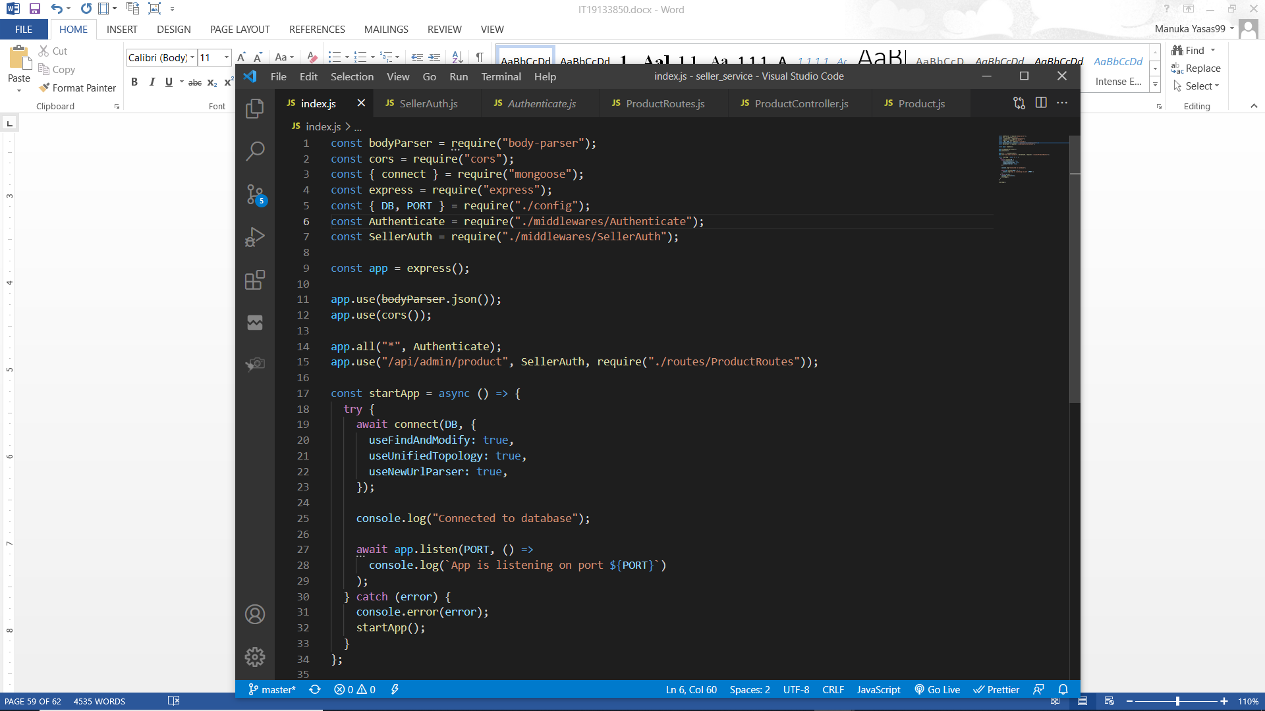

## Payment Security

In order to provide extra security when making a payment through credit card gateway or mobile payment gateway, order details along with the transfer amount will be hashed.

When the user is paying through credit card / mobile then a request will be sent to the gateway with transfer amount and order id. Since these data could be changed, another parameter is sent which is a hashed value generated using the order id, transfer amount and order secret key. Order secret key will be saved in environment configurations in both the services. The payment gateway will hash the data received (transfer amount and order id) with the order secret and generate a hashed value. If this value and the hashed parameter sent along with the data matches then the payment is secure and can be made.

(In real scenario payment gateways will use the Client User ID and Secret received when registering to the gateway)

Also after completing the payment, gateway will send a request to the buyer service with the data such as order id, transfer amount and payment hash code. Payment hash code is generated using the order id, transfer amount and payment secret key. Payment secret key will be saved in environment configurations in both the services. Then the buyer service will validate and compare a payment hash codes and if valid the order payment will be updated as paid and notifications will be sent through mail and SMS.

# Screenshots of the User Interfaces

Register

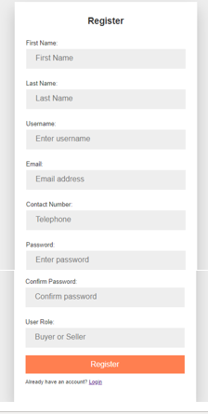

Login

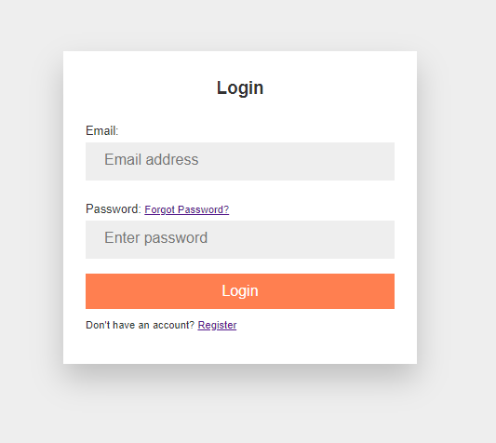

Forgot Password

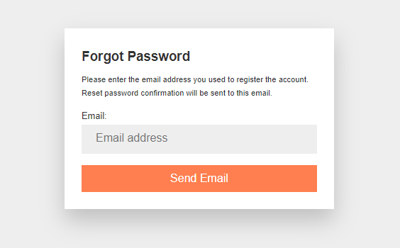

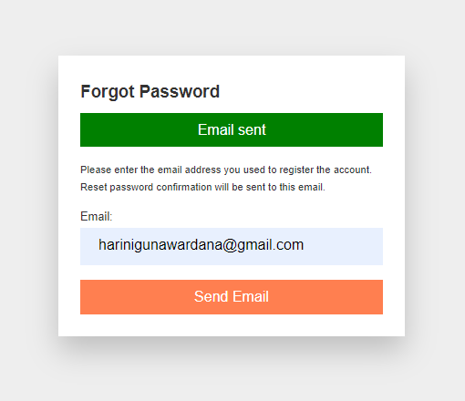

Reset Password

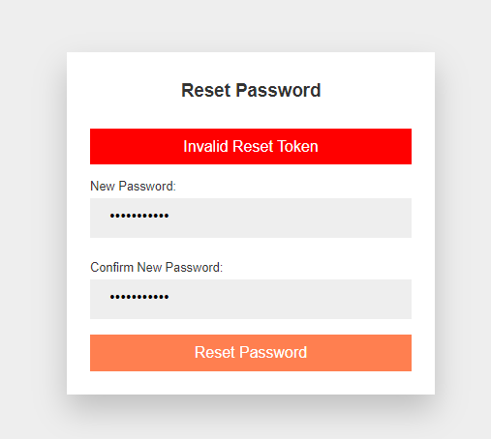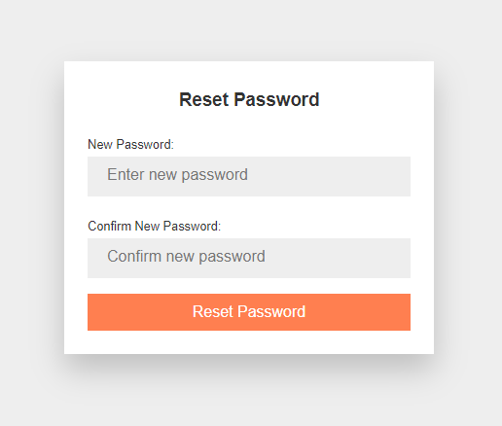

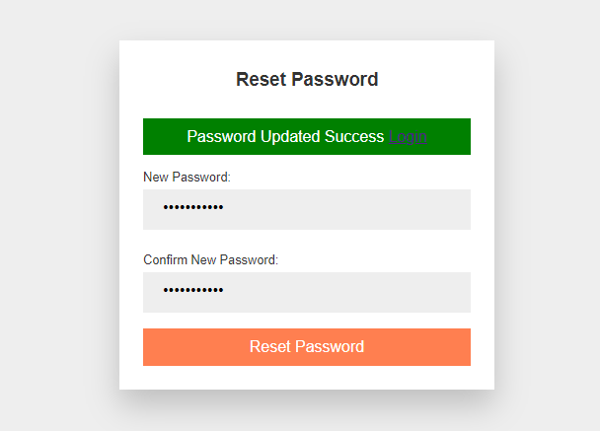

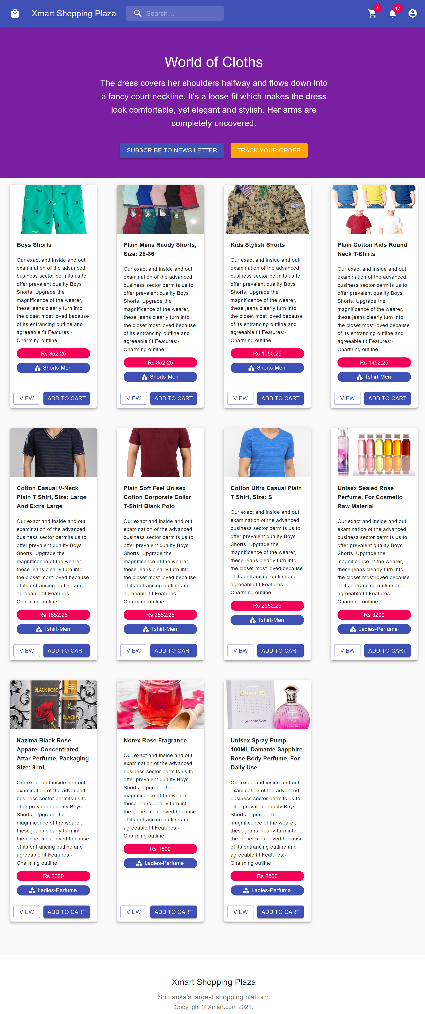

Search products

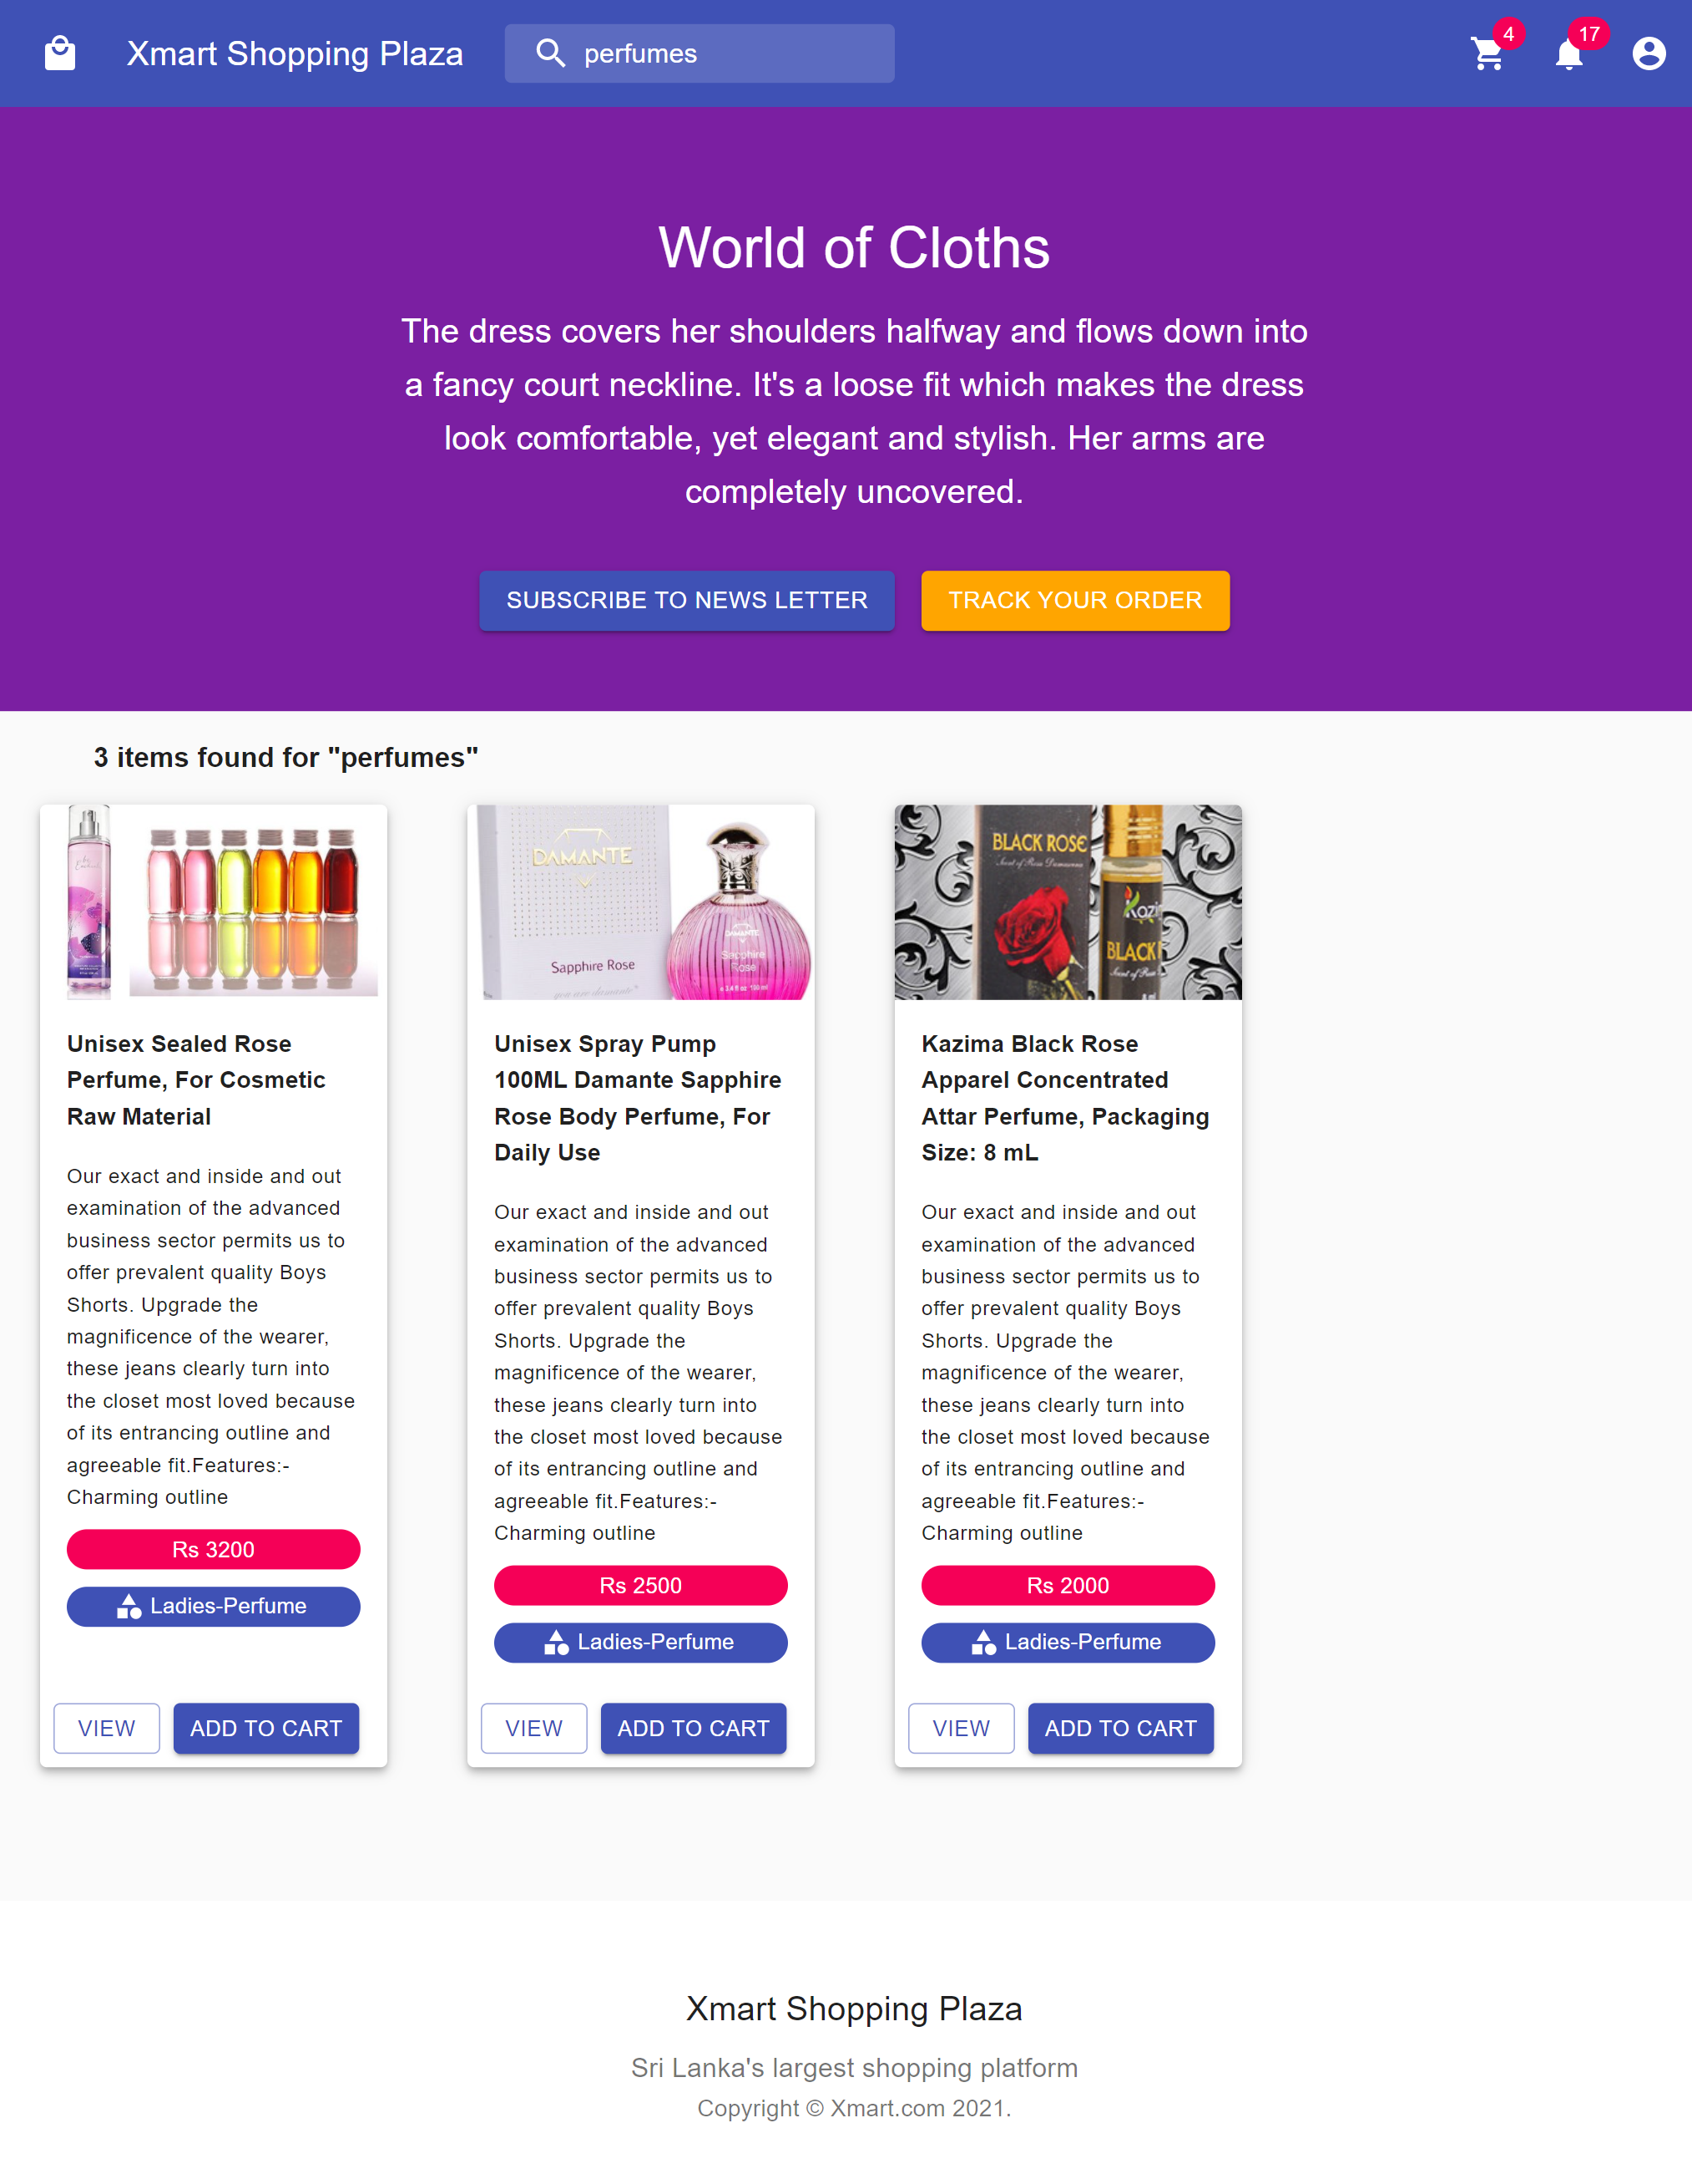

View product

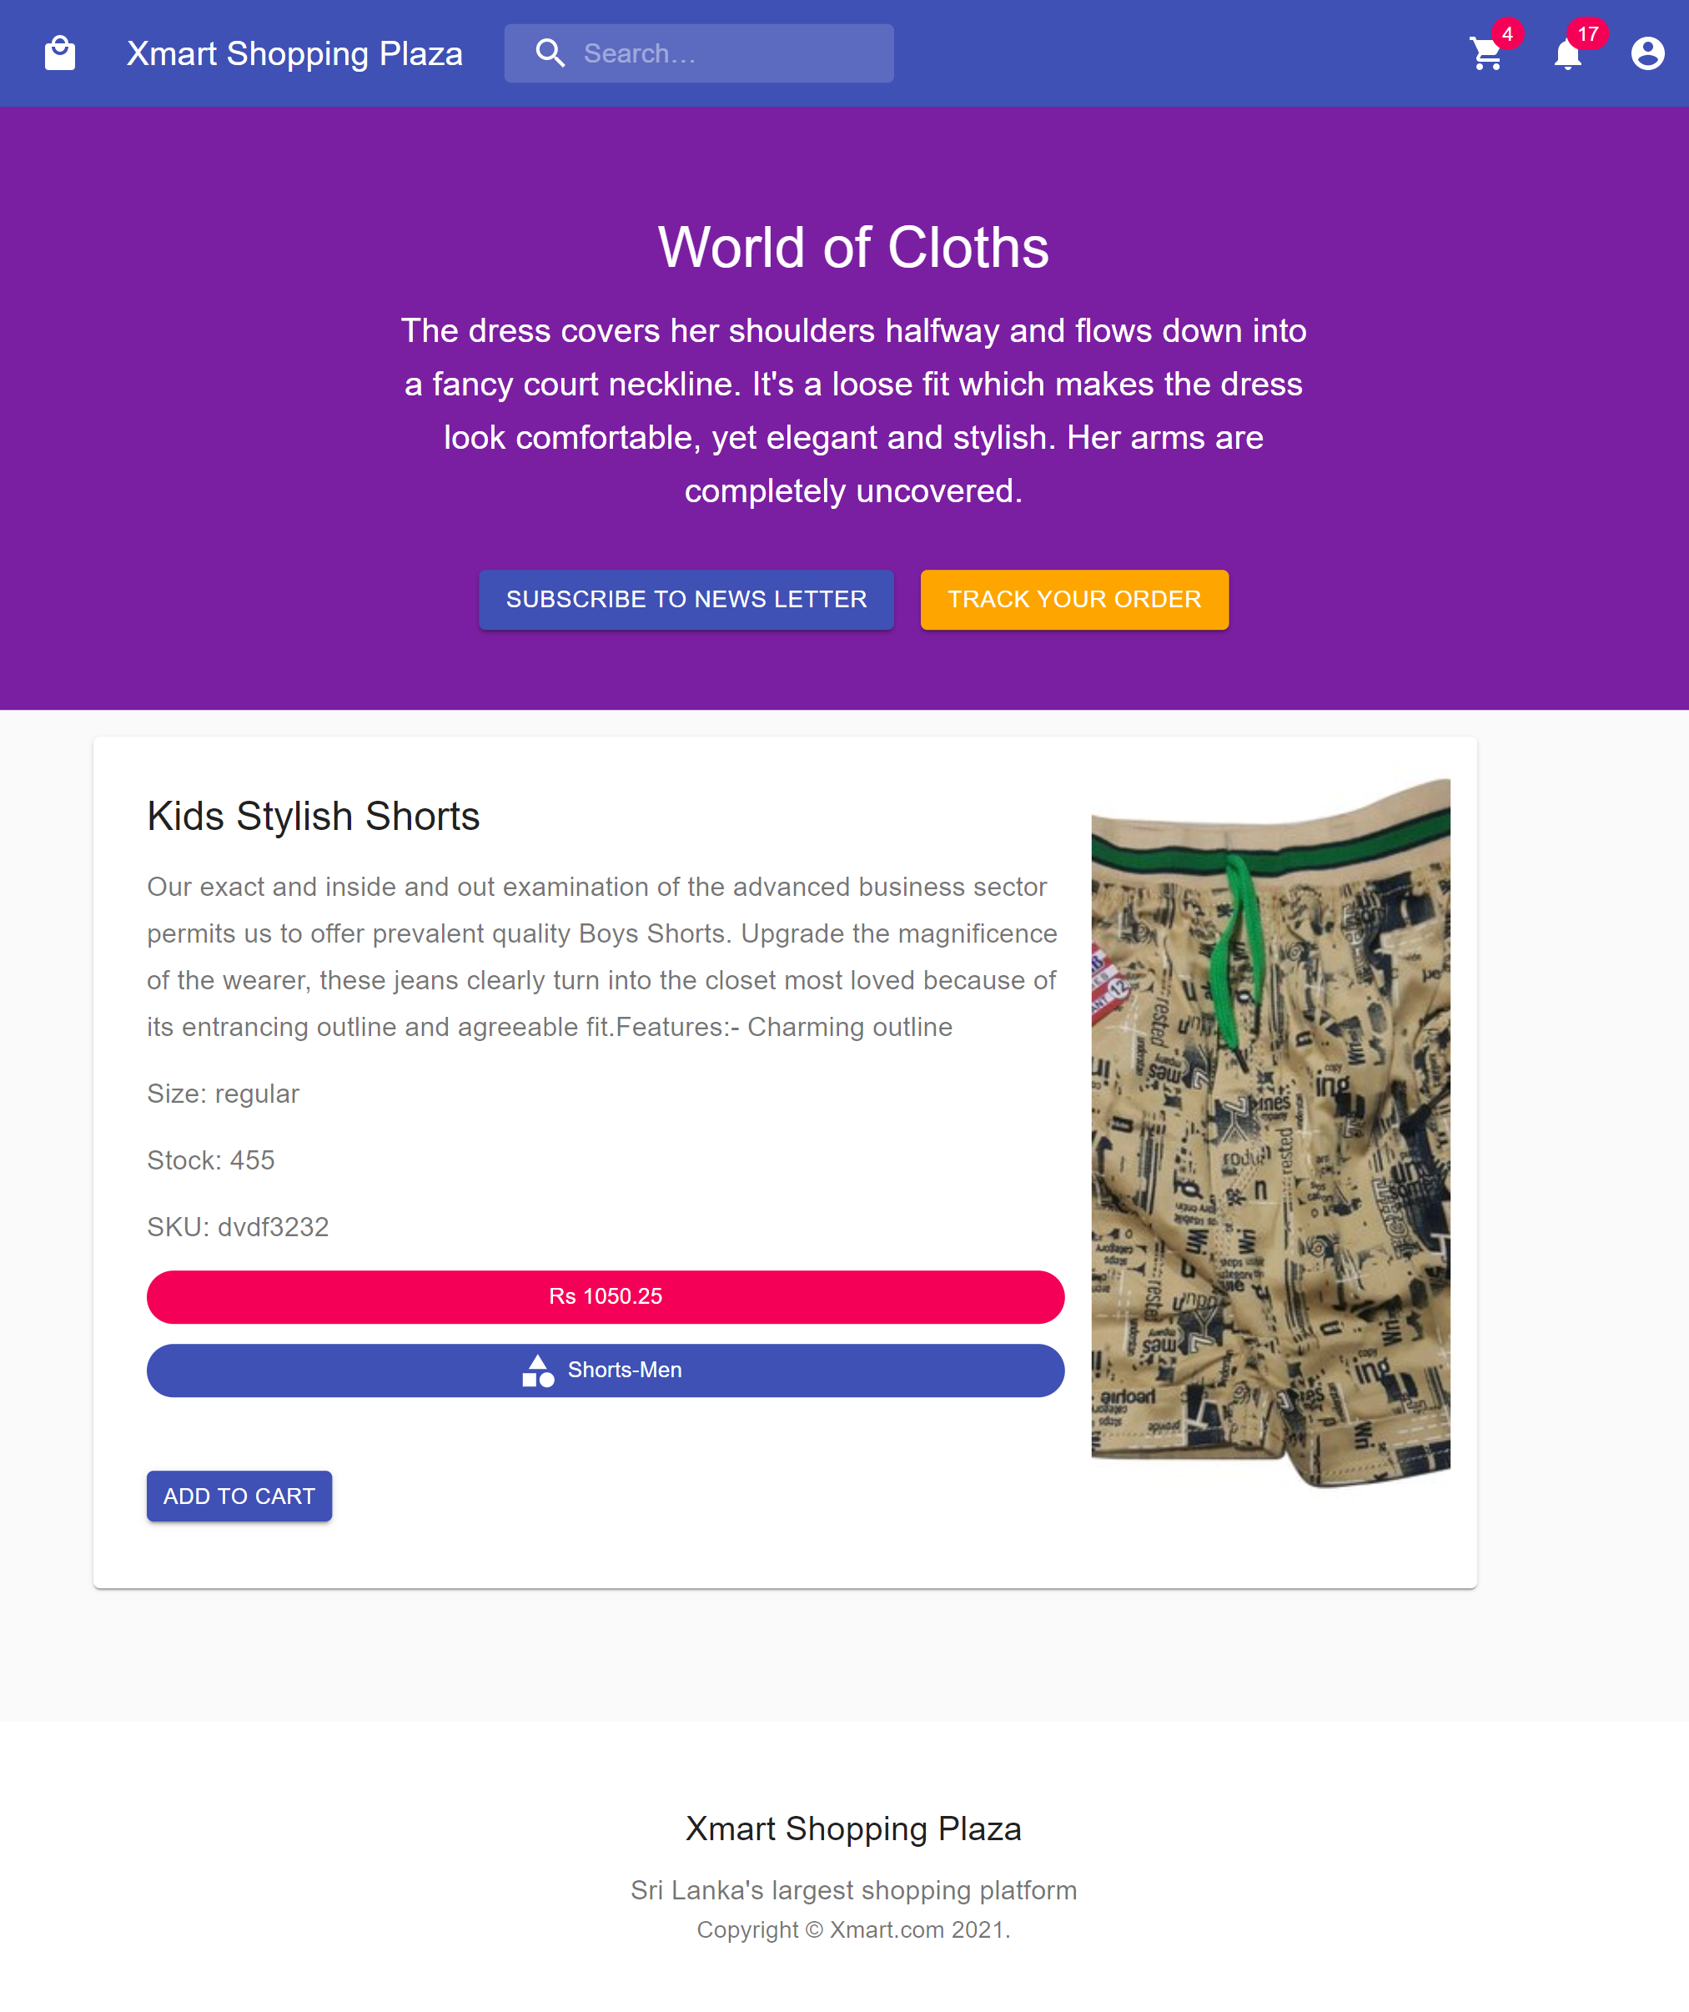

Add to cart

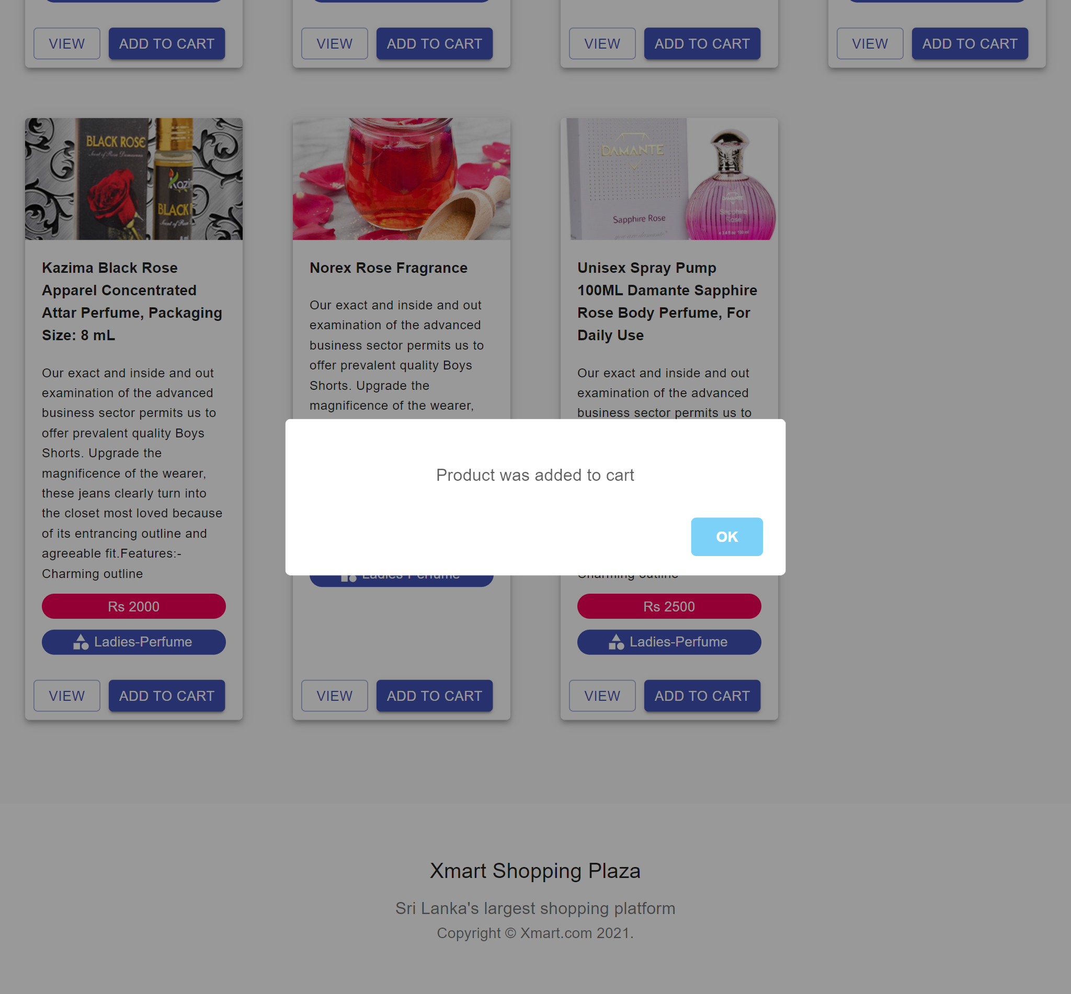

Shopping cart

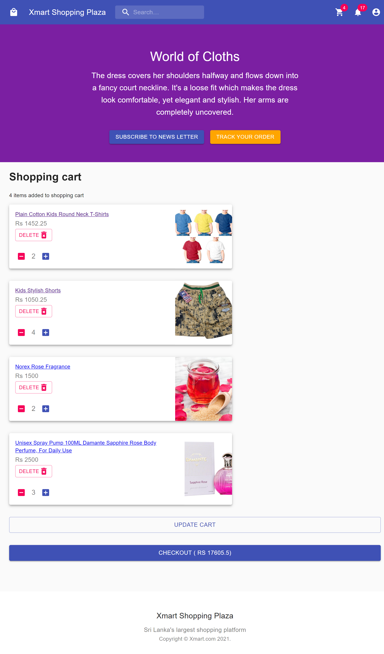

Order details

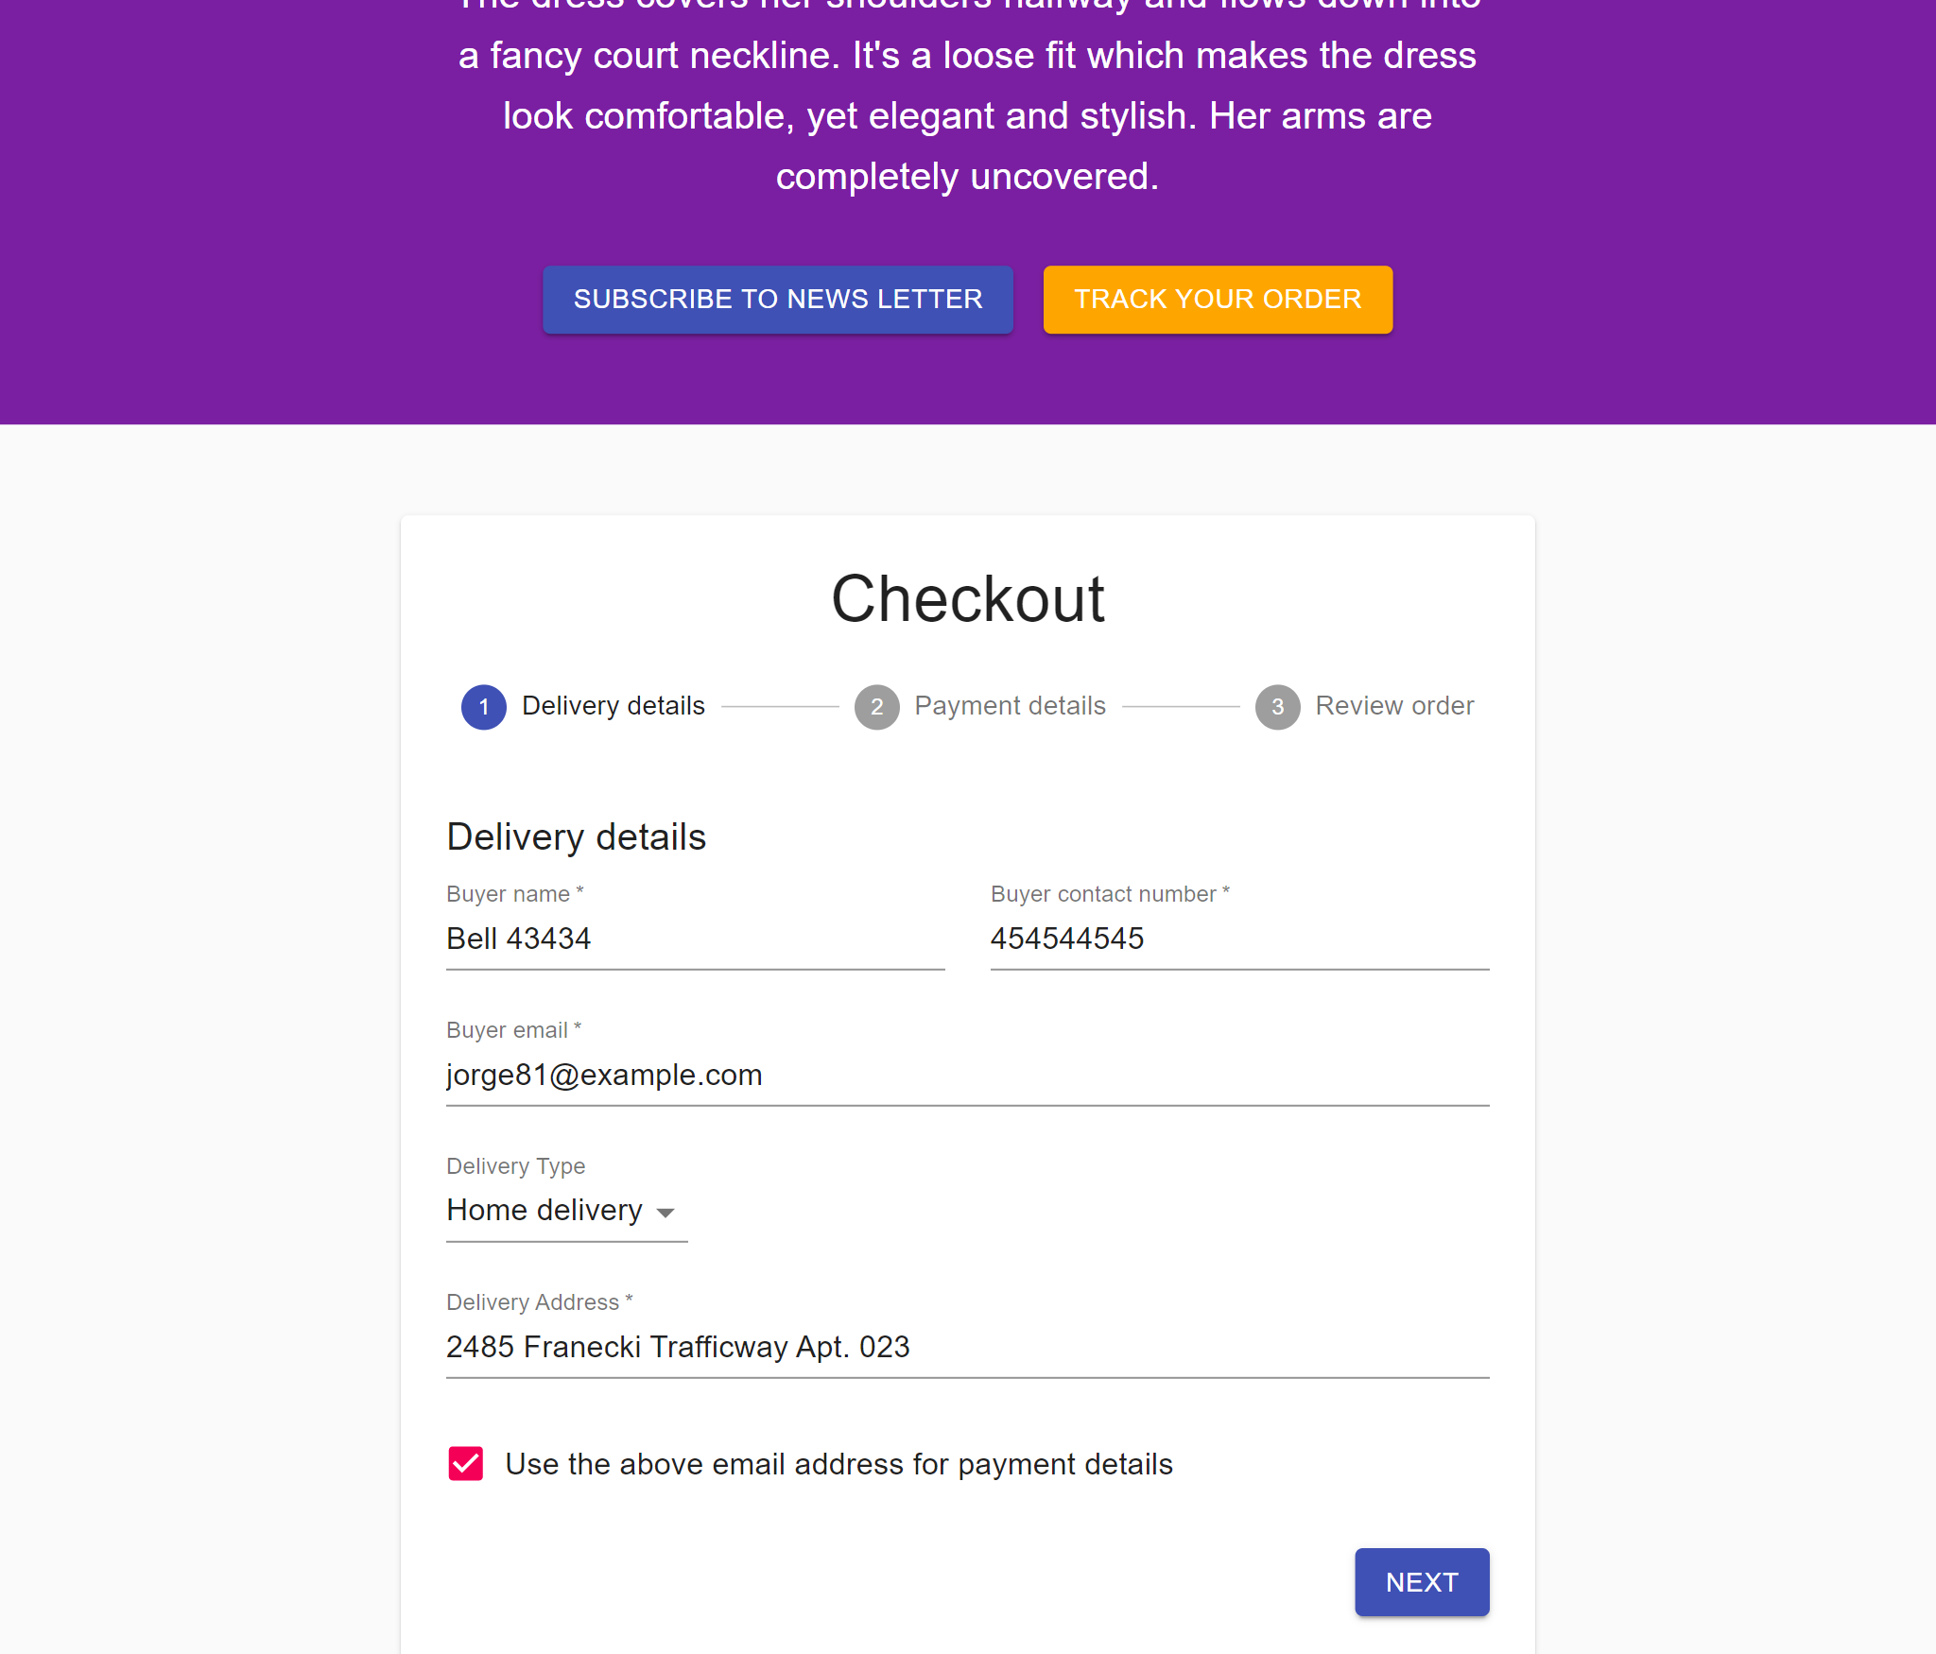

Payment credit card

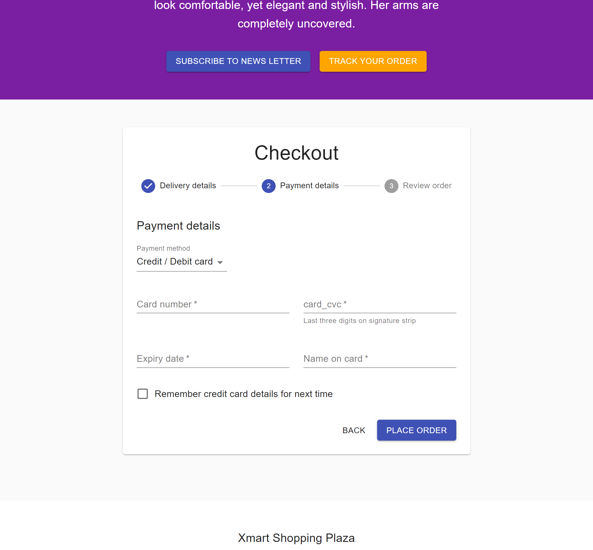

Payment mobile

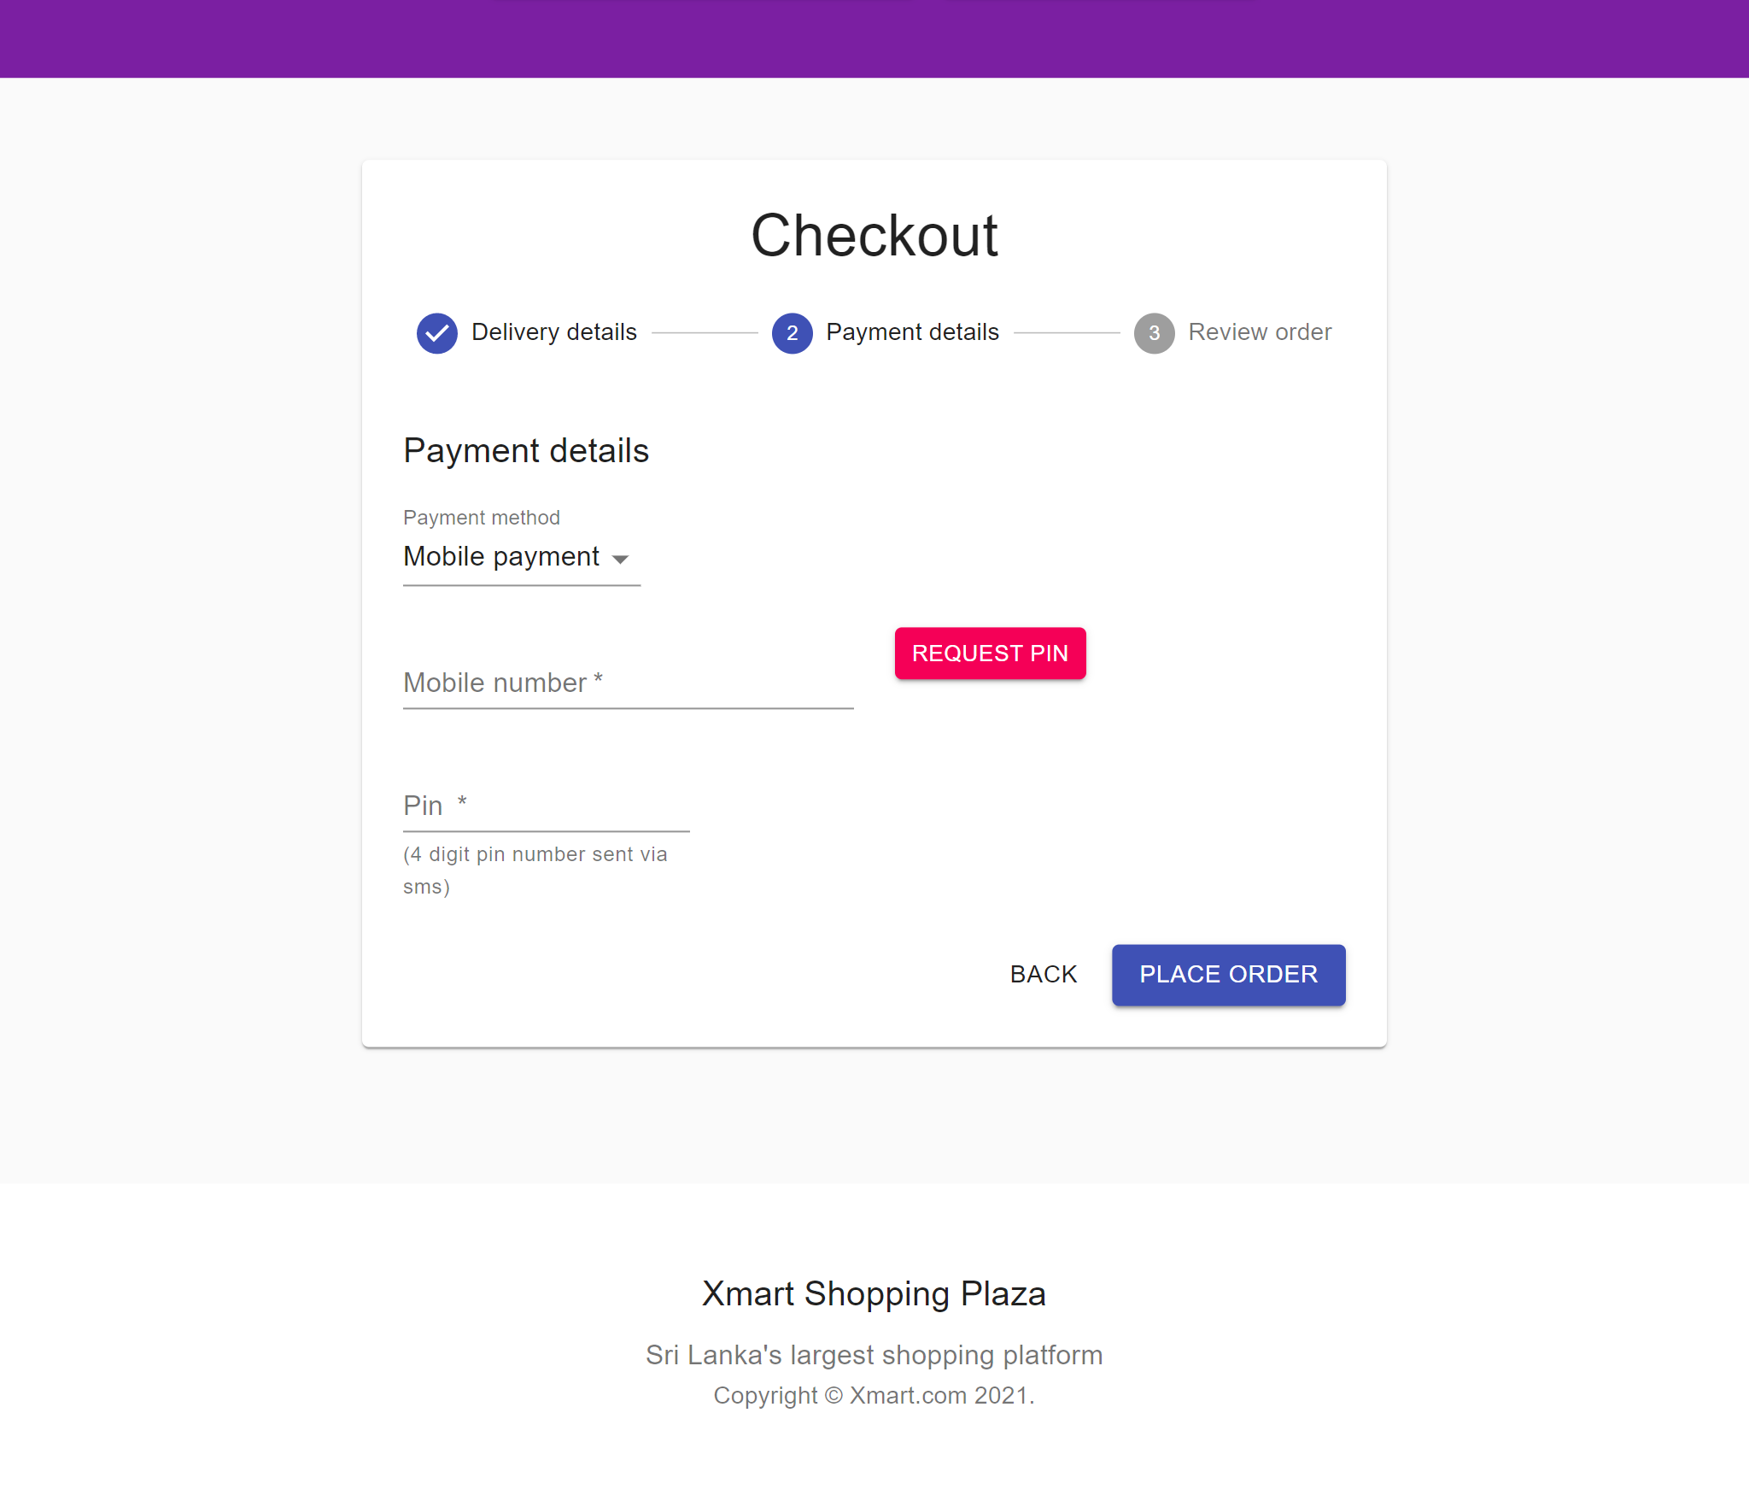

Validators

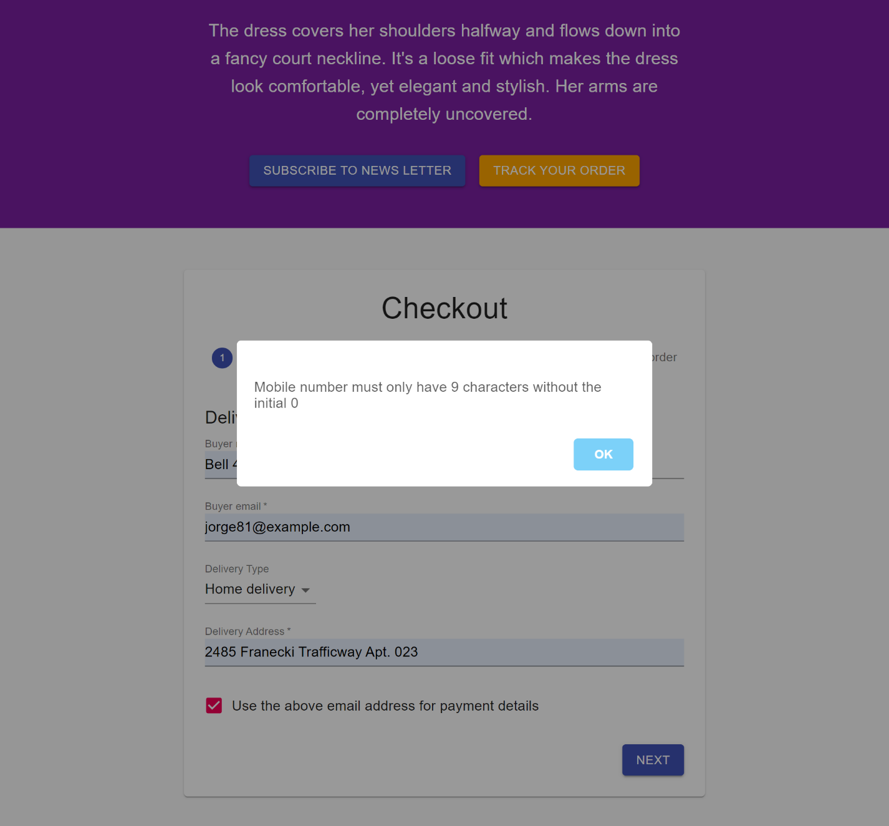

Payment cash on delivery

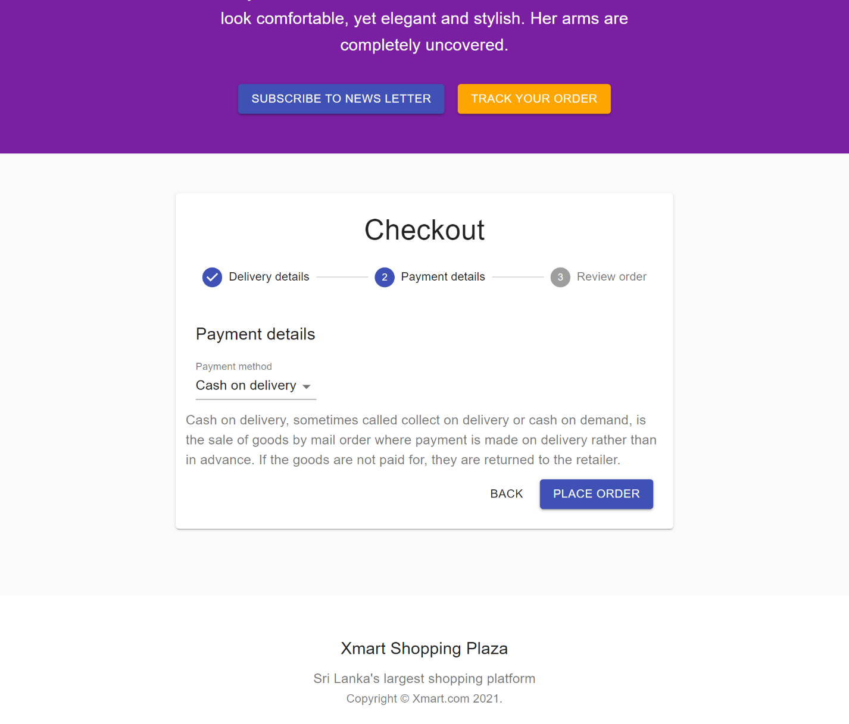

Order success

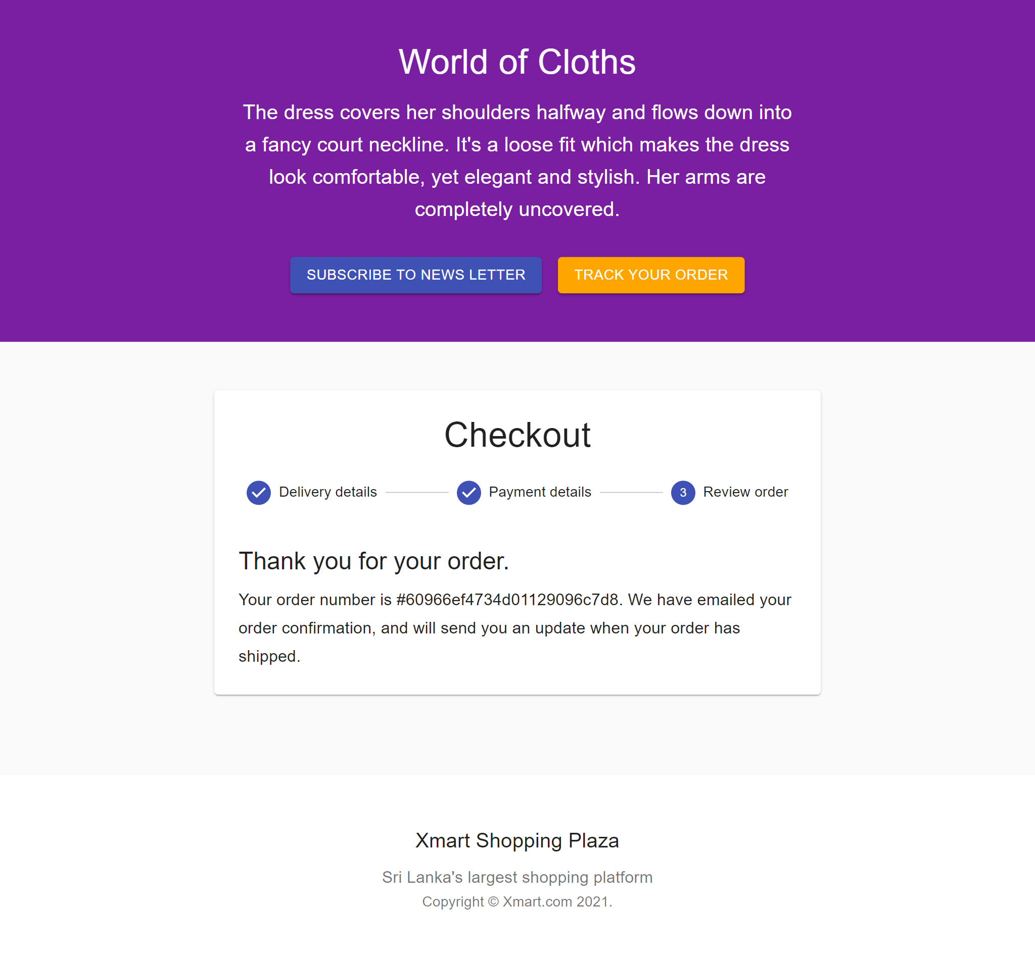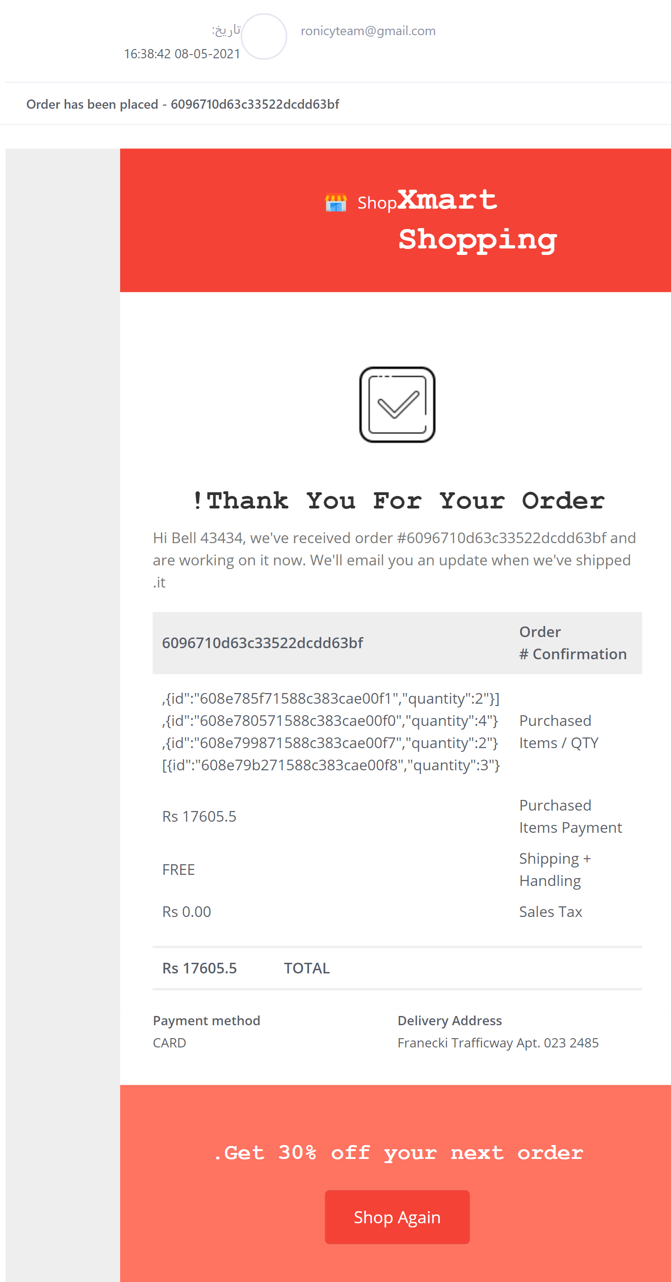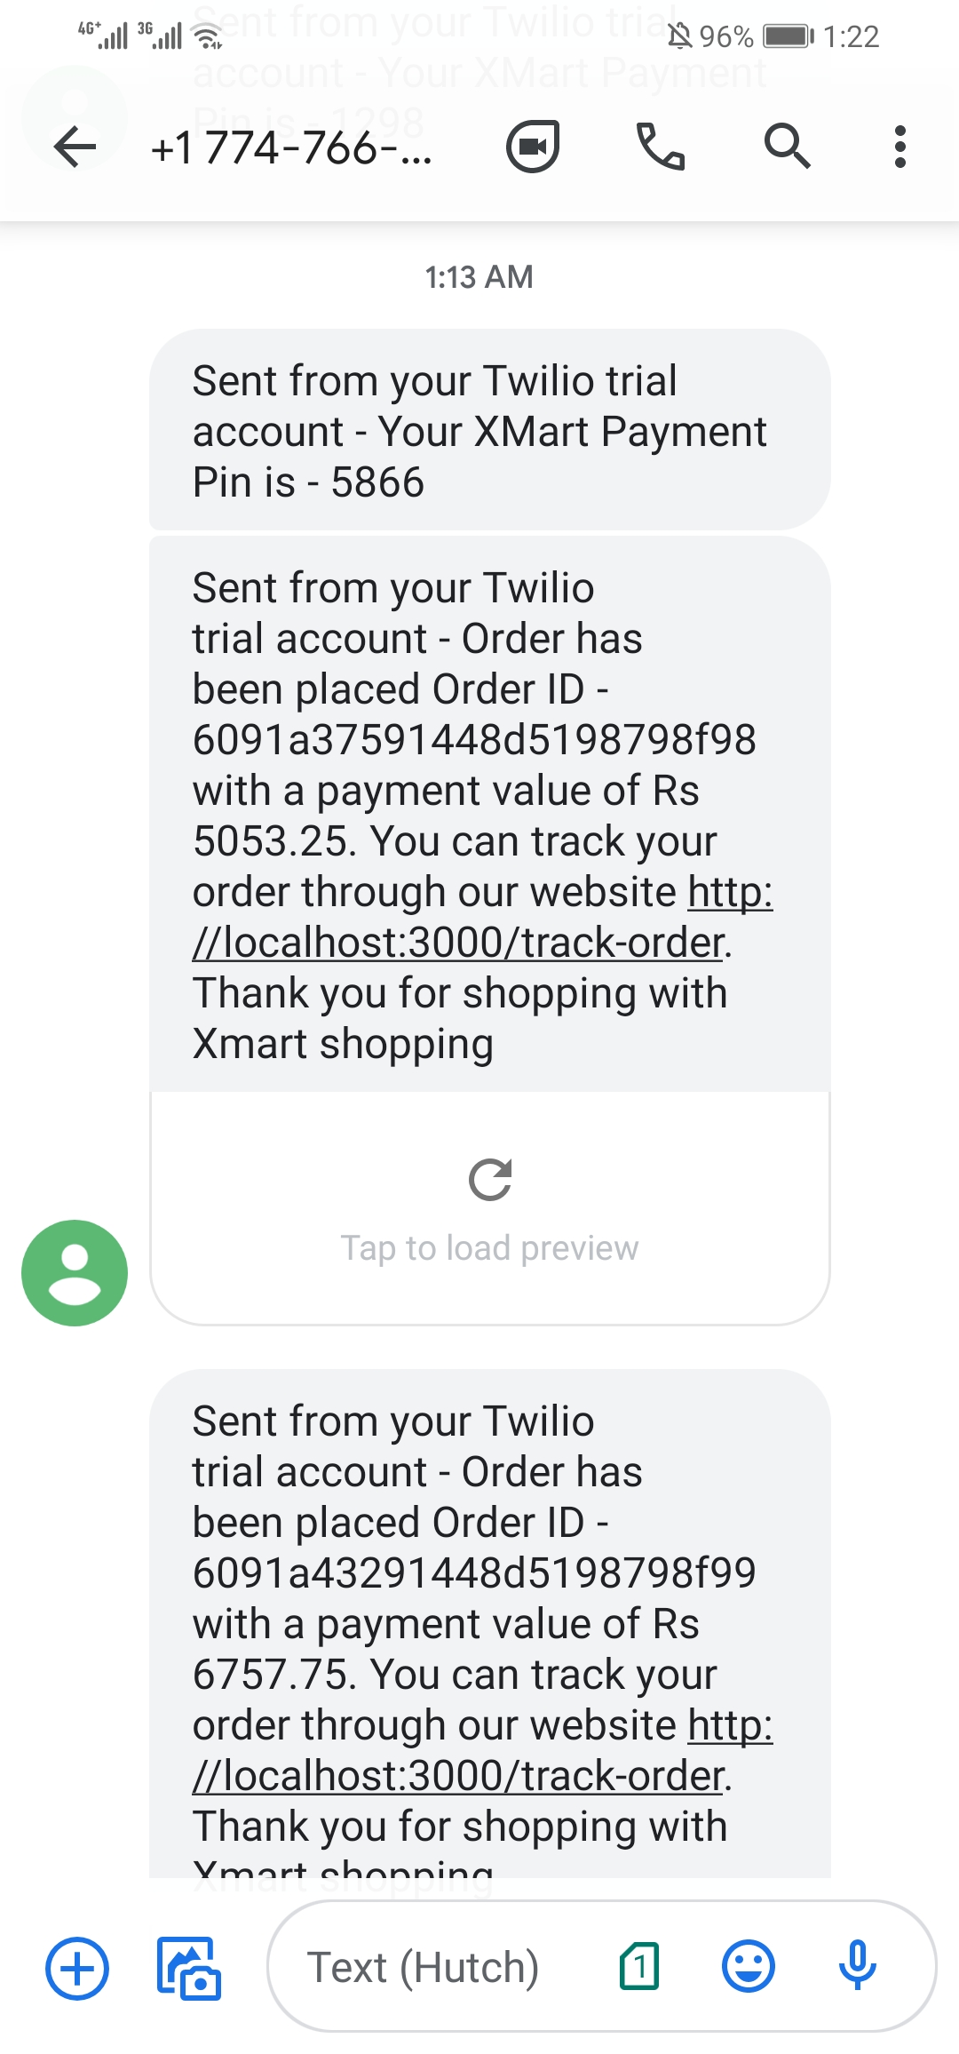

Seller dashboard list products

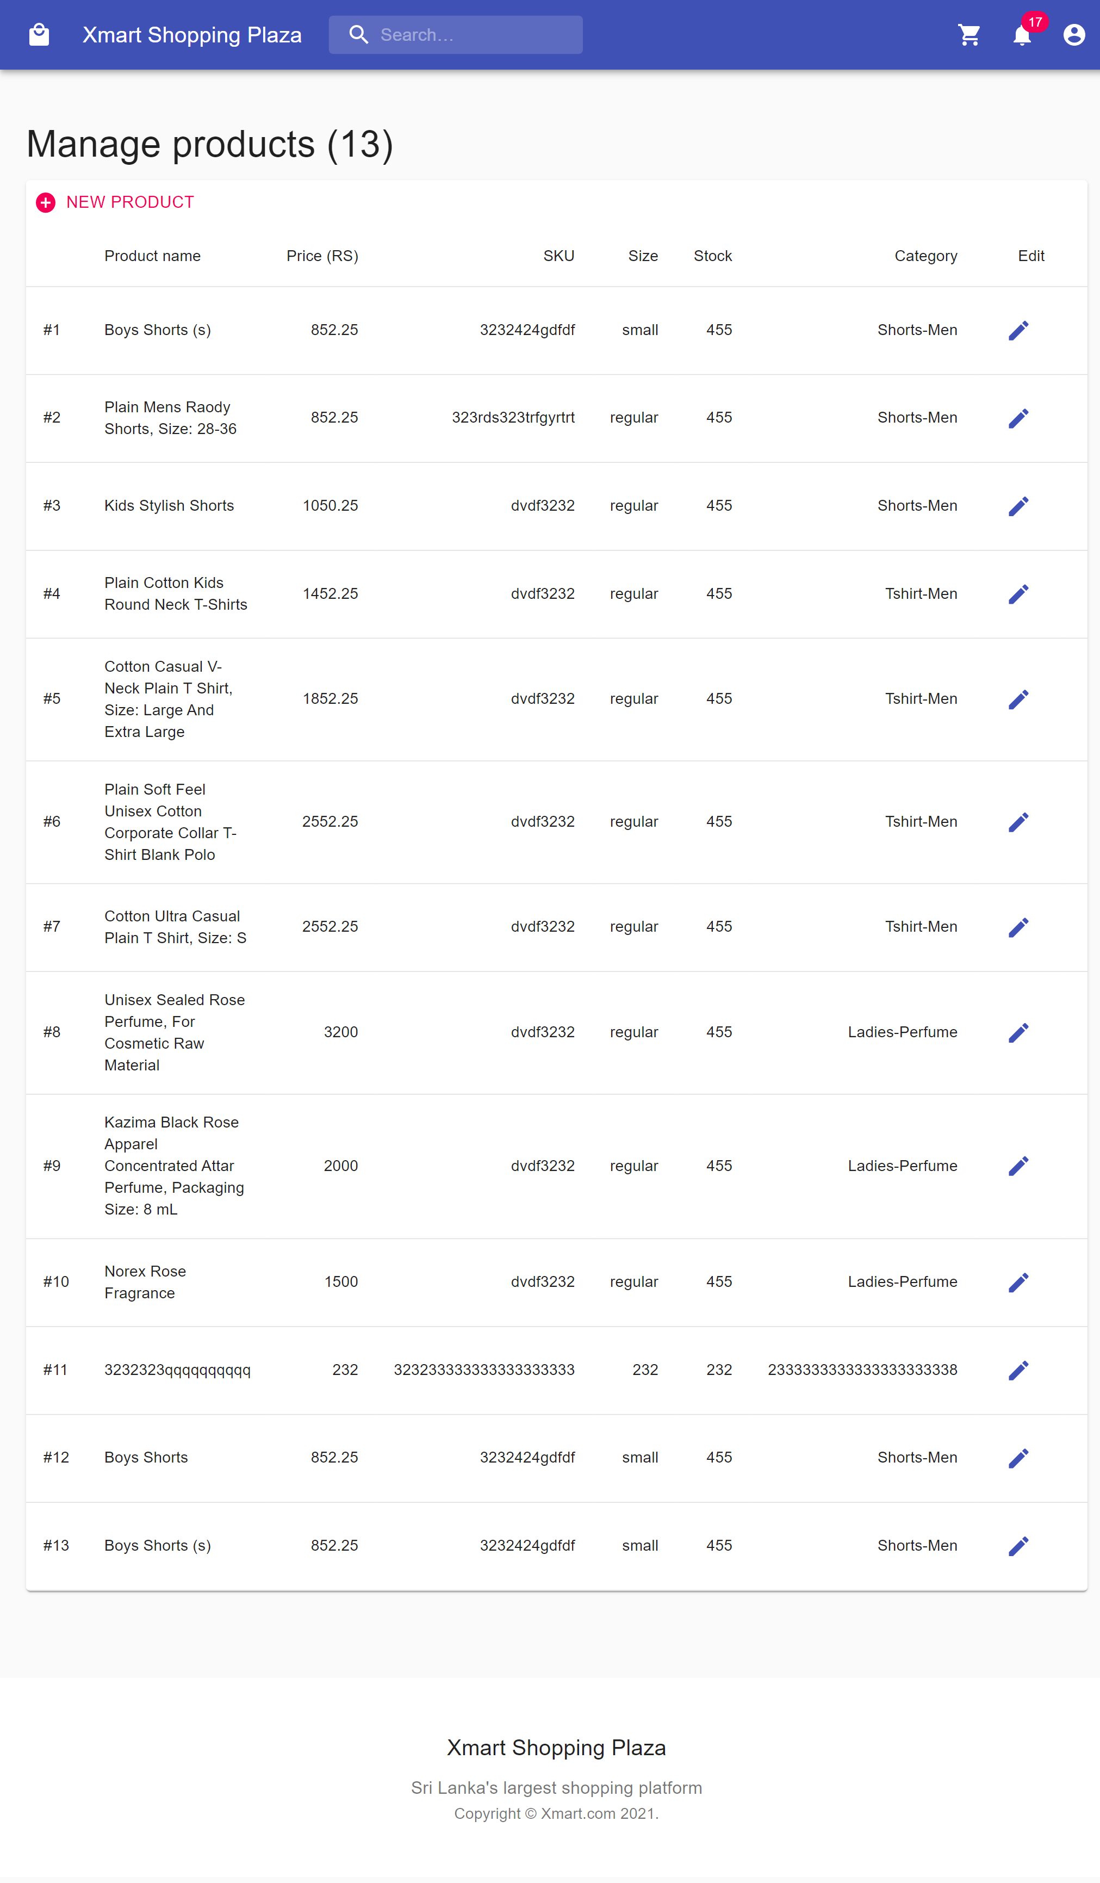

Seller dashboard add products

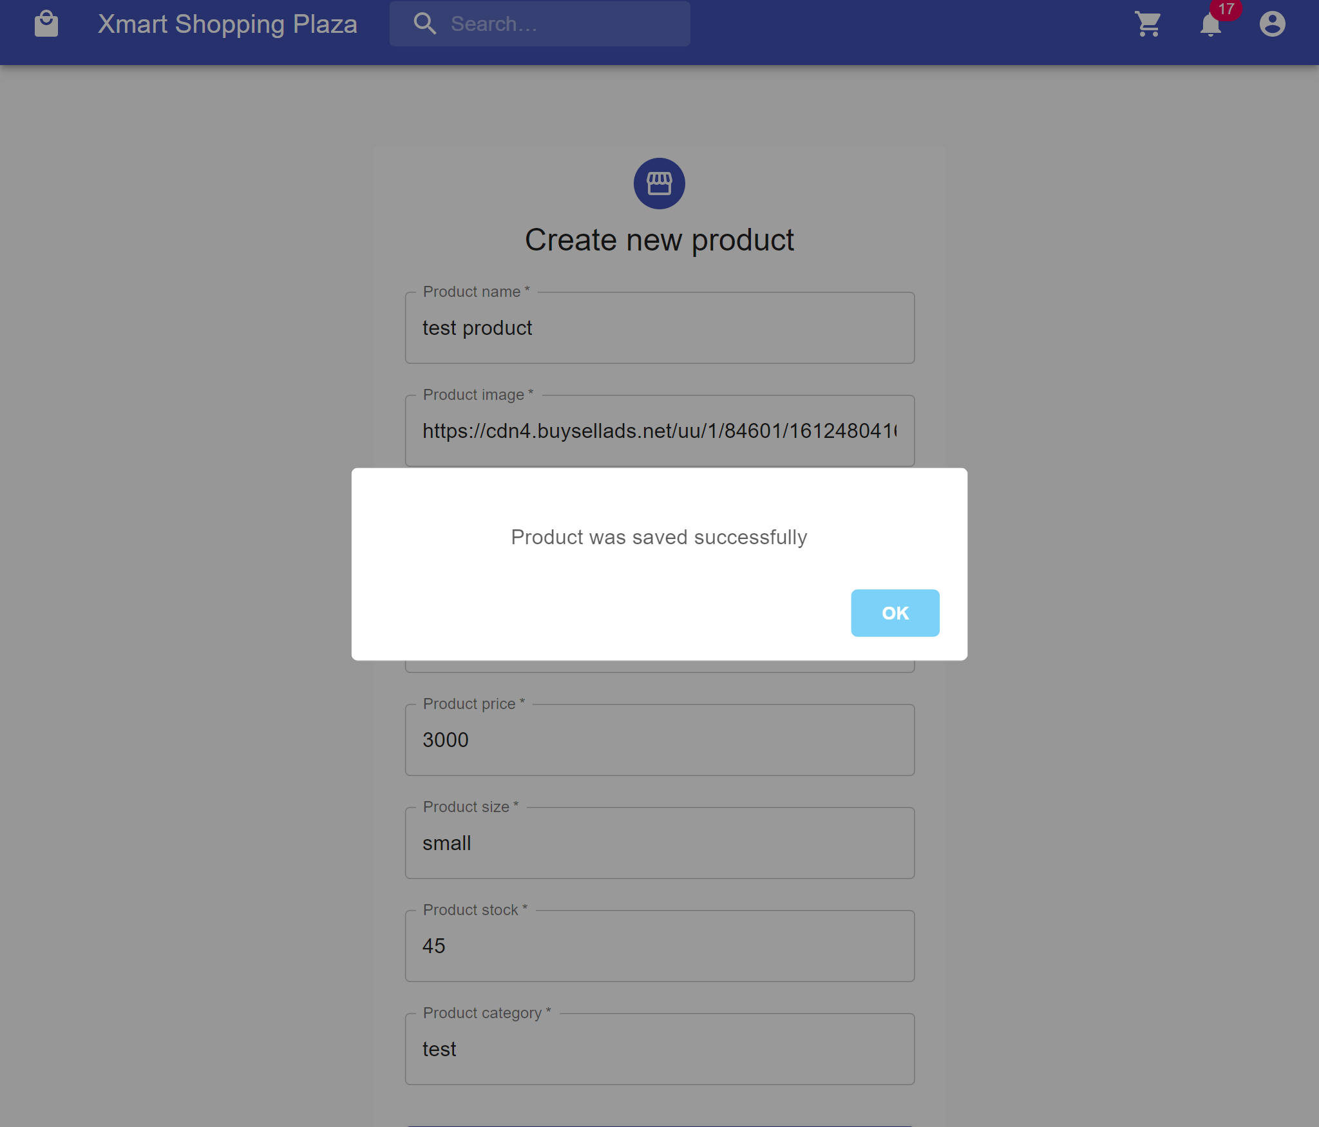

Seller dashboard update products

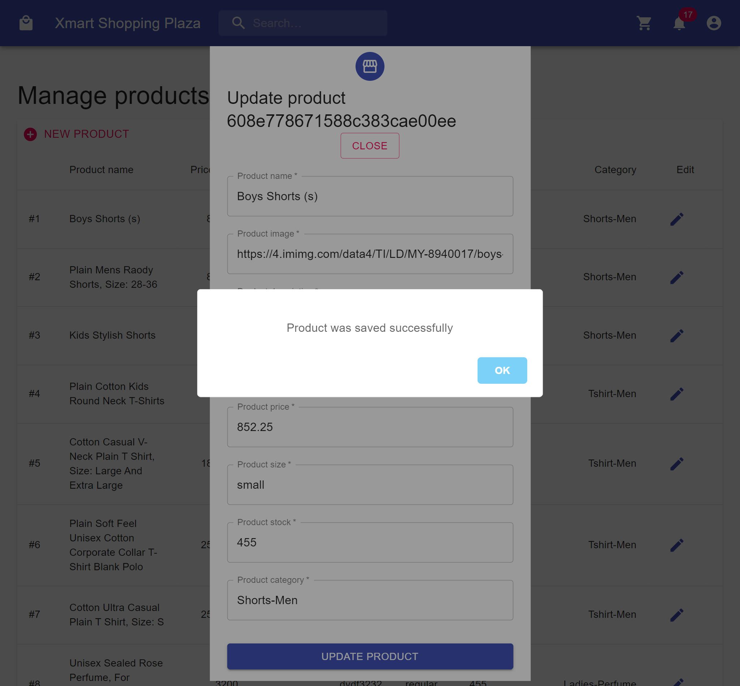

Delivery dashboard login

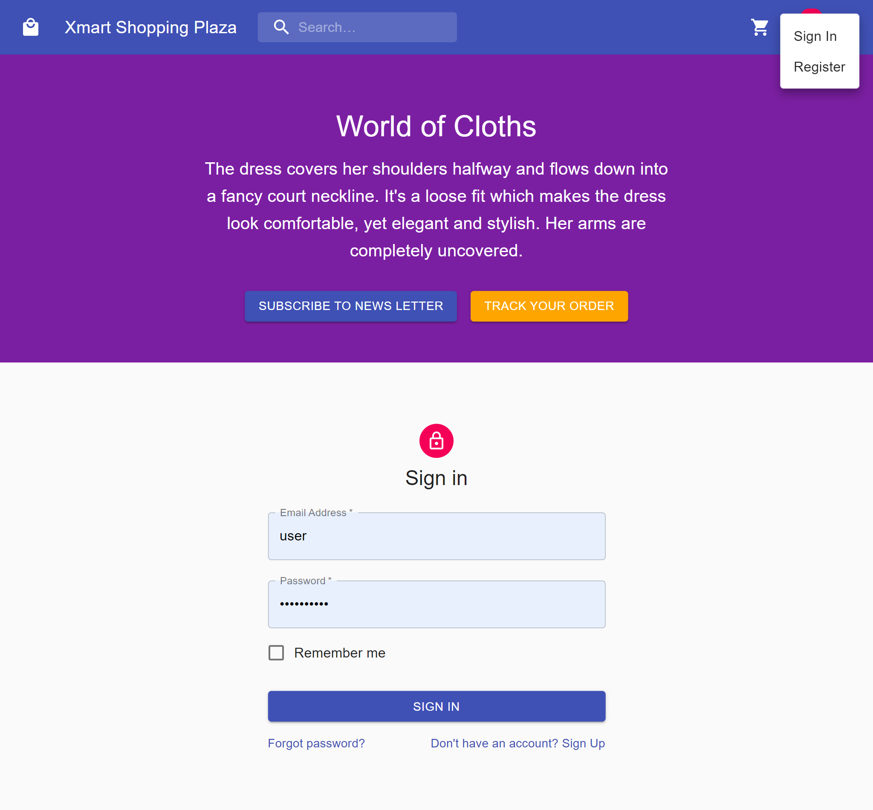

Delivery dashboard register

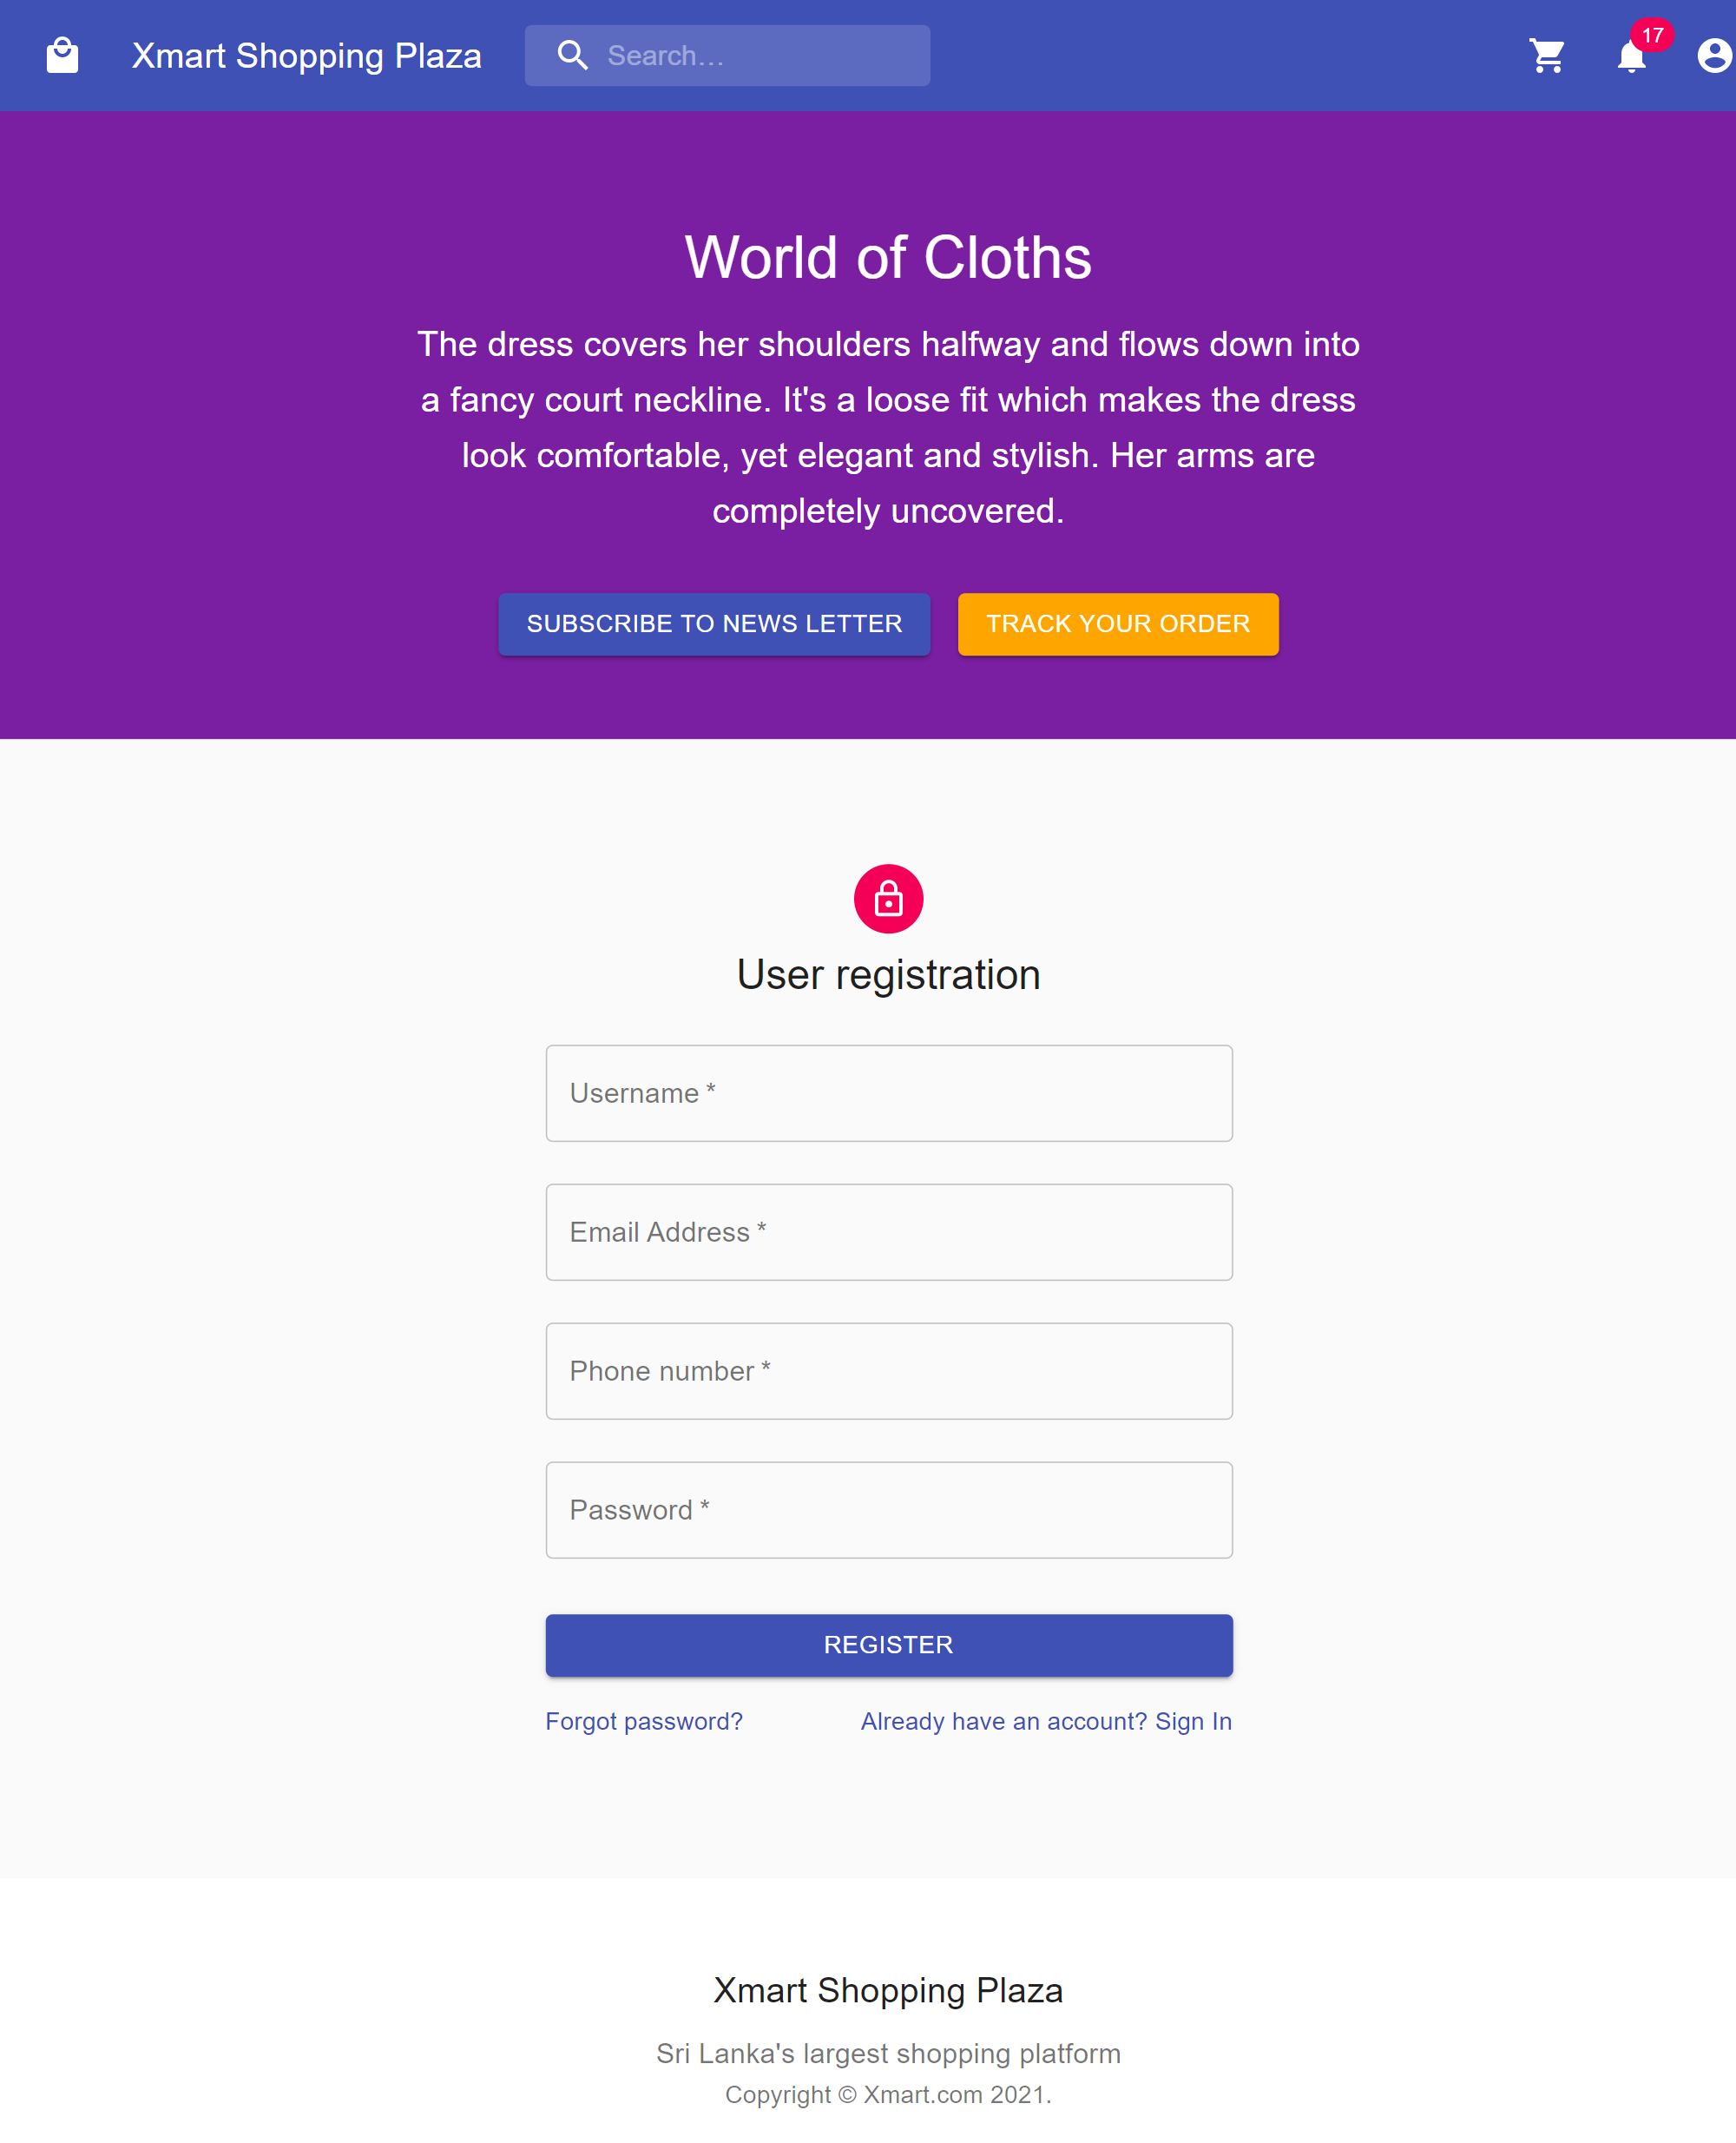

Delivery dashboard list delivery

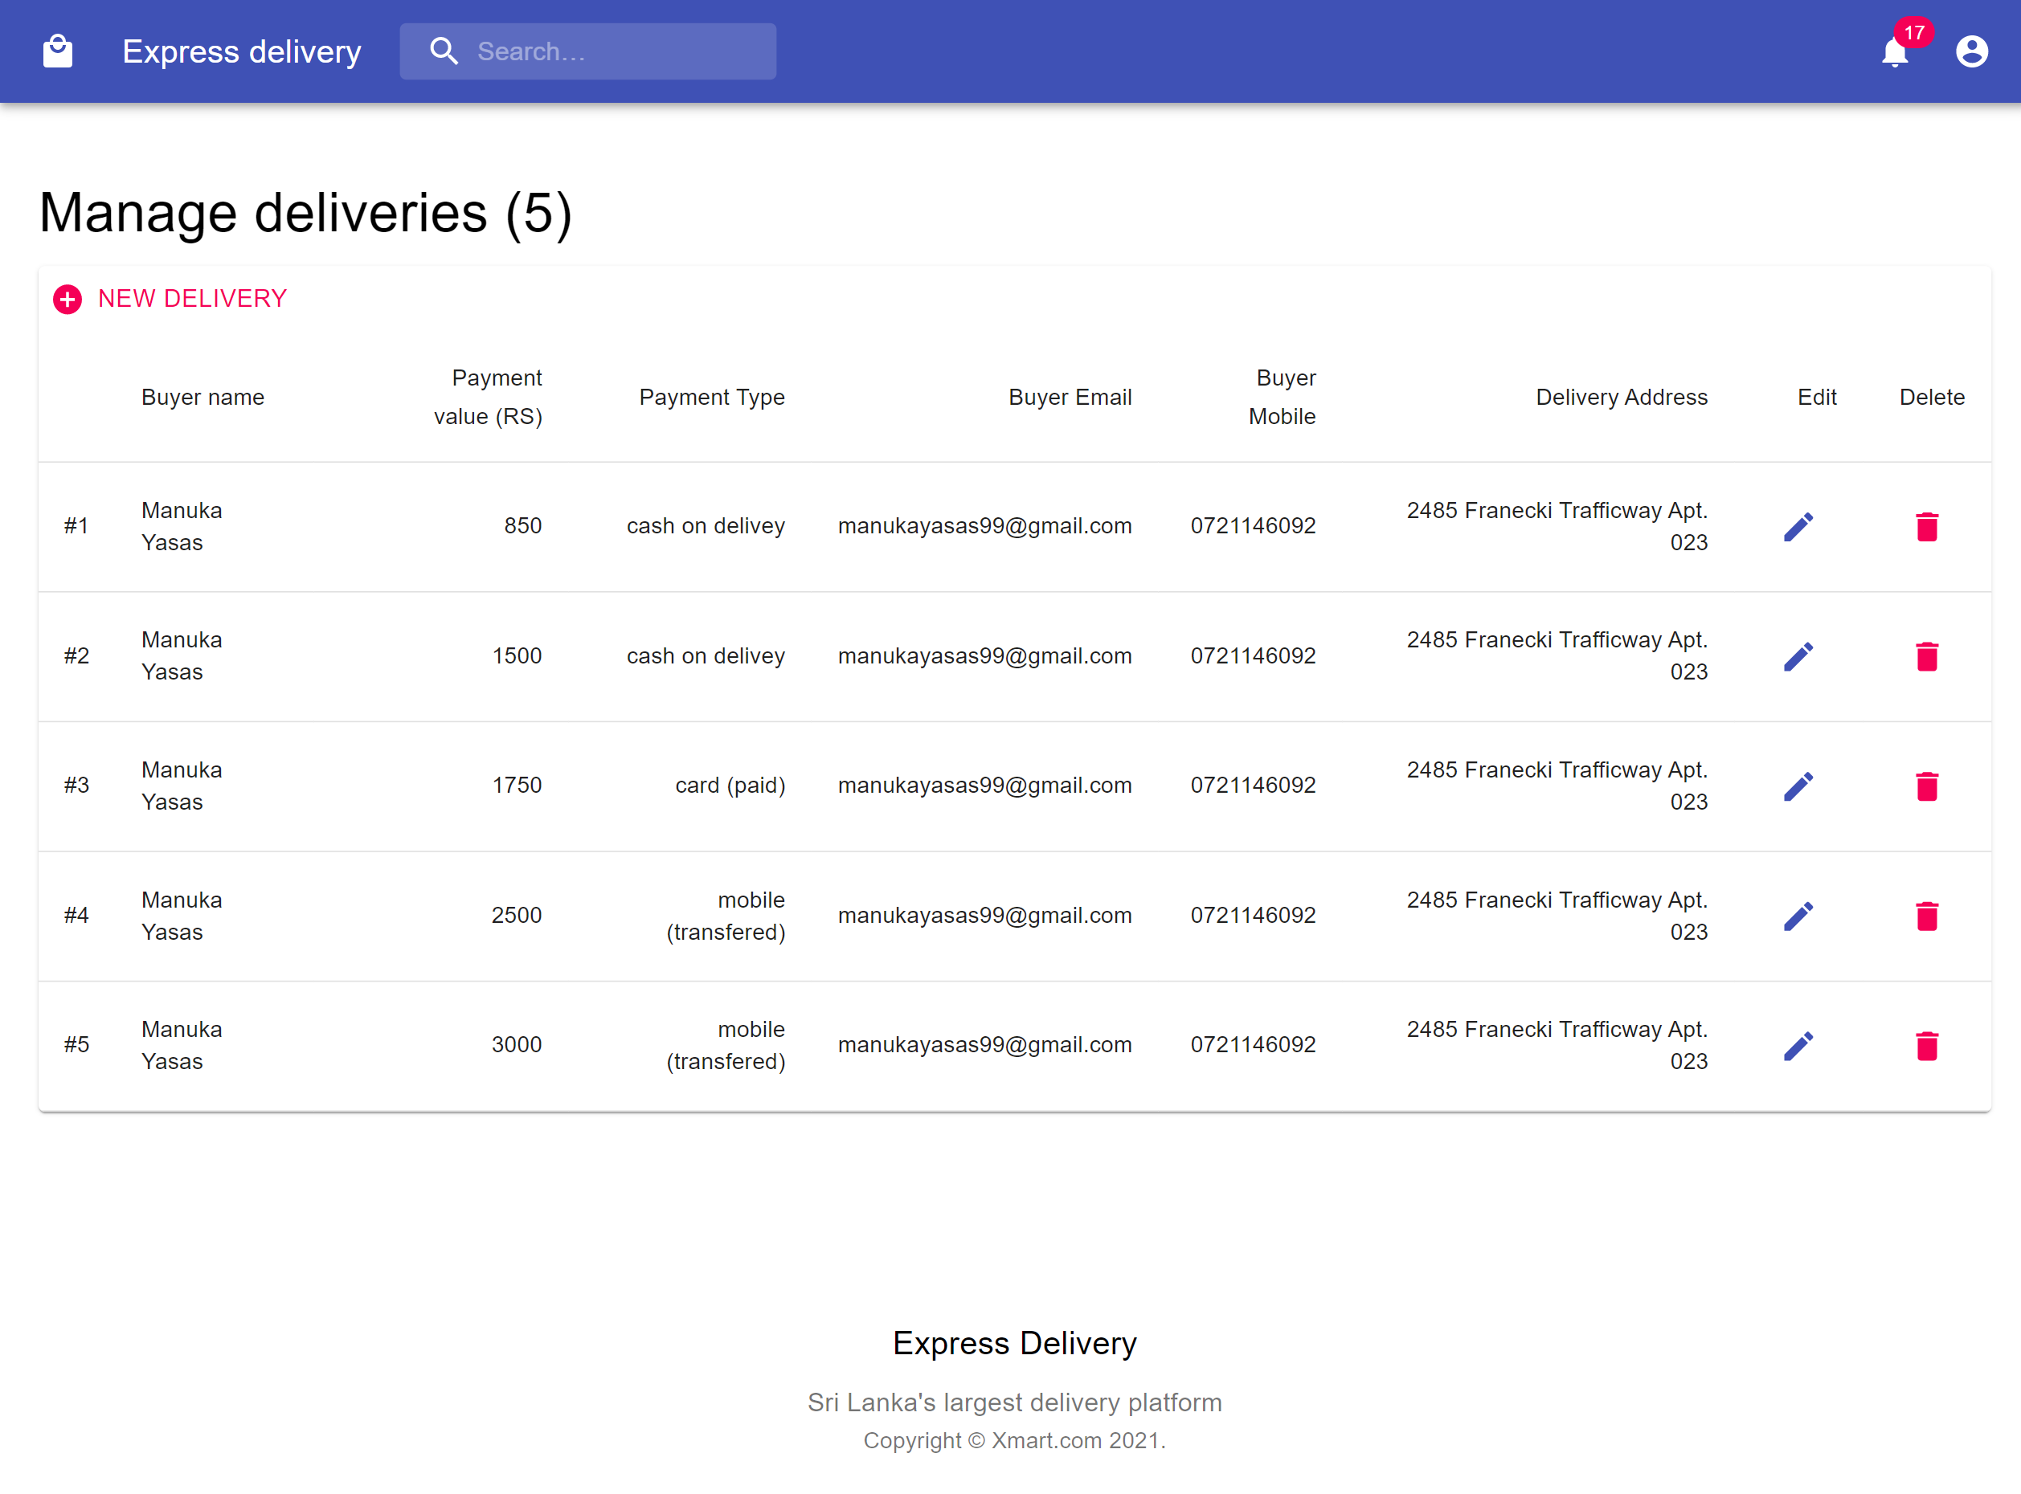

Delivery dashboard add delivery

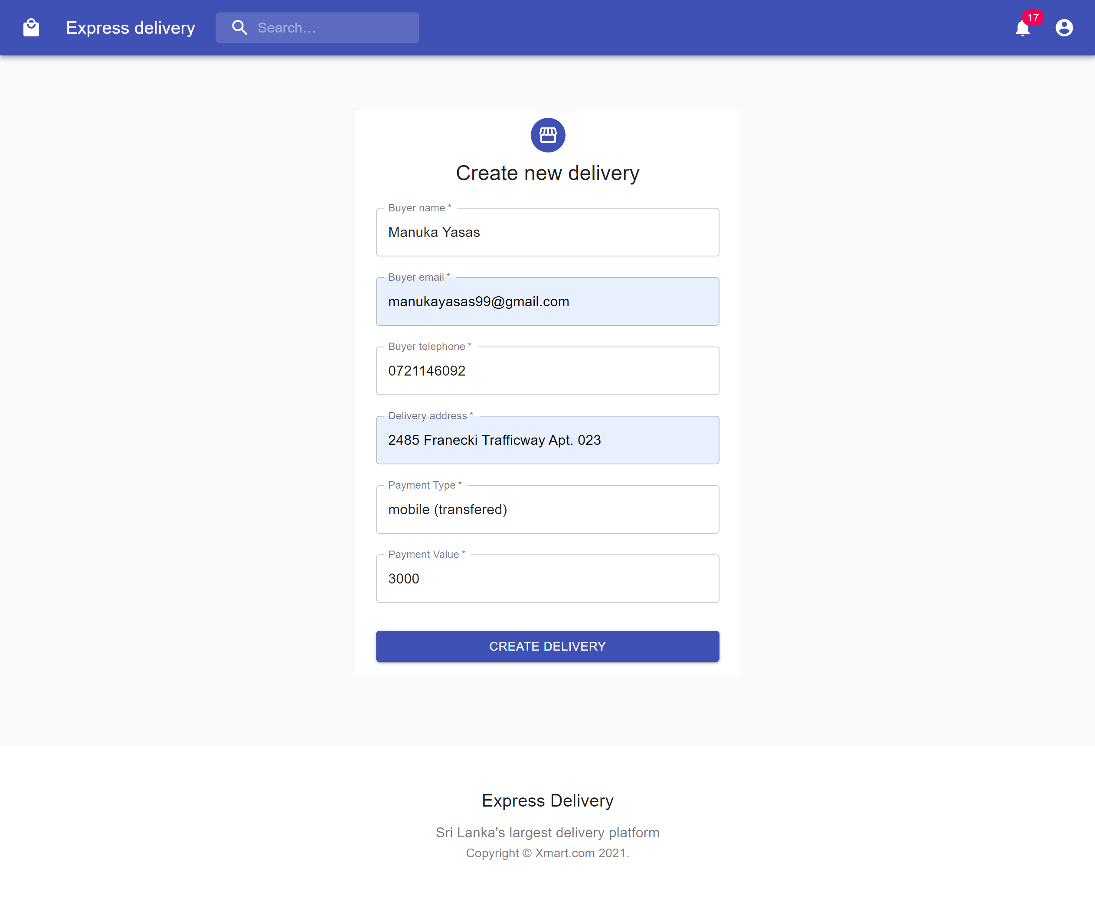

Delivery dashboard update delivery

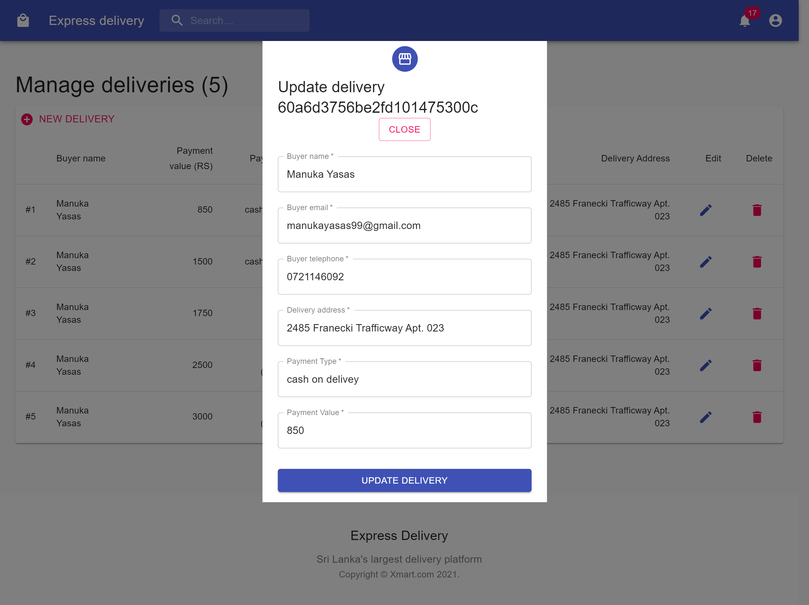

Track order

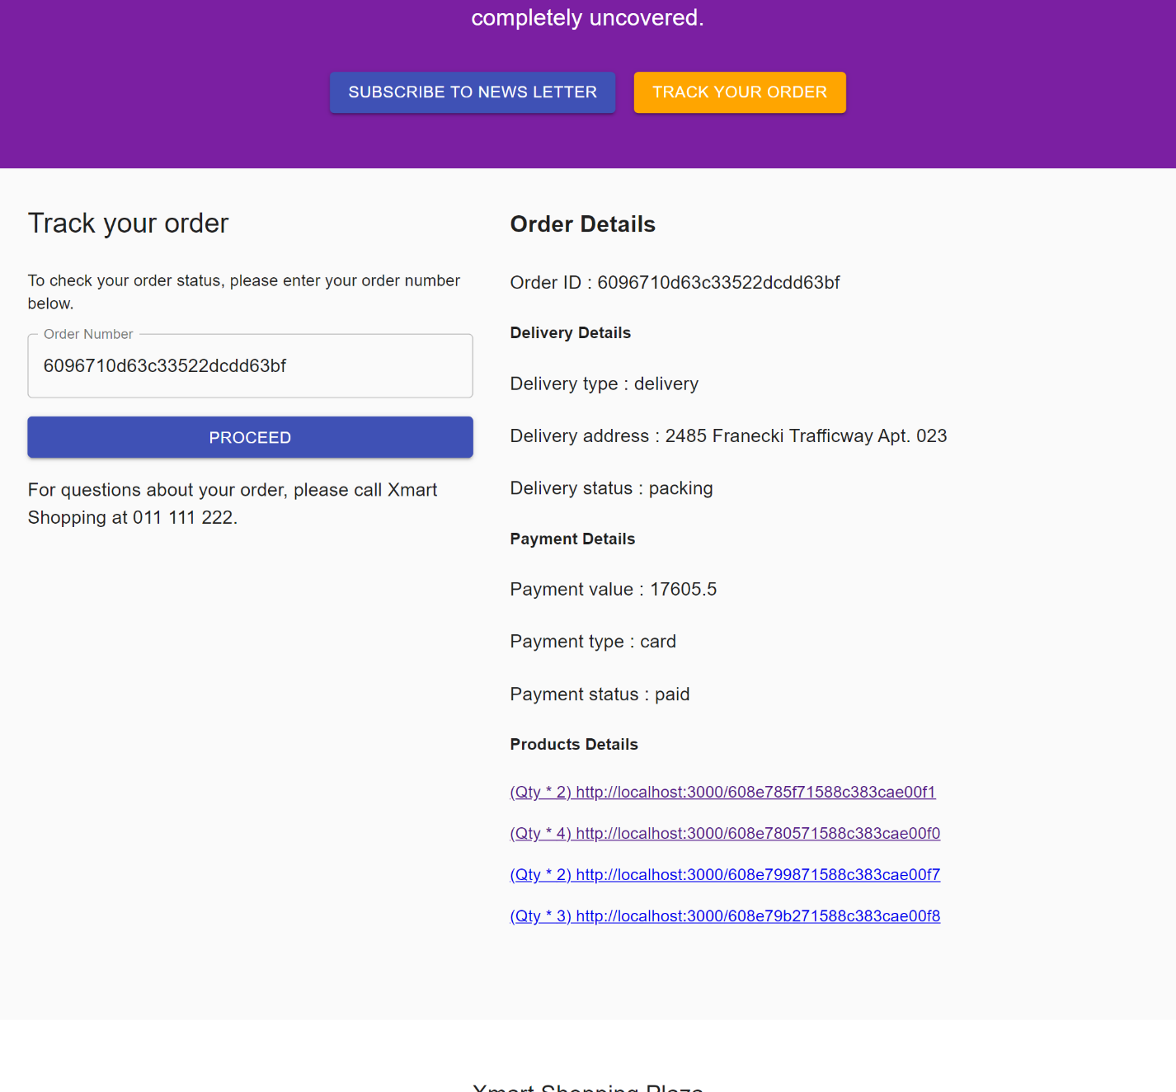

# Appendix

## Rest Services

### Authentication service

**server.js**

require('dotenv').config({path:"./config.env"});

const express = require ("express");

const connectDB = require ('./config/db');

const errorHandler = require('./middleware/error');

// Connect DB

connectDB();

const app = express();

app.use(express.json());

app.use('/api/auth/',require('./routes/auth_rou'));

app.use('/api/private/',require('./routes/private_rou'));

// Error Handler  middleware

app.use(errorHandler);

const PORT = process.env.PORT || 5000;

const server = app.listen(PORT,() => console.log ('Server running on port '+PORT));

process.on("unhandledRejection",(err, promise) => {

    console.log('Logged Error:' +err);

    server.close (() => process.exit (1) );

})

**Package.json**

{

  "name": "ds_project",

  "version": "1.0.0",

  "description": "",

  "main": "server.js",

  "scripts": {

    "start": "node server.js",

    "server": "nodemon server.js"

  },

  "keywords": [],

  "author": "Harini Gunawardana IT19215884",

  "license": "ISC",

  "dependencies": {

    "axios": "^0.21.1",

    "bcryptjs": "^2.4.3",

    "dotenv": "^8.2.0",

    "express": "^4.17.1",

    "jsonwebtoken": "^8.5.1",

    "mongoose": "^5.12.6",

    "nodemailer": "^6.6.0",

    "react-router-dom": "^5.2.0"

  },

  "devDependencies": {

    "nodemon": "^2.0.7"

  }

}

**Config/db.js**

const mongoose = require ('mongoose');

const connectDB = async() => {

    await mongoose.connect(process.env.MONGO_URI,{

        useNewUrlParser: true,

        useCreateIndex: true,

        useUnifiedTopology: true,

        useFindAndModify: true,

    });

    console.log(" MongoDB Connected");

};

    module.exports = connectDB;

**Controller/auth.js**

const crypto = require("crypto");

const User = require("../models/User");

const sendEmail = require("../utils/sendEmail");

exports.register = async (req, res) => {

  // Register

  const {

    firstname,

    lastname,

    username,

    email,

    telephone,

    password,

    userrole,

  } = req.body; //Register

  try {

    const user = await User.findOne({ email }); // check wheather there is a user with the requested email

    if (!user) {

      const user = await User.create({

        firstname,

        lastname,

        username,

        email,

        telephone,

        password,

        userrole,

      }); //if not, create the user

      sendToken(user, 201, res);

    } else {

      return res

        .status(400)

        .json({

          success: false,

          error: "Email in use. Please provide new email",

        });

    }

  } catch (error) {

    console.log(error);

  }

};

exports.login = async (req, res) => {

  //Login

  const { email, password } = req.body; // check that email and password are provided

  if (!email || !password) {

    return res

      .status(422)

      .json({ success: false, error: "Please provide email and password" }); // bad request

  }

  try {

    const user = await User.findOne({ email }).select("+password"); // check that user is avaliable by email

    if (!user) {

      return res

        .status(400)

        .json({ success: false, error: "Invalid credentials" });

    }

    const isMatch = await user.matchPasswords(password); // check that passwords match

    if (!isMatch) {

      return res

        .status(404)

        .json({ success: false, error: "Invalid credentials" });

    }

    sendToken(user, 200, res);

  } catch (error) {

    res.status(500).json({ success: false, error: error.messeage });

  }

};

exports.forgotPassword = async (req, res) => {

  // Forgot Password

  const { email } = req.body;

  try {

    const user = await User.findOne({ email }); // checks if email exists or not

    if (!user) {

      return res

        .status(404)

        .json({ success: false, error: "Email could not be sent" });

    }

    const resetToken = user.getResetPasswordToken(); // Generate reset token, convert into hash code and store

    await user.save();

    const resetUrl = `http://localhost:3000/passwordreset/${resetToken}`; // message with url

    const message = `

                        <h1> You have requested a password reset </h1>

                        <p> Please go to this link to reset your password </p>

                        <a href=${resetUrl} clicktracking=off>${resetUrl}</a>

                      `;

    try {

      await sendEmail({

        to: user.email,

        subject: "Password reset request",

        text: message,

      });

      res.status(200).json({ success: true, data: "Email sent" });

    } catch (error) {

      user.resetPasswordToken = undefined;

      user.resetPasswordExpire = undefined;

      await user.save();

      return res

        .status(500)

        .json({ success: false, error: "Email could not be sent" });

    }

  } catch (error) {

    console.log(error);

  }

};

exports.resetPassword = async (req, res) => {

  //Reset Password

  const resetPasswordToken = crypto

    .createHash("sha256")

    .update(req.params.resetToken)

    .digest("hex"); // compare the token in url and hashed version

  try {

    const user = await User.findOne({

      resetPasswordToken,

      resetPasswordExpire: { $gt: Date.now() }, // token expiration

    });

    if (!user) {

      return res

        .status(400)

        .json({ success: false, error: "Invalid Reset Token" });

    }

    user.password = req.body.password;

    user.resetPasswordToken = undefined;

    user.resetPasswordExpire = undefined;

    await user.save();

    res.status(201).json({

      success: true,

      data: "Password Updated Success",

      token: user.getSignedJwtToken(),

    });

  } catch (error) {

    console.log(err);

  }

};

const sendToken = (user, statusCode, res) => {

  const token = user.getSignedJwtToken();

  res.status(statusCode).json({ success: true, token });

};

exports.ValidateToken = async (req, res) => {

  try {

    // validate token in request

    if (!req.body.token)

      return res.status(422).json({ message: "JWT token is required" });

    // validate JWT token

    var decodedToken = jwt.verify(req.body.token, KEY);

    // fetch user token token user id

    var user = await User.findById(decodedToken.user_id);

    return res.status(200).json(user);

  } catch (error) {

    return res.status(400).json({ message: "JWT token is not valid" });

  }

};

**Controller/private.js**

exports.getPrivateData = (req,res,next) => {

    res.status(200).json({

        success:true,

        data:"You got access to the private data in this route",

    });

};

**Middleware/auth.js**

// Check for json web tokens in the header

const jwt = require('jsonwebtoken');

const User = require ('../models/User');

const ErrorResponse = require('../utils/errorResponse');

exports.protect = async (req,res,next)=>{

    let token;

    if(req.headers.authorization && req.headers.authorization.startsWith("Bearer"))

    {

       token = req.headers.authorization.split("")[1]

    }

    if(!token)

    {

      return res.status(401).json ({success:false, error:"Not authorized to access this route"});

    }

    try

    {

        const decoded = jwt.verify(token,process.env.JWT_SECRET);

        const user = await user.findById(decoded.id); // find the user by token

        if(!user)

        {

            return next(new ErrorResponse ("No user found with this id",404)); // if the user not found return the error

        }

        req.user= user;

        next();

    }

    catch (error)

    {

        return next (new ErrorResponse (" Not authorized to access this route",401));

    }

};

**Middleware/error.js**

const ErrorResponse = require("../utils/errorResponse");

const errorHandler = (err, req, res, next) => {

  let error = { ...err };

  error.message = err.message;

  if (err.code === 11000) {

    const message = `Duplicate Field value entered`;

    error = new ErrorResponse(message, 400);

  }

  if (err.name === "ValidationError") {

    const message = Object.values(err.errors).map((val) => val.message);

    error = new ErrorResponse(message, 400);

  }

  console.log(error.message);

  res.status(error.statusCode || 500).json({

    success: false,

    error: error.message || "Server Error",

  });

};

module.exports = errorHandler;

**Models/User.js**

const crypto = require('crypto');

const mongoose = require('mongoose');

const bcrypt = require('bcryptjs');

const jwt = require('jsonwebtoken');

//const { resetPassword } = require('../routes/auth');

const UserSchema = new mongoose.Schema(

    {

        firstname: {

            type: String,

            required:[true, "Please provide first name"]  // validations

        },

       lastname: {

            type: String,

            required:[true, "Please provide last name"]  // validations

        },

        username: {

            type: String,

            required:[true, "Please provide a username"]  // validations

        },

        email: {

            type: String,

            required:[true, "Please provide an email"] ,   // validations

            unique: true,

            match: [

                /^(([^<>()[\]\\.,;:\s@"]+(\.[^<>()[\]\\.,;:\s@"]+)*)|(".+"))@((\[[0-9]{1,3}\.[0-9]{1,3}\.[0-9]{1,3}\.[0-9]{1,3}\])|(([a-zA-Z\-0-9]+\.)+[a-zA-Z]{2,}))$/,

                "Please provide a valid email",

              ],

            },

            telephone: {

                type: String,

                required:[true, "Please provide a telephone number"] , //validations

            },

            password: {

                type: String,

                required: [true,"Please provide a password"], // validations

                minlength:6,

                select:false   // to avoid passing the password when quering unless specifically asked for it.

            },

            userrole: {

                type: String,

                required:[true, "Please provide the role"]  // validations

            },

            resetPasswordToken: String,

            resetPasswordExpire: Date

    }

);

UserSchema.pre("save", async function(next){  //

    if (!this.isModified("password")){

        next();

    }

const salt = await bcrypt.genSalt(10);    // await bcz it returns a promise

this.password = await bcrypt.hash (this.password,salt); // this refers to password in controller/auth.js

// Change the password that was sent, save  the new password in password field

next();

});

UserSchema.methods.matchPasswords = async function (password)

{

    return await bcrypt.compare (password, this.password);    // comparing passwords

};

UserSchema.methods.getSignedJwtToken =  function ()

{

   return jwt.sign({id:this._id}, process.env.JWT_SECRET,{expiresIn: process.env.JWT_EXPIRE}); //

};

UserSchema.methods.getResetPasswordToken = function()

{

    const resetToken = crypto.randomBytes(20).toString("hex");

    this.resetPasswordToken = crypto.createHash("sha256").update(resetToken).digest("hex");

    this.resetPasswordExpire = Date.now() + 10* (60*1000);// 10 mins  //Reset Password token  expires on 10 mins

    return resetToken;

}

const User = mongoose.model("User",UserSchema);

module. exports = User;

**Routes/auth_rou.js**

const express = require("express");

const router = express.Router();

const {

  register,

  login,

  forgotPassword,

  resetPassword,

  ValidateToken,

} = require("../controller/auth");

// register user

router.post("/register", register);

// authenticate

router.post("/login", login);

// recover password

router.post("/forgotPassword", forgotPassword);

// accepting reset token when resetting the password

router.put("/passwordreset/:resetToken", resetPassword);

// validate token

router.post("/validateToken", ValidateToken);

module.exports = router;

**Routes/private_rou.js**

const express = require("express");

const { getPrivateData } = require("../controller/private");

const router = express.Router();

const { protect } = require("../middleware/auth");

router.route("/").get(protect, getPrivateData);

module.exports = router;

**Utils/errorResponse.js**

  // Blue print to error response message

  class ErrorResponse extends Error

  {

      constructor (message, statusCode)

      {

          super(message);

          this.statusCode = statusCode;

      }

  }

  module.exports = ErrorResponse;

**Utils/sendMail.js**

const nodemailer = require("nodemailer");

const sendEmail = (options) => {

  const transporter = nodemailer.createTransport({

    service: process.env.EMAIL_SERVICE,

    auth: {

      user: process.env.EMAIL_USERNAME,

      pass: process.env.EMAIL_PASSWORD,

    },

  });

  const mailOptions = {

    from: process.env.EMAIL_FROM,

    to: options.to,

    subject: options.subject,

    html: options.text,

  };

  transporter.sendMail(mailOptions, function (err, info) {

    if (err) {

      console.log(err);

    } else {

      console.log(info);

    }

  });

};

module.exports = sendEmail;

### Seller service

**Index.js**

const bodyParser = require("body-parser");

const cors = require("cors");

const { connect } = require("mongoose");

const express = require("express");

const { DB, PORT } = require("./config");

const Authenticate = require("./middlewares/Authenticate");

const SellerAuth = require("./middlewares/SellerAuth");

const app = express();

app.use(bodyParser.json());

app.use(cors());

app.all("*", Authenticate);

app.use("/api/admin/product", SellerAuth, require("./routes/ProductRoutes"));

const startApp = async () => {

  try {

    await connect(DB, {

      useFindAndModify: true,

      useUnifiedTopology: true,

      useNewUrlParser: true,

    });

    console.log("Connected to database");

    await app.listen(PORT, () =>

      console.log(`App is listening on port ${PORT}`)

    );

  } catch (error) {

    console.error(error);

    startApp();

  }

};

startApp();

**Package.json**

{

  "name": "buyer_service",

  "version": "1.0.0",

  "description": "",

  "main": "index.js",

  "scripts": {

    "test": "echo \"Error: no test specified\" && exit 1",

    "start": "nodemon index.js"

  },

  "keywords": [],

  "author": "Manuka Yasas",

  "license": "ISC",

  "dependencies": {

    "body-parser": "^1.19.0",

    "cors": "^2.8.5",

    "dotenv": "^8.2.0",

    "express": "^4.17.1",

    "mongoose": "^5.12.5",

    "nodemon": "^2.0.7",

    "request": "^2.88.2"

  }

}

**Config/index.js**

require("dotenv").config();

module.exports = {

  DB: process.env.APP_DB,

  PORT: process.env.APP_PORT,

  AUTH_GATEWAY: process.env.AUTH_GATEWAY,

};

**.env**

APP_DB = mongodb://127.0.0.1:27017/ds_buyer_service

APP_PORT = 5006

AUTH_GATEWAY = http://192.168.61.1:8280/auth/validateToken

**Controller/productController.js**

const Product = require("../model/Product");

// list all the products

exports.listProducts = async (req, res) => {

  try {

    let products = await Product.find();

    return res.status(200).json(products);

  } catch (error) {

    console.error(error);

    return res.status(400).json({ message: "Error when retrriving products" });

  }

};

// find product based on id

exports.findProduct = async (req, res) => {

  try {

    let product = await Product.findById(req.params.pid);

    if (product) return res.status(200).json(product);

    else return res.status(400).json({ message: "Product not found" });

  } catch (error) {

    console.error(error);

    return res.status(400).json(error);

  }

};

// create / update a product

exports.saveProduct = async (req, res) => {

  try {

    // initialize product to be be created or update

    var product = new Product();

    // if product id is sent then retrive that product and update else create new product.

    if (req.params.pid) product = await Product.findById(req.params.pid);

    // set new product data

    product.name = req.body.name;

    product.image = req.body.image;

    product.description = req.body.description;

    product.price = req.body.price;

    product.sku = req.body.sku;

    product.size = req.body.size;

    product.stock = req.body.stock;

    product.category = req.body.category;

    // save product

    var result = {};

    try {

      result = await product.save();

    } catch (error) {

      return res.status(422).json(error);

    }

    // updating / saving failes

    if (result && result.error)

      return res.status(400).json({

        message: "Error when saving product",

        product: result._doc,

      });

    // saved successfully

    return res.status(200).json({

      message: "Product was saved successfully",

      product: result._doc,

    });

  } catch (error) {

    console.error(error);

    return res.status(400).json({ message: "Product not found" });

  }

};

// delete a product

exports.deleteProduct = async (req, res) => {

  try {

    let result = await Product.findByIdAndDelete(req.params.pid);

    // delete failed

    if (result && result.error)

      return res.status(400).json({ message: "Error when deleting product" });

    // delete successfull

    return res

      .status(200)

      .json({ message: "Product was deleted successfully" });

  } catch (error) {

    console.error(error);

    return res.status(400).json(error);

  }

};

**Middlewares/Authenticate.js**

const { getAuthUserFromBearerToken } = require("../util/Auth");

const Authenticate = async (req, res, next) => {

  // get the auth user from token by the auth service

  let user = await getAuthUserFromBearerToken(req.header("authorization"));

  if (user) req.user = user;

  return next();

};

module.exports = Authenticate;

**Middlewares/SellerAuth.js**

const SellerAuth = async (req, res, next) => {

  if (req.user && req.user.role == "seller") return next();

  else return res.send(401, "Unauthorized");

};

module.exports = SellerAuth;

**Model/Product.js**

const { model, Schema } = require("mongoose");

const productSchema = new Schema(

  {

    name: {

      type: String,

      required: [true, "Please enter a valid product name"],

      minlength: [8, "Product name must have at least 8 characters"],

    },

    image: {

      type: String,

      required: [true, "Please enter a valid product image"],

      minlength: [8, "Product image must have at least 8 characters"],

    },

    description: {

      type: String,

      required: [true, "Please enter a valid product description"],

      minlength: [20, "Product description must have at least 20 characters"],

    },

    category: {

      type: String,

      required: [true, "Please enter a valid product category"],

      minlength: [4, "Product category must have at least 4 characters"],

    },

    price: {

      type: Number,

      required: [true, "Please enter a valid product price"],

      minlength: [3, "Product price must have at least 3 characters"],

    },

    sku: {

      type: String,

      required: [true, "Please enter a valid product sku"],

      minlength: [8, "Product sku must have at least 8 characters"],

    },

    size: {

      type: String,

      required: [true, "Please enter a valid product size"],

      minlength: [2, "Product size must have at least 2 characters"],

    },

    stock: {

      type: Number,

      required: [true, "Please enter a valid product name"],

      minlength: [1, "Product stock must have at least 1 character"],

    },

  },

  { timestamps: true }

);

productSchema.index({ name: "text", description: "text" });

module.exports = model("product", productSchema);

**Routes/ProductRoutes.js**

const router = require("express").Router();

const ProductController = require("../controllers/ProductController");

// save product

router.post("/", ProductController.saveProduct);

// update product

router.put("/:pid", ProductController.saveProduct);

// get all products

router.get("/", ProductController.listProducts);

// get product based on id

router.get("/:pid", ProductController.findProduct);

// delete product

router.delete("/:pid", ProductController.deleteProduct);

module.exports = router;

**Util/Auth.js**

const util = require("util");

var request = require("request");

const { AUTH_GATEWAY } = require("../config");

// contact auth service through esb to validate the jwt token and get the user

const getAuthUserFromBearerToken = async (bearer_token) => {

  var token = String(bearer_token).slice(7);

  const options = {

    url: AUTH_GATEWAY,

    method: "POST",

    headers: {

      "Content-Type": "application/json",

    },

    maxRedirects: 20,

    body: JSON.stringify({

      token: `${token}`,

    }),

  };

  const requestPromise = util.promisify(request);

  try {

    const response = await requestPromise(options);

    // console.log(response.body);

    let jsonBody = response.body ? JSON.parse(response.body) : {};

    if (response.statusCode == 200 && jsonBody._id) return jsonBody;

    else return null;

  } catch (error) {

    console.error(error);

  }

};

module.exports = { getAuthUserFromBearerToken };

### Buyer service

**index.js**

const bodyParser = require("body-parser");

const cors = require("cors");

const { connect } = require("mongoose");

const express = require("express");

const { DB, PORT } = require("./config");

const Authenticate = require("./middlewares/Authenticate");

const app = express();

app.use(bodyParser.json());

app.use(cors());

app.all("*", Authenticate);

app.use("/api/product", require("./routes/ProductRoutes"));

app.use("/api/order", require("./routes/OrderRoutes"));

app.use("/api/cart", require("./routes/CartRoutes"));

app.use("/api/payment", require("./routes/PaymentRoutes.js"));

const startApp = async () => {

  try {

    await connect(DB, {

      useFindAndModify: true,

      useUnifiedTopology: true,

      useNewUrlParser: true,

    });

    console.log("Connected to database");

    await app.listen(PORT, () =>

      console.log(`App is listening on port ${PORT}`)

    );

  } catch (error) {

    console.error(error);

    startApp();

  }

};

startApp();

**package.json**

{

    "name": "buyer_service",

    "version": "1.0.0",

    "description": "",

    "main": "index.js",

    "scripts": {

        "test": "echo \"Error: no test specified\" && exit 1",

        "start": "nodemon index.js"

    },

    "keywords": [],

    "author": "Manuka Yasas",

    "license": "ISC",

    "dependencies": {

        "axios": "^0.21.1",

        "body-parser": "^1.19.0",

        "cors": "^2.8.5",

        "dotenv": "^8.2.0",

        "express": "^4.17.1",

        "fs": "0.0.1-security",

        "handlebars": "^4.7.7",

        "jsonwebtoken": "^8.5.1",

        "md5": "^2.3.0",

        "mongoose": "^5.12.5",

        "nodemailer": "^6.6.0",

        "nodemailer-smtp-transport": "^2.7.4",

        "nodemon": "^2.0.7",

        "passport": "^0.4.1",

        "passport-jwt": "^4.0.0",

        "request": "^2.88.2",

        "twilio": "^3.61.0"

    }

}

**Config/index.js**

require("dotenv").config();

module.exports = {

  DB: process.env.APP_DB,

  PORT: process.env.APP_PORT,

  KEY: process.env.APP_KEY,

  AUTH_GATEWAY: process.env.AUTH_GATEWAY,

  MAIL_USER: process.env.MAIL_USER,

  MAIL_PASSWORD: process.env.MAIL_PASSWORD,

  TWILIO_ACCOUNT_SID: process.env.TWILIO_ACCOUNT_SID,

  TWILIO_AUTH_TOKEN: process.env.TWILIO_AUTH_TOKEN,

  TWILIO_NUMBER: process.env.TWILIO_NUMBER,

  PAYMENT_SECRET: process.env.PAYMENT_SECRET,

  ORDER_SECRET: process.env.ORDER_SECRET,

};

**controller/CartController.js**

const Cart = require("../model/Cart");

const Product = require("../model/Product");

const OrderValidator = require("../validators/OrderValidator");

exports.addToCart = async (req, res) => {

  try {

    // validate the products in the cart

    //use the validator used to validate order products

    var validatedOrder = await OrderValidator.ValidateOrderProducts(req, res);

    var cart = await Cart.findOne({ user_id: req.user._id });

    if (!cart) {

      // ifthe user does not habve a cart

      cart = new Cart({

        user_id: req.user._id,

        products: validatedOrder.products,

        payment_value: validatedOrder.payment_value,

      });

    } else {

      // if the user already have a cart

      cart.products = [...cart.products, ...validatedOrder.products];

      cart.payment_value =

        validatedOrder.payment_value + validatedOrder.payment_value;

    }

    var result = await cart.save();

    // if cart save fail

    if (result && result.error) return res.status(400).json(result);

    return res

      .status(200)

      .json({ message: "All changes was saved", cart: result._doc });

  } catch (error) {

    console.error(error);

    return res.status(400).json({ message: "Unexpected error" });

  }

};

// get cart od the logged in user

exports.getCart = async (req, res) => {

  try {

    var cart = await Cart.findOne({ user_id: req.user._id });

    // if the cart exist and if the cart has products, get the products rom the cart

    if (cart && cart.products.length > 0) {

      for (var index = 0; index < cart.products.length; index++) {

        try {

          // add all the product data

          cart.products[index].data = await Product.findById(

            cart.products[index].id

          );

        } catch (error) {

          console.log(error);

        }

      }

    }

    return res.status(200).json(cart ? cart : {});

  } catch (error) {

    console.error(error);

    return res.status(400).json({ message: "User cart not found" });

  }

};

// add, update or delete a product in cart

exports.storeToCart = async (req, res) => {

  try {

    var validatedCart = {};

    // validate the products in the cart if it has products only

    if (

      req.body.products &&

      Array.isArray(req.body.products) &&

      req.body.products.length > 0

    )

      validatedCart = await OrderValidator.ValidateOrderProducts(req, res);

    else {

      // no cart products means that user have deleted all the products from the cart

      // we can allow it because the cart can be empty

      validatedCart.products = [];

      validatedCart.payment_value = 0;

    }

    // get cart details

    var cart = await Cart.findOne({ user_id: req.user._id });

    if (!cart) {

      // ifthe user does not habve a cart

      cart = new Cart({

        user_id: req.user._id,

        products: validatedCart.products,

        payment_value: validatedCart.payment_value,

      });

    } else {

      // if the user already have a cart

      cart.products = validatedCart.products;

      cart.payment_value = validatedCart.payment_value;

    }

    // save cart

    var result = await cart.save();

    if (result && result.error) return res.status(400).json(result);

    return res

      .status(200)

      .json({ message: "All changes was saved", cart: result._doc });

  } catch (error) {

    console.error(error);

    return res.status(400).json({ message: "Invalid cart details" });

  }

};

**controller/OrderController.js**

const { ORDER_SECRET } = require("../config");

const Order = require("../model/Order");

var md5 = require("md5");

const OrderValidator = require("../validators/OrderValidator");

// new order

exports.newOrder = async (req, res) => {

  try {

    // validate the order products including product id and product stock

    var validatedOrder = await OrderValidator.ValidateOrderProducts(req, res);

    //save the order

    let order = new Order({

      order_status: "pending",

      user_id: req.user._id,

      products: validatedOrder.products,

      payment_value: validatedOrder.payment_value,

    });

    let result = await order.save();

    if (result && result.error) return res.status(400).json(result);

    else return res.status(200).json(result);

  } catch (error) {

    console.error(error);

    return res.status(400).json(error);

  }

};

// retrive the order tails based on id

exports.getOrderDetails = async (req, res) => {

  try {

    var order = await Order.findById(req.params.order_id);

    return res.status(200).json(order);

  } catch (error) {

    console.error(error);

    return res.status(400).json({ message: "Order not found" });

  }

};

// after the order is created user can save the buyer info and the delivery info

exports.saveOrderDetails = async (req, res) => {

  try {

    // validate the requset

    var validatedOrder = await OrderValidator.ValidateOrderDetails(req, res);

    // get the order

    var order = await Order.findById(req.params.order_id);

    order.buyer_name = validatedOrder.buyer_name;

    order.buyer_email = validatedOrder.buyer_email;

    order.buyer_phone = validatedOrder.buyer_phone;

    order.delivery_type = validatedOrder.delivery_type;

    order.delivery_address = validatedOrder.delivery_address;

    // save details

    var result = await order.save();

    if (result && result.error) return res.status(400).json(result.error);

    else {

      // hash parameters of the order to confirm payment details from gateways

      var hash_order_code = md5(

        `${ORDER_SECRET}${order._id}${order.payment_value}`

      );

      result = { ...result._doc, hash_order_code };

      return res.status(200).json(result);

    }

  } catch (error) {

    console.error(error);

    return res.status(400).json({ message: "Order not found" });

  }

};

**controller/PaymentController.js**

var md5 = require("md5");

const { PAYMENT_SECRET } = require("../config");

const Order = require("../model/Order");

const {

  notifyPaymentSuccessfull,

  notifyPaymentFailed,

} = require("../util/Payment");

const OrderValidator = require("../validators/OrderValidator");

// sent from payment gateways

// payement gateways will send info after the payemnt completed

exports.paymentOrderNotification = async (req, res) => {

  try {

    var order = await Order.findById(req.body.order_id);

    // hash paras and validate if the payment was made

    var hash_pay_code_valid = md5(

      `${PAYMENT_SECRET}${order._id}${order.payment_value}`

    );

    if (hash_pay_code_valid == req.body.hash_pay_code) {

      // complete order if hashed matches

      console.log("Valid payment");

      order.payment_status = "paid";

      order.delivery_status = "packing";

      order.order_status = "validating";

      order.payment_type = req.body.payment_type;

      var result = await order.save();

      // send error if saving failed

      if (result && result.error) {

        notifyPaymentFailed(order);

        return res.status(400).json(result);

      }

      // send email and mobile sms after completing payment

      notifyPaymentSuccessfull(order);

    } else {

      console.error("Failed to match hash in order");

      notifyPaymentFailed(order);

    }

  } catch (error) {

    console.error(error);

    console.error("Invalid payment");

    notifyPaymentFailed(order);

  }

  return res.status(200).json("ok");

};

// complete the cash on delivery order

exports.codPayment = async (req, res) => {

  try {

    var order = await Order.findById(req.body.order_id);

    // validateOrderDetails function accpts req , res.

    //validateOrderDetails will validate the req.body therefore create a new request object and append order data and user to it other than writing a new function.

    // append the order to the reuest body and the request user to the user

    var req_data = { body: { ...order._doc }, user: { ...req.user } };

    // validate order details

    var validatedOrder = OrderValidator.ValidateOrderDetails(req_data, res);

    order.payment_status = "pending";

    order.delivery_status = "packing";

    order.order_status = "validating";

    order.payment_type = "COD";

    var result = await order.save();

    if (result && result.error) {

      notifyPaymentFailed(order);

      return res.status(400).json(result);

    }

    // send email and mobile sms after completing payment

    notifyPaymentSuccessfull(order);

    return res

      .status(200)

      .json({ message: "Order was placed successfully", status: 1 });

  } catch (error) {

    console.error(error);

    notifyPaymentFailed(order);

    return res.status(400).json({ errors: { message: "Payment failed" } });

  }

};

**controller/ProductController.js**

const Product = require("../model/Product");

// list all the products

exports.listProducts = async (req, res) => {

  try {

    let products = await Product.find();

    return res.status(200).json(products);

  } catch (error) {

    console.error(error);

    return res.status(422).json(error);

  }

};

// find product based on id

exports.findProduct = async (req, res) => {

  try {

    let product = await Product.findById(req.params.pid);

    if (product) return res.status(200).json(product);

    else return res.status(422).json({ message: "Product not found" });

  } catch (error) {

    console.error(error);

    return res.status(422).json(error);

  }

};

// search products , full text search

exports.searchProducts = async (req, res) => {

  try {

    let products = await Product.find({

      $text: { $search: req.params.text },

    });

    if (products.length > 0) return res.status(200).json(products);

    else return res.status(400).json({ message: "Products not found" });

  } catch (error) {

    console.error(error);

    return res.status(400).json(error);

  }

};

// save a new product

exports.storeProduct = async (req, res) => {

  try {

    const newProduct = new Product({

      name: req.body.name,

      image: req.body.image,

      description: req.body.description,

      price: req.body.price,

      sku: req.body.sku,

      size: req.body.size,

      stock: req.body.stock,

      category: req.body.category,

    });

    const result = await newProduct.save();

    if (result && result.error) return res.status(422).json(result);

    else

      return res

        .status(200)

        .json({ message: "Product was saved successfully" });

  } catch (error) {

    console.error(error);

    return res.status(422).json(error);

  }

};

// update a product

exports.updateProduct = async (req, res) => {

  try {

    let product = await Product.findById(req.params.pid);

    if (product) {

      product.name = req.body.name;

      product.image = req.body.image;

      product.description = req.body.description;

      product.price = req.body.price;

      product.sku = req.body.sku;

      product.size = req.body.size;

      product.stock = req.body.stock;

      const result = await product.save();

      if (result && result.error) return res.status(422).json(result);

      else

        return res

          .status(200)

          .json({ message: "Product was updated successfully" });

    } else return res.status(422).json({ message: "Product not found" });

  } catch (error) {

    console.error(error);

    return res.status(422).json(error);

  }

};

// delete a product

exports.deleteProduct = async (req, res) => {

  try {

    let result = await Product.findByIdAndDelete(req.params.pid);

    if (result && result.error) return res.status(422).json(result);

    else

      return res

        .status(200)

        .json({ message: "Product was deleted successfully" });

  } catch (error) {

    console.error(error);

    return res.status(422).json(error);

  }

};

// buy a product

exports.buyProduct = async (req, res) => {

  try {

    let result = await Product.findByIdAndDelete(req.params.pid);

    if (result && result.error) return res.status(422).json(result);

    else

      return res

        .status(200)

        .json({ message: "Product was deleted successfully" });

  } catch (error) {

    console.error(error);

    return res.status(422).json(error);

  }

};

**middlewares/Authenticate.js**

const { getAuthUserFromBearerToken } = require("../util/Auth");

const Authenticate = async (req, res, next) => {

  // get the auth user from token by the auth service

  let user = await getAuthUserFromBearerToken(req.header("authorization"));

  if (user) req.user = user;

  return next();

};

module.exports = Authenticate;

**middlewares/UserAuth.js**

const { getAuthUserFromBearerToken } = require("../util/Auth");

const userAuth = async (req, res, next) => {

  if (req.user && req.user._id.length > 0) return next();

  else return res.send(401, "Unauthorized");

};

module.exports = userAuth;

**model/Cart.js**

const { model, Schema } = require("mongoose");

const cartSchema = new Schema({

    user_id: { type: String, required: true },

    products: { type: Array, required: true },

    payment_value: { type: Number, required: false },

}, { timestamps: true });

module.exports = model("cart", cartSchema);

**model/Order.js**

const { model, Schema } = require("mongoose");

const orderSchema = new Schema(

  {

    order_status: { type: String, required: true },

    user_id: { type: String, required: true },

    products: { type: Array, required: true },

    buyer_name: { type: String, required: false },

    buyer_email: { type: String, required: false },

    buyer_phone: { type: Number, required: false },

    payment_value: { type: Number, required: false },

    payment_type: {

      type: String,

      default: "card",

      enum: ["COD", "card", "mobile"],

    },

    payment_status: { type: String, required: false },

    delivery_type: {

      type: String,

      default: "delivery",

      enum: ["pickup", "delivery"],

    },

    delivery_address: { type: String, required: false },

    delivery_status: { type: String, required: false },

  },

  { timestamps: true }

);

module.exports = model("order", orderSchema);

**model/Product.js**

const { model, Schema } = require("mongoose");

const productSchema = new Schema({

    name: { type: String, required: true },

    image: { type: String, required: true },

    description: { type: String, required: true },

    category: { type: String, required: true },

    price: { type: Number, required: true },

    sku: { type: String, required: true },

    size: { type: String, required: true },

    stock: { type: Number, required: true },

}, { timestamps: true });

productSchema.index({ name: "text", description: "text" });

module.exports = model("product", productSchema);

**routes/CartRoutes.js**

const CartController = require("../controllers/CartController");

const userAuth = require("../middlewares/UserAuth");

const router = require("express").Router();

// add product to the user cart

router.post("/add", userAuth, CartController.addToCart);

// get the user cart

router.get("/", CartController.getCart);

// add, update and delete product , product _quantity from cart

router.post("/", userAuth, CartController.storeToCart);

module.exports = router;

**routes/OrderRoutes.js**

const router = require("express").Router();

const OrderController = require("../controllers/OrderController");

const userAuth = require("../middlewares/UserAuth");

// new order

router.post("/", userAuth, OrderController.newOrder);

//get the order by id

router.get("/:order_id", OrderController.getOrderDetails);

// save order details including delivery

router.post("/:order_id", userAuth, OrderController.saveOrderDetails);

module.exports = router;

**routes/PaymentRoutes.js**

const router = require("express").Router();

const PaymentController = require("../controllers/PaymentController");

const userAuth = require("../middlewares/UserAuth");

// receive order comple notification from gateways

router.post("/notify", PaymentController.paymentOrderNotification);

// complete cod order

router.post("/pay/cod", userAuth, PaymentController.codPayment);

module.exports = router;

**routes/ProductRoutes.js**

const router = require("express").Router();

const ProductController = require("../controllers/ProductController");

// get all products

router.get("/", ProductController.listProducts);

// save product

router.post("/", ProductController.storeProduct);

// get product based on id

router.get("/:pid", ProductController.findProduct);

// search product

router.get("/search/:text", ProductController.searchProducts);

// update product

router.patch("/:pid", ProductController.updateProduct);

// delete product

router.delete("/:pid", ProductController.deleteProduct);

module.exports = router;

**util/Auth.js**

const util = require("util");

var request = require("request");

const { AUTH_GATEWAY } = require("../config");

// contact auth service through esb to validate the jwt token and get the user

const getAuthUserFromBearerToken = async (bearer_token) => {

  var token = String(bearer_token).slice(7);

  const options = {

    url: AUTH_GATEWAY,

    method: "POST",

    headers: {

      "Content-Type": "application/json",

    },

    maxRedirects: 20,

    body: JSON.stringify({

      token: `${token}`,

    }),

  };

  const requestPromise = util.promisify(request);

  try {

    const response = await requestPromise(options);

    // console.log(response.body);

    let jsonBody = response.body ? JSON.parse(response.body) : {};

    if (response.statusCode == 200 && jsonBody._id) return jsonBody;

    else return null;

  } catch (error) {

    console.error(error);

  }

};

module.exports = { getAuthUserFromBearerToken };

**util/MailService.js**

var nodemailer = require("nodemailer");

var { MAIL_USER, MAIL_PASSWORD } = require("../config");

var fs = require("fs");

// send a mail using gmail

exports.sendMail = (mailOptions) => {

    var transporter = nodemailer.createTransport({

        service: "gmail",

        auth: {

            user: MAIL_USER,

            pass: MAIL_PASSWORD,

        },

    });

    transporter.sendMail(mailOptions, function(error, info) {

        if (error) {

            console.log(error);

        } else {

            console.log("Email sent: " + info.response);

        }

    });

};

// read a .html file and get its data

exports.readHTMLFile = async(path) => {

    try {

        var data = fs.readFileSync(path, { encoding: "utf-8" });

        return data;

    } catch (error) {

        console.error(error);

        return null;

    }

};

**util/Payment.js**

const { MAIL_USER } = require("../config");

const { sendMail, readHTMLFile } = require("./MailService");

var handlebars = require("handlebars");

const { sendSms } = require("./SmsService");

// send email and sms notifing payment successfully

exports.notifyPaymentSuccessfull = async (order) => {

  // send email

  var html = await readHTMLFile("./templates/mail/OrderPlaced.html");

  // get the email template

  var template = handlebars.compile(html);

  var replacements = {

    orderID: order._id,

    buyer_name: order.buyer_name,

    delivery_address: order.delivery_address,

    payment_type: order.payment_type,

    payment_value: order.payment_value,

    products: JSON.stringify(order.products),

  };

  var htmlToSend = template(replacements);

  var mailOptions = {

    from: MAIL_USER,

    to: order.buyer_email,

    subject: `Order has been placed - ${order._id}`,

    html: htmlToSend,

  };

  sendMail(mailOptions);

  // send sms

  var smsOptions = {

    to: order.buyer_phone,

    body: `Order has been placed Order ID - ${order._id} with a payment value of Rs ${order.payment_value}. You can track your order through our website http://localhost:3000/track-order. Thank you for shopping with Xmart shopping`,

  };

  // sendSms(smsOptions);

};

// send email and sms notifing payment successfully

exports.notifyPaymentFailed = async (order) => {

  var message = `Order has not been placed - ${order._id}, There were errors while placing your order please contact our customer service for assistance`;

  var mailOptions = {

    from: MAIL_USER,

    to: order.buyer_email,

    subject: `Order has not been placed - ${order._id}`,

    text: message,

  };

  sendMail(mailOptions);

  // send sms

  var smsOptions = {

    to: order.buyer_phone,

    body: message,

  };

  // sendSms(smsOptions);

};

**util/SmsService.js**

const {

    TWILIO_ACCOUNT_SID,

    TWILIO_AUTH_TOKEN,

    TWILIO_NUMBER,

} = require("../config");

const client = require("twilio")(TWILIO_ACCOUNT_SID, TWILIO_AUTH_TOKEN);

// send sms using twilio

exports.sendSms = (smsOptions) => {

    try {

        client.messages

            .create({

                body: smsOptions.body,

                from: TWILIO_NUMBER,

                to: `+94${smsOptions.to}`,

            })

            .then((message) => console.log(message));

    } catch (error) {

        console.log(error);

    }

};

**validators/OrderValidator.js**

const Product = require("../model/Product");

// validate the request and check if there is user_id, buyer_email, buyer_name, buyer_phone, delivery_type and address

exports.ValidateOrderDetails = async (req, res) => {

  var mailformat = /^[a-zA-Z0-9.!#$%&'*+/=?^_`{|}~-]+@[a-zA-Z0-9-]+(?:\.[a-zA-Z0-9-]+)*$/;

  var order = req.body;

  var err_message = "";

  if (!order) err_message = "Invalid order";

  else if (order.user_id !== req.user._id)

    err_message = "This order does not belongs to you";

  else if (order.order_status !== "pending")

    err_message =

      "User cannot modify order details at this stage please contact our customer service";

  else if (!order.buyer_name || order.buyer_name.length == 0)

    err_message = "Buyer name is required";

  else if (!order.buyer_email || order.buyer_email.length == 0)

    err_message = "Buyer email is required";

  else if (!order.buyer_email.match(mailformat))

    err_message = "Email format is invalid";

  else if (!order.buyer_phone) err_message = "Buyer contact number is required";

  else if (isNaN(order.buyer_phone))

    err_message = "Mobile number contains invalid characters";

  else if (order.buyer_phone.toString().length != 9)

    err_message =

      "Mobile number must only have 9 characters without the initial 0";

  else if (!order.delivery_type) err_message = "Select delivery type";

  else if (

    !(order.delivery_type == "pickup" || order.delivery_type == "delivery")

  )

    err_message = "Selected delivery type is not valid";

  else if (order.delivery_type == "delivery" && !order.delivery_address)

    err_message = "Enter delivery address";

  else if (order.delivery_type == "pickup") order.delivery_address = "";

  if (err_message.length > 0)

    return res.status(422).json({ message: err_message });

  else return order;

};

// validate order products

// validate the request and check if there is product_id, product_quantity,

exports.ValidateOrderProducts = async (req, res) => {

  var order = req.body;

  var err_message = "";

  try {

    // validate req body

    if (!order) err_message = "Invalid order details";

    else if (

      !order.products ||

      !Array.isArray(order.products) ||

      order.products.length == 0

    )

      err_message = "Invalid order products";

    else {

      var productErrors = [];

      var totalValue = 0;

      var validateOrderProducts = [];

      // validate products individually

      for (let index = 0; index < order.products.length; index++) {

        try {

          var orderProduct = order.products[index];

          // check if order product id exist in DB

          var product = await Product.findById(orderProduct.id);

          if (!product)

            productErrors.push(`${orderProduct.id} Invalid product details`);

          else if (!orderProduct.quantity || isNaN(orderProduct.quantity))

            productErrors.push(`${orderProduct.id} Select order quantity`);

          else if (orderProduct.quantity > product.stock)

            productErrors.push(

              `${orderProduct.id} Product does not have enough stock`

            );

          else {

            totalValue += product.price * orderProduct.quantity;

            // to remove unnessory data sent from the frontend( ex description, image)

            validateOrderProducts.push({

              id: orderProduct.id,

              quantity: orderProduct.quantity,

            });

          }

        } catch (error) {

          productErrors.push(`${orderProduct.id} Invalid product details`);

        }

      }

      if (productErrors.length > 0)

        return res

          .status(422)

          .json({ message: "There were errors in products", productErrors });

      else {

        // set order payment and validated order products

        order.payment_value = totalValue;

        order.products = validateOrderProducts;

      }

    }

    if (err_message.length > 0)

      return res.status(422).json({ message: err_message });

    else return order;

  } catch (error) {

    return res.status(422).json({ message: "There were errors in products" });

  }

};

**.env**

APP_KEY = oOTypsdWE4fzzwe

APP_DB = mongodb://127.0.0.1:27017/ds_buyer_service

APP_PORT = 5001

AUTH_GATEWAY = http://192.168.61.1:8280/auth/validateToken

MAIL_USER = ronicyteam@gmail.com

MAIL_PASSWORD = ronicy123

TWILIO_ACCOUNT_SID = AC58e2c8a739370106a9c458b8b56e53bb

TWILIO_AUTH_TOKEN = 852295c50ae6fb3dbbf2a6d9990964c8s

TWILIO_NUMBER = +17747664321

ORDER_SECRET = ssdsd3324v343535

PAYMENT_SECRET = 445433ddss2WFvTY158

### Credit card payment gateway service

**index.js**

const bodyParser = require("body-parser");

const cors = require("cors");

const { connect } = require("mongoose");

const express = require("express");

const { DB, PORT } = require("./config");

const app = express();

app.use(bodyParser.json());

// app.use(cors());

app.use("/api/gateway/card", require("./routes/GatewayRoutes"));

const startApp = async() => {

    try {

        await connect(DB, {

            useFindAndModify: true,

            useUnifiedTopology: true,

            useNewUrlParser: true,

        });

        console.log("Connected to database");

        await app.listen(PORT, () =>

            console.log(`App is listening on port ${PORT}`)

        );

    } catch (error) {

        console.error(error);

        startApp();

    }

};

startApp();

**package.json**

{

    "name": "card_service",

    "version": "1.0.0",

    "description": "",

    "main": "index.js",

    "scripts": {

        "test": "echo \"Error: no test specified\" && exit 1",

        "start": "nodemon index.js"

    },

    "author": "Manuka Yasas",

    "license": "ISC",

    "dependencies": {

        "axios": "^0.21.1",

        "body-parser": "^1.19.0",

        "cors": "^2.8.5",

        "dotenv": "^8.2.0",

        "express": "^4.17.1",

        "md5": "^2.3.0",

        "mongoose": "^5.12.7",

        "nodemon": "^2.0.7"

    }

}

**Config/index.js**

require("dotenv").config();

module.exports = {

  DB: process.env.APP_DB,

  PORT: process.env.APP_PORT,

  PAYMENT_SECRET: process.env.PAYMENT_SECRET,

  ORDER_SECRET: process.env.ORDER_SECRET,

  PAYMENT_NOTIFY_URL: process.env.PAYMENT_NOTIFY_URL,

};

**Controller/GatewayController.js**

var md5 = require("md5");

const { default: axios } = require("axios");

const {

  ORDER_SECRET,

  PAYMENT_SECRET,

  PAYMENT_NOTIFY_URL,

} = require("../config");

const Card = require("../models/Card");

const {

  validatePaymentRequest,

  matchCardDetails,

} = require("../util/GatewayValidations");

exports.makePayment = async (req, res) => {

  try {

    // validate request body

    var validatedDetails = validatePaymentRequest(req, res);

    // hash paras and validate if the payment details are valid

    var hash_order_code_valid = md5(

      `${ORDER_SECRET}${req.body.order_id}${req.body.transfer_amount}`

    );

    //check if payment details and hash matches

    if (hash_order_code_valid == req.body.hash_order_code) {

      // get card details

      var card = await Card.findOne({ card_no: req.body.card_no });

      // match credit card details

      var transferInfo = matchCardDetails(card, validatedDetails, res);

      // complete transaction

      card.balance -= transferInfo.transfer_amount;

      var result = await card.save();

      // save failed

      if (result && result.error) return res.status(400).json(result.error);

      //payment complted therefour notify main server payment complted

      notifyServer(transferInfo.order_id, transferInfo.transfer_amount);

      return res.status(200).json({

        payment: "Payment was successfull",

        status: 1,

      });

    }

    // if hashing fails

    return res

      .status(400)

      .json({ message: "Invalid payment details, refresh and try again" });

  } catch (error) {

    console.log(error);

    return res.status(400).json({ message: "Invalid card number" });

  }

};

const notifyServer = (orderID, transfer_amount) => {

  // hash the payment data to validate at the buyer server(main)

  var hash_pay_code = md5(`${PAYMENT_SECRET}${orderID}${transfer_amount}`);

  axios

    .post(PAYMENT_NOTIFY_URL, {

      order_id: orderID,

      payment_type: "card",

      hash_pay_code,

    })

    .then((res) => console.log(res))

    .catch((err) => console.log(err));

};

**Model/Card.js**

const { model, Schema } = require("mongoose");

const cardSchema = new Schema(

  {

    card_no: { type: Number, required: true },

    card_cvc: { type: Number, required: true },

    card_holder_name: { type: String, required: true },

    balance: { type: Number, required: true },

  },

  { timestamps: true }

);

module.exports = model("card", cardSchema);

**Routes/GatewayRoutes.js**

const GatewayController = require("../controllers/GatewayController");

const router = require("express").Router();

router.post("/", GatewayController.makePayment);

module.exports = router;

**util/GatewayValidations.js**

// validate payment request boduy

exports.validatePaymentRequest = (req, res) => {

  var message = "";

  var details = req.body;

  if (!details && !details.order_id) message = "Invalid payment details";

  else if (!details.hash_order_code) message = "Invalid payment hash";

  else if (!details.card_no) message = "Enter card number";

  else if (isNaN(details.card_no)) message = "Invalid card number";

  else if (!details.card_cvc) message = "Enter card CVC";

  else if (isNaN(details.card_cvc)) message = "Invalid card CVC";

  else if (!details.card_holder_name) message = "Enter card holder name";

  else if (!details.transfer_amount) message = "Enter transfer amount";

  else if (isNaN(details.transfer_amount)) message = "Invalid transfer amount";

  if (message.length > 0) return res.status(422).json({ message });

  else return details;

};

// validate credit card deatils with provided details

exports.matchCardDetails = (card, req_details, res) => {

  var err_message = "";

  if (!card)

    err_message =

      "There is no credit card associated with the card no provided";

  else if (card.card_cvc != req_details.card_cvc)

    err_message = "Card CVC number did not match";

  else if (card.card_holder_name != req_details.card_holder_name)

    err_message = "Card holder name did not match";

  else if (card.balance < req_details.transfer_amount)

    err_message = "Card balance is not suffient";

  if (err_message.length > 0)

    return res.status(422).json({ message: err_message });

  else return req_details;

};

**.env**

APP_DB = mongodb://127.0.0.1:27017/ds_buyer_service

APP_PORT = 5003

ORDER_SECRET = ssdsd3324v343535

PAYMENT_SECRET = 445433ddss2WFvTY158

PAYMENT_NOTIFY_URL = http://192.168.61.1:8280/payment/notify/server

### Mobile payment gateway service

**Index.js**

const bodyParser = require("body-parser");

const cors = require("cors");

const { connect } = require("mongoose");

const express = require("express");

const { DB, PORT } = require("./config");

const app = express();

app.use(bodyParser.json());

// app.use(cors());

app.use("/api/gateway/mobile", require("./routes/GatewayRoutes"));

const startApp = async() => {

    try {

        await connect(DB, {

            useFindAndModify: true,

            useUnifiedTopology: true,

            useNewUrlParser: true,

        });

        console.log("Connected to database");

        await app.listen(PORT, () =>

            console.log(`App is listening on port ${PORT}`)

        );

    } catch (error) {

        console.error(error);

        startApp();

    }

};

startApp();

**Package.json**

{

    "name": "mobile_payment_gateway_service",

    "version": "1.0.0",

    "description": "",

    "main": "index.js",

    "scripts": {

        "test": "echo \"Error: no test specified\" && exit 1",

        "start": "nodemon index.js"

    },

    "author": "Manuka Yasas",

    "license": "ISC",

    "dependencies": {

        "axios": "^0.21.1",

        "body-parser": "^1.19.0",

        "cors": "^2.8.5",

        "dotenv": "^8.2.0",

        "express": "^4.17.1",

        "md5": "^2.3.0",

        "mongoose": "^5.12.7",

        "nodemon": "^2.0.7",

        "twilio": "^3.61.0"

    }

}

**Config/index.js**

require("dotenv").config();

module.exports = {

  DB: process.env.APP_DB,

  PORT: process.env.APP_PORT,

  TWILIO_ACCOUNT_SID: process.env.TWILIO_ACCOUNT_SID,

  TWILIO_AUTH_TOKEN: process.env.TWILIO_AUTH_TOKEN,

  TWILIO_NUMBER: process.env.TWILIO_NUMBER,

  PAYMENT_SECRET: process.env.PAYMENT_SECRET,

  ORDER_SECRET: process.env.ORDER_SECRET,

  PAYMENT_NOTIFY_URL: process.env.PAYMENT_NOTIFY_URL,

};

**Controllers/GatewayController.js**

var md5 = require("md5");

const { default: axios } = require("axios");

const {

  ORDER_SECRET,

  PAYMENT_SECRET,

  PAYMENT_NOTIFY_URL,

} = require("../config");

const Mobile = require("../models/Mobile");

const {

  validatePaymentRequest,

  validateMobileNumber,

} = require("../util/GatewayValidations");

const { sendSms } = require("../util/SmsService");

exports.makePayment = async (req, res) => {

  try {

    var validatedPayment = validatePaymentRequest(req, res);

    // hash paras and validate if the payment details are valid

    var hash_order_code_valid = md5(

      `${ORDER_SECRET}${req.body.order_id}${req.body.transfer_amount}`

    );

    //check if payment details and hash matches

    if (hash_order_code_valid == req.body.hash_order_code) {

      // get the mobile object from DB to validate

      var mobile = await Mobile.findOne({

        mobile_no: validatedPayment.mobile_no,

      });

      // match mobile data with request data

      var err_message = "";

      if (!mobile) err_message = "invalid mobile number";

      else if (mobile.pin != req.body.pin)

        err_message = "pin number did not match";

      // iff data is not matched

      if (err_message.length > 0)

        return res.status(400).json({ message: err_message });

      // if data is matched

      // complete transaction

      mobile.balance += Number.parseFloat(req.body.transfer_amount);

      var result = await mobile.save();

      // save failed

      if (result && result.error) return res.status(400).json(result.error);

      //payment complted therefour notify main server payment complted

      notifyServer(req.body.order_id, req.body.transfer_amount);

      return res.status(200).json({

        payment: "Payment was successfull",

        status: 1,

      });

    }

    // if hashing fails

    return res

      .status(400)

      .json({ message: "Invalid payment details, refresh and try again" });

  } catch (error) {

    console.log(error);

    return res.status(400).json({

      errors: { message: "This mobile number does not accept payments" },

    });

  }

};

exports.requestPin = async (req, res) => {

  try {

    var phone_number = req.params.number;

    console.log(phone_number);

    // validate mobile number

    var error = validateMobileNumber(phone_number);

    if (error.length > 0) return res.status(400).json({ mesaage: error });

    // send pin number

    // generate random 4 digit pin

    var pin = Math.floor(1000 + Math.random() * 9000);

    console.log(pin);

    var mobile = await Mobile.findOne({ mobile_no: phone_number });

    if (!mobile) {

      mobile = new Mobile({

        mobile_no: phone_number,

        pin,

      });

    } else mobile.pin = pin;

    var result = await mobile.save();

    // save failed

    if (result && result.error)

      return res

        .status(400)

        .json({ message: "Unexpected error please try again" });

    // send the pin via sms

    var smsOptions = {

      to: phone_number,

      body: `Your XMart Payment Pin is - ${pin}`,

    };

    await sendSms(smsOptions);

    return res.status(200).json({

      message: "Pin was sent successfull",

    });

  } catch (error) {

    console.log(error);

    return res

      .status(400)

      .json({ errors: { message: "Invalid mobile number" } });

  }

};

// notify server that the payment was completed

const notifyServer = (orderID, transfer_amount) => {

  // hash the payment data to validate at the buyer server

  var hash_pay_code = md5(`${PAYMENT_SECRET}${orderID}${transfer_amount}`);

  console.log(hash_pay_code);

  axios

    .post(PAYMENT_NOTIFY_URL, {

      order_id: orderID,

      payment_type: "mobile",

      hash_pay_code,

    })

    .then((res) => console.log(res))

    .catch((err) => console.log(err));

};

**Models/Mobile.js**

const { model, Schema } = require("mongoose");

const mobileSchema = new Schema({

    mobile_no: { type: Number, required: true },

    pin: { type: Number, required: true },

    balance: { type: Number, default: 0 },

}, { timestamps: true });

module.exports = model("mobile", mobileSchema);

**Routes/GatewayRoutes.js**

const GatewayController = require("../controllers/GatewayController");

const router = require("express").Router();

router.post("/", GatewayController.makePayment);

router.post("/request-pin/:number", GatewayController.requestPin);

module.exports = router;

**util/GatewayValidations.js**

exports.validatePaymentRequest = (req, res) => {

  var message = "";

  var details = req.body;

  if (!details) message = "Invalid payment details";

  else if (!details.order_id) message = "Invalid order details";

  else if (!details.hash_order_code) message = "Invalid payment hash";

  else if (this.validateMobileNumber(details.mobile_no).length > 0)

    message = "Enter a valid 9 digit mobile number, without the initial 0";

  else if (!details.pin) message = "Enter pin number";

  else if (isNaN(details.pin))

    message = "Pin number contains invalid characters";

  else if (details.pin.length != 4) message = "Pin number should have 4 digits";

  else if (!details.transfer_amount) message = "Enter transfer amount";

  else if (isNaN(details.transfer_amount)) message = "Invalid transfer amount";

  if (message.length > 0) return res.status(422).json({ message });

  else return details;

};

exports.validateMobileNumber = (number) => {

  if (!number || isNaN(number) || number.length != 9)

    return "Enter a valid 9 digit mobile number, without the initial 0";

  return "";

};

**util/SmsService.js**

const {

  TWILIO_ACCOUNT_SID,

  TWILIO_AUTH_TOKEN,

  TWILIO_NUMBER,

} = require("../config");

const client = require("twilio")(TWILIO_ACCOUNT_SID, TWILIO_AUTH_TOKEN);

exports.sendSms = async (smsOptions) => {

  try {

    await client.messages

      .create({

        body: smsOptions.body,

        from: TWILIO_NUMBER,

        to: `+94${smsOptions.to}`,

      })

      .then((message) => console.log(message));

  } catch (error) {

    console.log(error);

  }

};

**.env**

APP_DB = mongodb://127.0.0.1:27017/ds_buyer_service

APP_PORT = 5004

TWILIO_ACCOUNT_SID = AC58e2c8a739370106a9c458b8b56e53bb

TWILIO_AUTH_TOKEN = 852295c50ae6fb3dbbf2a6d9990964c8s

TWILIO_NUMBER = +17747664321

ORDER_SECRET = ssdsd3324v343535

PAYMENT_SECRET = 445433ddss2WFvTY158

PAYMENT_NOTIFY_URL = http://192.168.61.1:8280/payment/notify/server

### Delivery service

**Server.js**

require("dotenv").config({ path: "./config.env" });

const express = require("express");

const connectDB = require("./config/db");

const passport = require("passport");

const cors = require("cors");

// Routes

const deliveryRoutes = require("./routes/api/delivery");

const AuthRoutes = require("./routes/api/AuthRoutes");

const { UserAuth } = require("./middlewares/UserAuth");

const app = express();

//Bodyparser middleware

app.use(express.json());

app.use(cors());

// Connect to the DB

connectDB();

app.use(passport.initialize());

require("./middlewares/Passport")(passport);

// auth routes

app.use("/api/auth", AuthRoutes);

// delivery routes

app.use("/api/admin/delivery", UserAuth, deliveryRoutes);

const PORT = process.env.PORT || 5000;

app.listen(PORT, () => console.log("Server run at port " + PORT));

//

**Package.json**

{

"name": "delivery_api",

"version": "1.0.0",

"description": "",

"main": "index.js",

"scripts": {

"dev": "nodemon server",

"start": "nodemon server.js"

},

"keywords": [],

"author": "Harini Gunawardana",

"license": "ISC",

"dependencies": {

"bcrypt": "^5.0.1",

"cors": "^2.8.5",

"dotenv": "^9.0.2",

"express": "^4.17.1",

"jsonwebtoken": "^8.5.1",

"mongoose": "^5.12.9",

"nodemon": "^2.0.7",

"passport": "^0.4.1",

"passport-jwt": "^4.0.0"

}

**}**

**config/db.js**

const mongoose = require("mongoose");

const connectDB = async () => {

  await mongoose.connect(process.env.MONGO_URI, {

    useNewUrlParser: true,

    useCreateIndex: true,

    useUnifiedTopology: true,

    useFindAndModify: true,

  });

  console.log(" MongoDB Connected");

};

module.exports = connectDB;

**controllers/AuthController.js**

const bcrypt = require("bcrypt");

const jwt = require("jsonwebtoken");

const User = require("../models/User");

const {

  validateUserInfo,

  validateLoginCredentials,

} = require("../util/AuthValidator");

// register user

exports.Register = async (req, res) => {

  try {

    var validatedUserInfo = await validateUserInfo(req, res);

    // save user

    const hashedPassword = await bcrypt.hash(validatedUserInfo.password, 12);

    const newUser = new User({

      ...validatedUserInfo,

      role: "user",

      password: hashedPassword,

    });

    var result = await newUser.save();

    return res.status(201).json({

      message: "User was registered",

      success: true,

      user: result._doc,

    });

  } catch (error) {

    console.error(error);

    return res.status(400).json({

      message: "User was not registered",

      success: false,

    });

  }

};

// authenticate user

exports.Authenticate = async (req, res) => {

  try {

    let validatedLoginCredentials = validateLoginCredentials(req, res);

    // fetch user with that email

    var user = await User.findOne({

      email: validatedLoginCredentials.email,

    });

    // response error if user was not found

    if (!user) {

      return res.status(400).json({

        message: "Unable match user credentials",

        success: false,

      });

    }

    // match password

    var isMatch = await bcrypt.compare(

      validatedLoginCredentials.password,

      user.password

    );

    // return error if passwods dopes nbot match

    if (!isMatch)

      return res.status(400).json({

        message: "Password does not match",

        success: false,

      });

    else {

      // login user with jwt token

      // jwt - create token

      let token = jwt.sign(

        {

          user_id: user._id,

          role: user.role,

          name: user.name,

        },

        process.env.AUTH_KEY,

        { expiresIn: "2 days" }

      );

      let result = {

        user_id: user._id,

        role: user.role,

        name: user.name,

        token,

        expiresIn: 168,

      };

      return res.status(200).json({

        ...result,

        message: "Success user login",

        success: true,

      });

    }

  } catch (error) {

    console.error(error);

    return res.status(400).json({

      message: "Failed to authenticate",

      success: false,

    });

  }

};

exports.Logout = async (req, res) => {

  req.logOut();

  return res.status(200).json({ message: "You have successfully logout" });

};

exports.Profile = async (req, res) => res.send(req.user);

exports.ValidateToken = async (req, res) => {

  try {

    // validate token in request

    if (!req.body.token)

      return res.status(422).json({ message: "JWT token is required" });

    // validate JWT token

    var decodedToken = jwt.verify(req.body.token, process.env.AUTH_KEY);

    // fetch user token token user id

    var user = await User.findById(decodedToken.user_id);

    return res.status(200).json(user);

  } catch (error) {

    return res.status(400).json({ message: "JWT token is not valid" });

  }

};

**controllers/DeliveryController.js**

const Delivery = require("../models/Delivery");

exports.newDelivery = async (req, res) => {

  const newDelivery = new Delivery(req.body);

  try {

    const delivery = await newDelivery.save();

    if (!delivery) throw Error("Something went wrong");

    res.status(200).json(delivery);

  } catch (error) {

    console.log(error);

    res.status(400).json({ message: error });

  }

};

exports.updateDelivery = async (req, res) => {

  try {

    const delivery = await Delivery.findByIdAndUpdate(req.params.id, req.body);

    if (!delivery) throw Error("Error when updating");

    res.status(200).json({ success: true });

  } catch (error) {

    console.log(error);

    res.status(400).json({ message: error });

  }

};

exports.deleteDelivery = async (req, res) => {

  try {

    const delivery = await Delivery.findByIdAndDelete(req.params.id);

    if (!delivery) throw Error("No Delivery found");

    res.status(200).json({ success: true });

  } catch (error) {

    res.status(400).json({ message: error });

  }

};

exports.findDelivery = async (req, res) => {

  try {

    const delivery = await Delivery.findById(req.params.id);

    if (!delivery) throw Error("No such item");

    res.status(200).json(delivery);

  } catch (error) {

    res.status(400).json({ message: error });

  }

};

exports.listAllDelivery = async (req, res) => {

  try {

    const delivery = await Delivery.find();

    if (!delivery) throw Error("No items");

    res.status(200).json(delivery);

  } catch (error) {

    res.status(400).json({ message: error });

  }

};

**middlewares/Passport.js**

const { Strategy, ExtractJwt } = require("passport-jwt");

const User = require("../models/User");

const opts = {

  jwtFromRequest: ExtractJwt.fromAuthHeaderAsBearerToken(),

  secretOrKey: process.env.AUTH_KEY,

};

module.exports = (passport) => {

  passport.use(

    new Strategy(opts, async (payload, done) => {

      await User.findById(payload.user_id)

        .then((user) => (user ? done(null, user) : done(null, false)))

        .catch((error) => done(null, false));

    })

  );

};

**middlewares/UserAuth,js**

const passport = require("passport");

// passport middleware

exports.UserAuth = passport.authenticate("jwt", { session: false });

**models/Delivery.js**

const mongoose = require("mongoose");

const DeliverySchema = new mongoose.Schema({

  buyername: {

    type: String,

    required: [true, "Please provide buyer name"], // validations

  },

  email: {

    type: String,

    required: [true, "Please provide an email"], // validations

    match: [

      /^(([^<>()[\]\\.,;:\s@"]+(\.[^<>()[\]\\.,;:\s@"]+)*)|(".+"))@((\[[0-9]{1,3}\.[0-9]{1,3}\.[0-9]{1,3}\.[0-9]{1,3}\])|(([a-zA-Z\-0-9]+\.)+[a-zA-Z]{2,}))$/,

      "Please provide a valid email",

    ],

  },

  telephone: {

    type: String,

    required: [true, "Please provide a telephone number"], //validations

  },

  address: {

    type: String,

    required: [true, "Please provide the delivery address"], // validations

  },

  paymentType: {

    type: String,

    required: [true, "Please provide the payment type"], // validations

  },

  paymentValue: {

    type: Number,

    required: [true, "Please provide the payment value"], // validations

  },

  date: {

    type: Date,

    default: Date.now,

  },

});

const Delivery = mongoose.model("Delivery", DeliverySchema);

module.exports = Delivery;

**models/User.js**

const { model, Schema } = require("mongoose");

const userSchema = new Schema(

  {

    name: { type: String, required: true },

    email: { type: String, required: true },

    phone: { type: Number, required: true },

    password: { type: String, required: true },

    role: { type: String, default: "buyer", enum: ["driver", "user"] },

  },

  { timestamps: true }

);

const User = model("user", userSchema);

module.exports = User;

**routers/api/AuthRoutes.js**

const router = require("express").Router();

const { UserAuth } = require("../../middlewares/UserAuth");

const AuthController = require("../../controllers/AuthController");

// register user

router.post("/register", AuthController.Register);

// login user

router.post("/login", AuthController.Authenticate);

router.get("/profile", UserAuth, AuthController.Profile);

router.post("/validateToken", AuthController.ValidateToken);

module.exports = router;

**routers/api/delivery.js**

const express = require("express");

const router = express.Router();

const DeliveryController = require("../../controllers/DeliveryController");

//Create delivery POST

router.post("/", DeliveryController.newDelivery);

// UPDATE delivery  api/delete/:id

router.patch("/:id", DeliveryController.updateDelivery);

// DELETE delivery  api/delete/:id

router.delete("/:id", DeliveryController.deleteDelivery);

// GET all deliveries

router.get("/", DeliveryController.listAllDelivery);

// GET one delivery

router.get("/:id", DeliveryController.findDelivery);

module.exports = router;

**util/AuthValidator.js**

const User = require("../models/User");

// validations

const validateUserInfo = async (req, res) => {

  var mailformat =

    /^[a-zA-Z0-9.!#$%&'*+/=?^_`{|}~-]+@[a-zA-Z0-9-]+(?:\.[a-zA-Z0-9-]+)*$/;

  var message = "";

  var user = req.body;

  //  validate request body

  if (!user) message = "Invalid user details";

  else if (!user.name || user.name.length == 0)

    message = "Enter a valid username";

  else if (!user.email || user.email.length == 0)

    message = "Enter a valid email";

  else if (!user.email.match(mailformat)) message = "Email format is invalid";

  else if (!user.phone) message = "Enter user contact number";

  else if (isNaN(user.phone))

    message = "Mobile number contains invalid characters";

  else if (user.phone.toString().length != 9)

    message = "Enter a valid 9 digit mobile number";

  else if (!user.password || user.name.password < 8)

    message = "Password must have at least 8 characters";

  else {

    // validate email

    var isEmailValid = await validateEmail(user.email);

    if (!isEmailValid)

      message = "There is a registered user with the email provided.";

  }

  // handle req errors

  if (message.length > 0)

    return res.status(422).json({

      message,

      success: false,

    });

  else return user;

};

// check if the provided email is saved on db

const validateEmail = async (email) => {

  let user = await User.findOne({ email });

  return user ? false : true;

};

const validateLoginCredentials = (req, res) => {

  var message = "";

  var credentials = req.body;

  // validate req body

  if (!credentials) message = "Invalid login credentials";

  else if (!credentials.email || credentials.email.length == 0)

    message = "Enter a valid user email";

  else if (!credentials.password || credentials.password.length == 0)

    message = "Enter a valid password";

  // handle req errors

  if (message.length > 0)

    return res.status(422).json({

      message,

    });

  else return credentials;

};

module.exports = {

  validateUserInfo,

  validateLoginCredentials,

};

**.config.env**

AUTH_KEY = qwqwqwqwqw323

PORT = 5010

MONGO_URI = mongodb://127.0.0.1:27017/ds_delivery_service